**Chapter 11: Mendel & Heredity**

|  |  |
| --- | --- |
| Objectives | 11.3 Vocabulary |
| * **Predict** the results of monohybrid genetic crosses by using Punnett squares. * **Apply** a test cross to determine the genotype of an organism with a dominant phenotype. * **Predict** the results of monohybrid genetic crosses by using probabilities. * **Analyze** a simple pedigree. | * Punnett square * Test cross * Probability * pedigree * Sex-linked gene |

* To predict the genotypes and phenotypes of offspring, Mendel ___________ his crosses and analyzed ________ amounts of data
* In 1905, a mathematician named Reginald ___________ devised a _______________ method, called a punnett square, for predicting the outcome of ________________ crosses

**Punnett Squares**

A **Punnett square** is a diagram that predicts the outcome of a ______________ cross by considering all possible ___________ combinations of gametes in the cross.

Remember, the two alleles in a gene _________________ during gamete formation

The possible gametes that the female can produce are written along the _________ of the square.

The possible gametes that the male can produce are written along the _________ side of the square.

Each box inside the square is filled in with two letters obtained by ___________ the allele along the ______ of the box with the allele along the _________ of the box.

* What process is occurring in each box when the gametes combine?
* What genotype will all of the possible offspring have?
* And the phenotype?

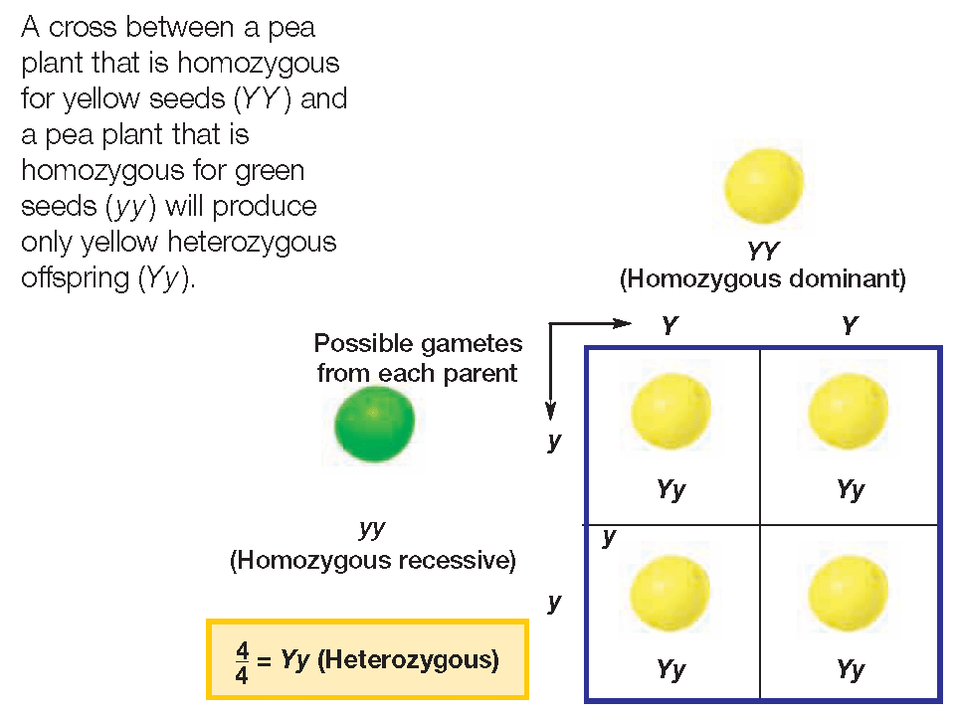

**Practice**

* Cross a two pea plants heterozygous for height…

T = tall and t = short

Genotype ratio?

Phenotype ratio?

**Practice**

* Cross a “female” pea plant heterozygous for seed color and a “male” recessive for seed color…

Y = yellow and y = green

Genotype ratio?

Phenotype ratio?

Reduce the ratio 2:2

Convert this ratio to a fraction

What percent does the fraction represent?

* The previous crosses were for genes on _________________ chromosomes
* Review…what are autosomes?
* Punnett squares can also be created for ________ chromosomes
  + In this case, the alleles must be linked on the _______ or _______ chromosome
* In 1910, Thomas Hunt __________ discovered sex-linked inheritance while studying _______ ________.
  + In fruit flies, the gene for eye color is linked on the ______ chromosome
* If R = red and r = white, determine the eye color and sex for the following genotypes
  + XRXR = ________________
  + XRXr = _________________
  + XrXr = __________________
  + XRY = __________________
  + XrY = __________________
* In humans, red green color blindness is a _____________ trait linked on the _____ chromosome
* Determine the following phenotypes…
  + XCXc = _______________
  + XcY = ________________
  + XCY = ________________
  + The female above does not have color blindness but ____________ the recessive allele

**Practice!**

* Cross a female who is a carrier for colorblindness with a male recessive for color blindness

C = normal vision and

c = colorblind

Genotype ratio?

Phenotype ratio?

Does a male offspring inherit colorbindness from his mom or dad?

* What genotype(s) may a purple pea plant have?
* Animal breeders, horticulturists, and others involved in breeding organisms often need to know whether an organism with a dominant phenotype is _______________ or ________________ for a trait.
* To determine the genotype, breeders cross the organism with an individual that is _____________ for the trait in a cross called a ________ cross

**Test cross**

* If the unknown genotype is PP, what color flowers will all of the offspring have?
* If the unknown genotype is Pp, what color flowers may the offspring have?

**Outcomes of Crosses**

* Like Punnett squares, ______________ calculations can be used to predict the results of genetic crosses.
* **Probability** is the _________________ that a specific event will occur.
* Probability =
* So if there are five marbles in a jar, and only one is red, what is the probability that you pull a red marble out of the jar?
* If you flip a coin, what is the probability that it will land heads up?
* If you flip a coin again, what is the probability that it will lands head up?
* So prior events do not affect the outcome of ____________ events
* In the following cross…

What is the probability that two

parents will have a girl?

What is the probability that their next child will be a girl?

* The outcomes predicted by Punnett squares are most often seen in ______________ populations….
  + Is everyone’s family made up of exactly half girls and half boys?
  + But a larger population, like the entire _________, is roughly 50:50 or 1:1
* To determine the probability of ____________ events or events occurring at the _________ time, the probability for each event is _________________ by eachother.
* What is the probability that a coin will land heads up four times consecutively?
* What is the probability that a pea plant offspring will have purple flowers?
* What is the probability that a pea plant offspring will be tall?
* What is the probability that a pea plant offspring will have purple flowers and tall height?

**Inheritance of Traits**

* Geneticists often prepare a **________________,** a family history that shows how a trait is inherited over _____________ generations.
* Pedigrees are particularly helpful if the trait is a genetic _______________ and the family members want to know if they are _____________ or if their _________________ might get the disorder.
* By analyzing a pedigree, we can determine if a trait is ______________ or ______ - linked and ____________ or ______________

Female = circle

Male = square

Horizontal Line = mating

Vertical line = offspring

Shaded = affected by the trait

Diagonal line = death from trait



**Autosomal recessive**

Most genetic disorders are caused by _____________ alleles

In this situation, an offspring with ______ recessive alleles has the trait, while each parent is a _________________

What allele combinations might have the other two offspring have?

**Autosomal Dominant**

If a trait is dominant, an affected individual will have at least ______ parent who also has the _____________ trait

Is the female parent homozygous dominant or heterozygous?

How do you know?

**Sex-linked**

If a trait is sex-linked, it will appear more often in ________ than in females

What genotype must all of the females have?

What chromosome does a male parent pass onto his son?

So is the recessive X-linked gene inherited from the male or female parent?