Chapter 11.4 Meiosis, Genetic Variation, & Sexual Reproduction
Objectives | Vocabulary
- Summarize the events that occur during meiosis.  - Relate crossing-over, independent assortment, and random fertilization to genetic variation.  - Differentiate between homologous chromosomes, autosomes, and sex chromosomes.  - Compare haploid and diploid cells. | - Haploid  - Diploid  - Somatic cell  - Germ line cell  - Gamete  - Meiosis | - Crossing over  - Independent assortment  - Sex chromosomes  - Autosome  - Homologous chromosome

Vocabulary | Definition
Somatic Cell
Diploid
Germ line Cell
Gamete
Haploid
Autosome
Sex Chromosome
Homologous Chromosomes
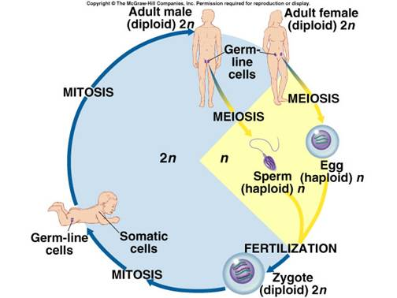
If a zygote divides and grows through mitosis, how does our body contain so many different types of cells?

Formation of Haploid Cells
Meiosis

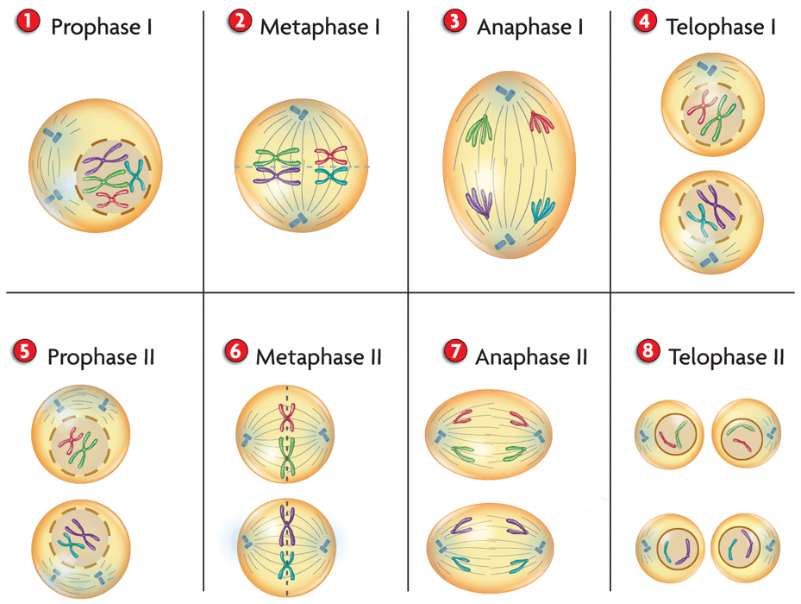

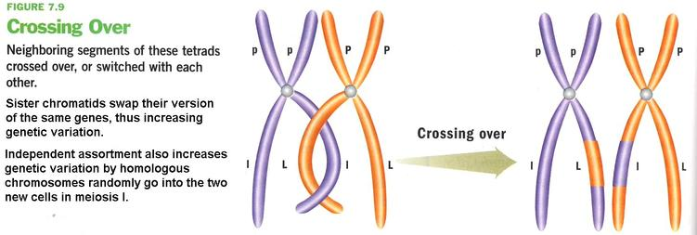
- a
Results of Crossing Over
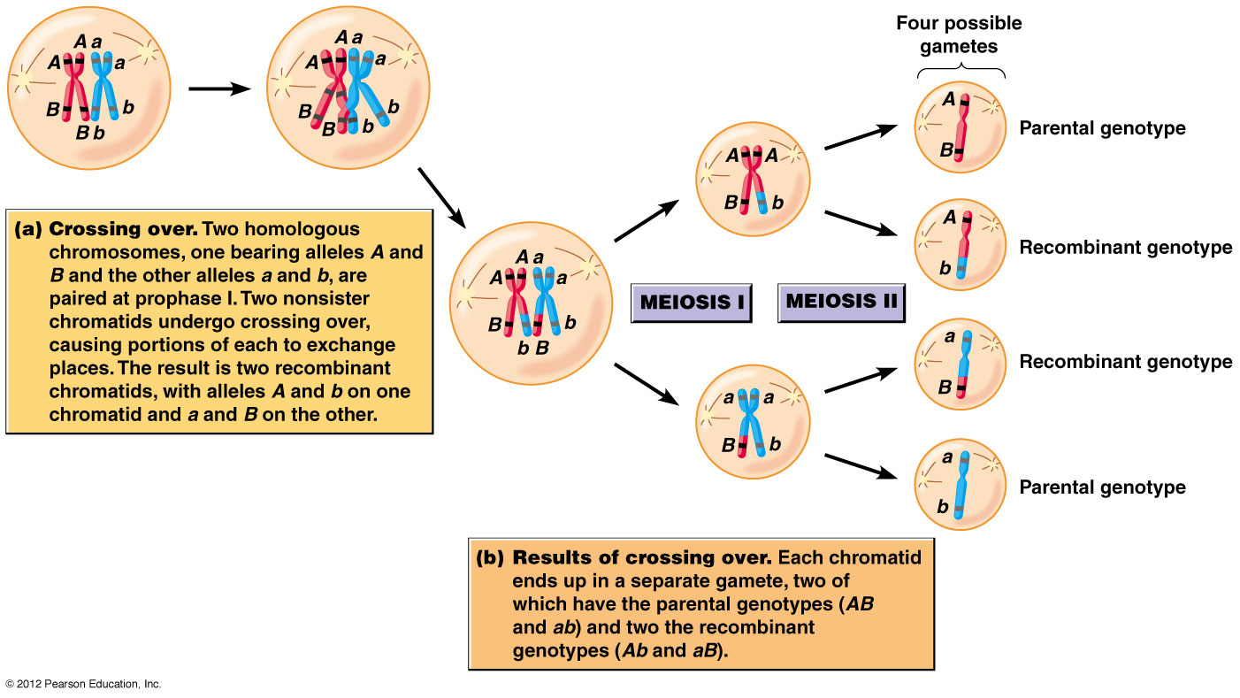
Independent Assortment
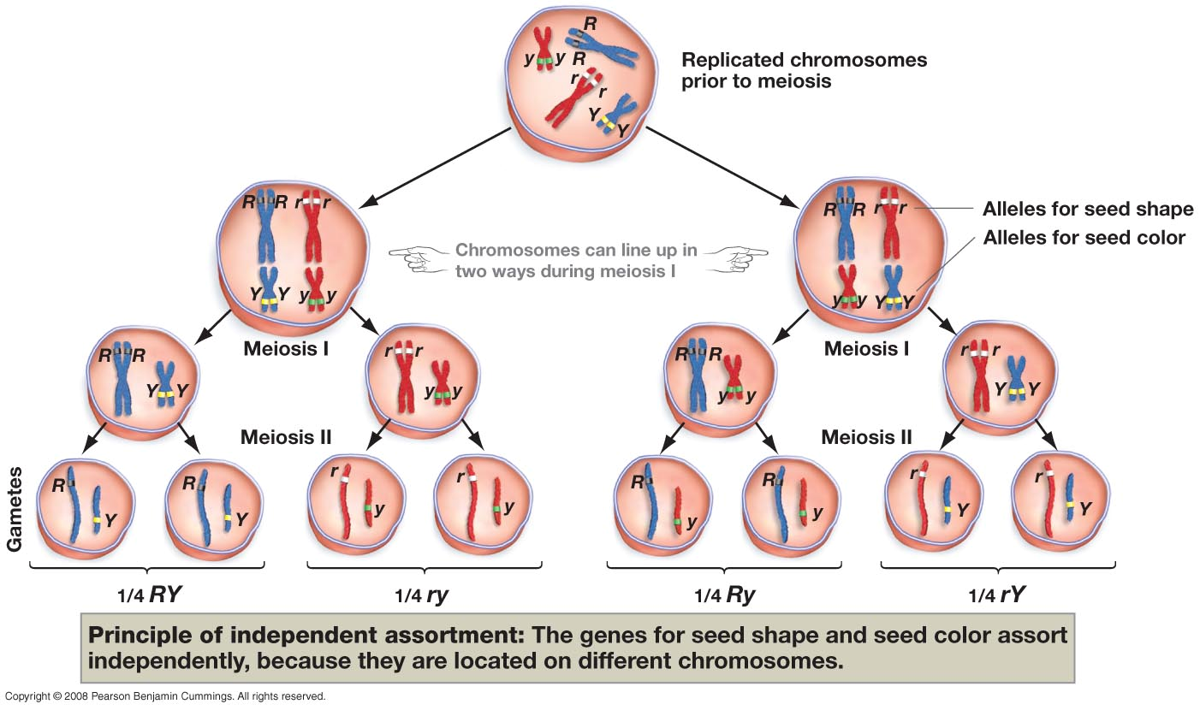
Random Fertilization

Why is Genetic Variation So important?

Relate crossing-over, independent assortment, and random fertilization to genetic variation.
Crossing Over
Independent Assortment
Random Fertilization

