Name: _____________________________________________________________ Class: ________________
- List 3 types of asexual reproduction?
  - _______________________________________________
  - _______________________________________________
  - _______________________________________________
- What is a clone.

- List one example of clone produced artificially (in a lab) and one produced naturally.
- What does “n” mean?

- What does 2n mean?

- What is the difference between a haploid individual and a diploid individual?

- Identify the Life cycle listed below, and fill in the bubbles and boxes with the correct terms and chromosomes numbers
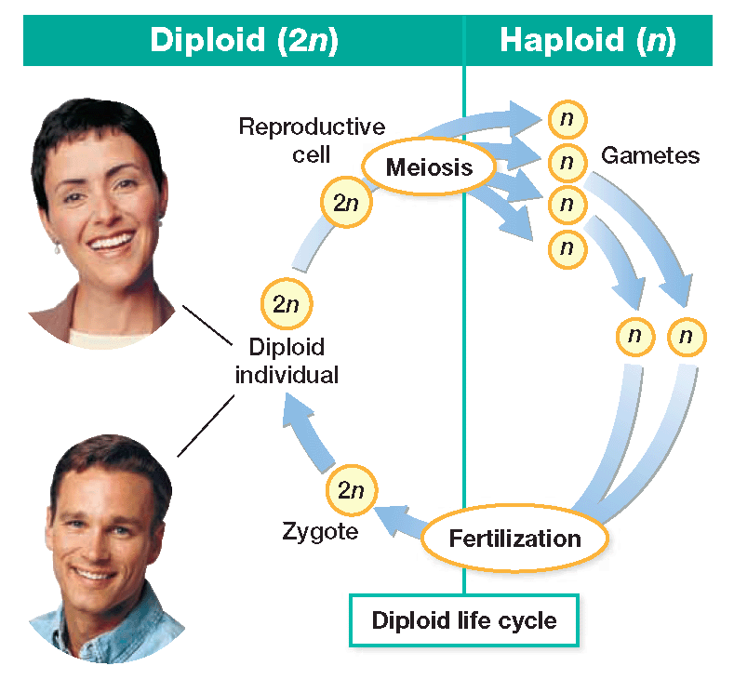
Put a star next to the things that are multicellular in the picture.
For all of the pictures, write the letter D for diploid or H for haploid
- In the picture above, what is another name for the reproductive cell that is used to produce gametes?
- Identify the life cycle listed below, and fill in the bubbles and boxes with the correct terms and chromosomes numbers
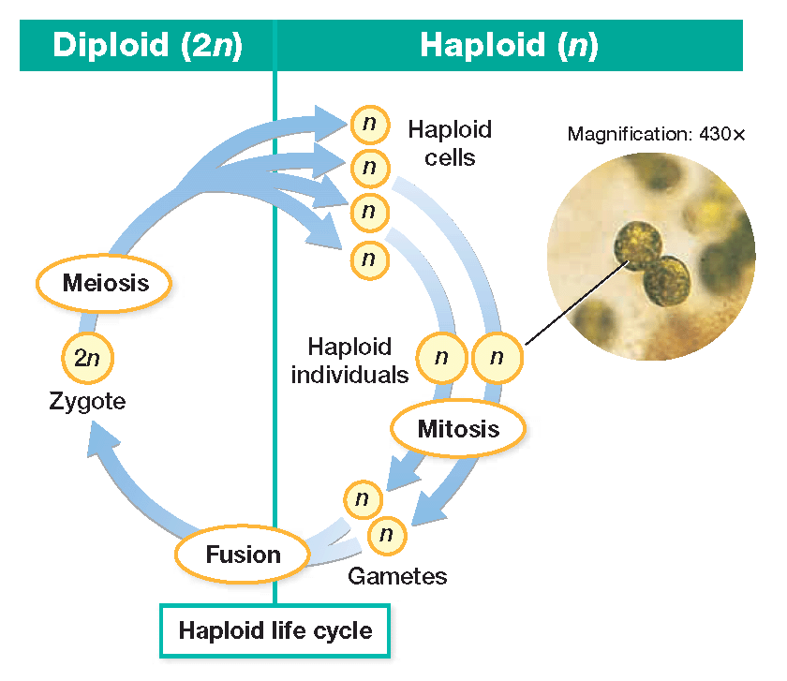
Put a star next to the things that are multicellular in the picture.
For all of the pictures, write the letter D for diploid or H for haploid
- For the life cycle listed below, fill in the bubbles and boxes with the correct terms and chromosomes numbers

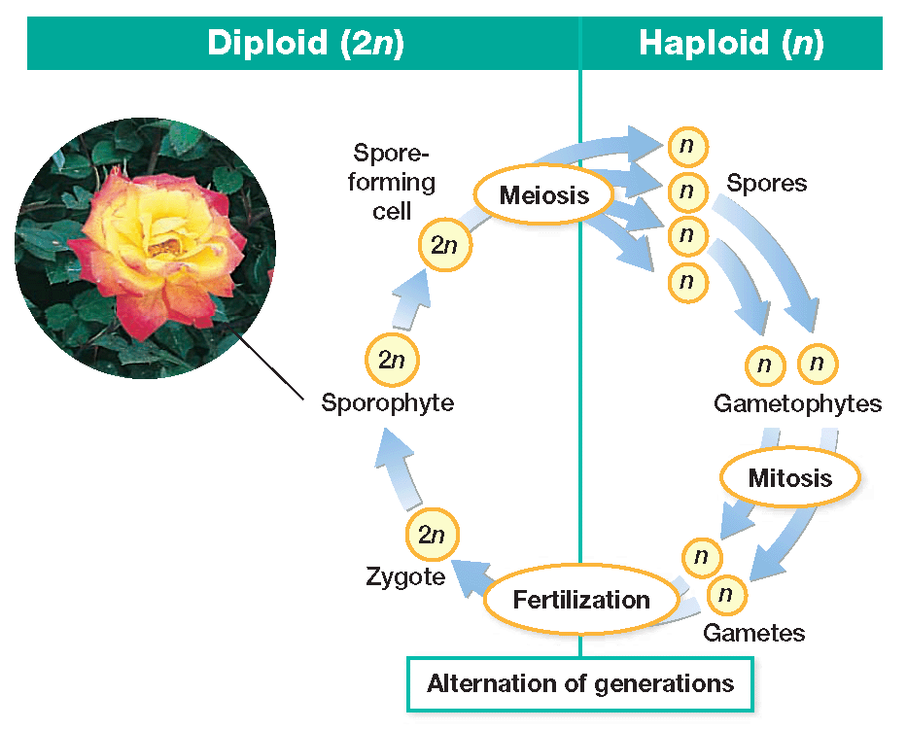
Put a star next to the things that are multicellular in the picture.
For all of the pictures, write the letter D for diploid or H for haploid

