Name:_______________________________________

Animal Cell Coloring
I. Directions: Color each part of the cell its designated color.
Cell Membrane(light brown) | Nucleolus (black) | Mitochondria (orange)
Cytoplasm (light yellow) | Golgi Apparatus (pink) | Lysosome (purple)
Nucleoplasm (pink) | Flagella (red/blue striped) | Microtubules (dark green)
Nuclear Membrane(dark brown) | Rough Endoplasmic Reticulum (dark blue) | Ribosome (red)
 | Smooth Endoplasmic Reticulum( light blue)
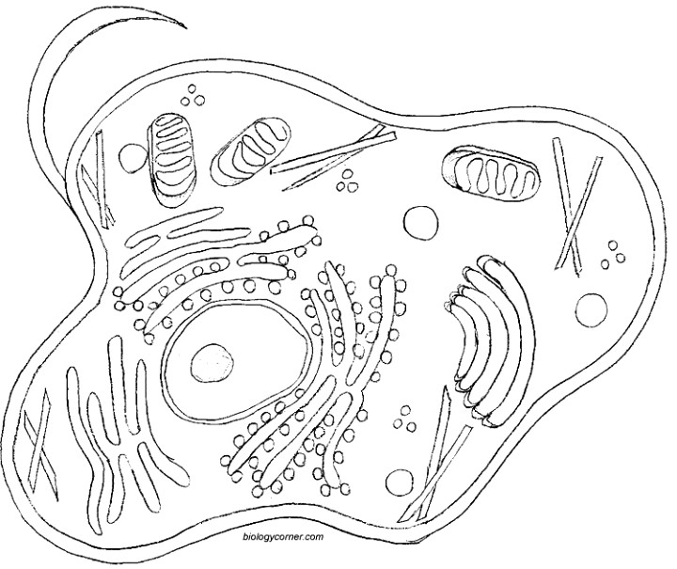
II. Briefly describe the function of the cell parts.
1. Cell membrane ______________________________________________
2. Endoplasmic Reticulum _________________________________________
3. Ribosome ____________________________________________________
4. Golgi Apparatus ____________________________________________________
5. Lysosome ____________________________________________________
6. Microtubule ____________________________________________________
7. Mitochondria ____________________________________________________
8. Nucleus ____________________________________________________

