Name: _____________________________1234567
1 Antibiotics, also known as antibacterials, are types of medications given for the treatment of an infection caused by microorganisms such as bacteria, fungi and parasites. However, they are not effective against viruses.

2 The Greek word anti means "against", and the Greek word bios means "life" (microorganisms are life forms).

3 Such illnesses as syphilis, tuberculosis, salmonella, and some forms of meningitis are caused by bacteria. Some bacteria are harmless, while others are good for us.

What are antibiotics?
4 The US National Library of Medicine says that antibiotics - powerful medicines that fight bacterial infections - can save lives when used properly. Antibiotics either stop bacteria from reproducing or kill them. "Your body's natural defenses can usually take it from there."

5 Before bacteria can multiply and cause symptoms, the body's immune system can usually destroy them¹. We have special white blood cells that attack harmful bacteria². Even if symptoms do occur, our immune system can usually cope and fight off the infection³. There are occasions, however, when it is all too much and some help is needed.....from antibiotics⁴.

6 The first antibiotic was penicillin. Such penicillin-related antibiotics as ampicillin, amoxicillin and benzylpenicilllin are widely used today to treat a variety of infections - these antibiotics have been around for a long time.

Continued on next page

Making connections to your personal experience: Think about a time you were sick and had to go to the doctor to get an antibiotic. What did you feel like, what were your symptoms, how long were you sick? ______________________________________________________________________________________________________________________________________________________________________________________________________________________________________________________________________________
Making Predictions: If antibiotics are not effective against viruses, predict what would happen if you had the flu virus and took antibiotics? __________________________________________________________________________________________
Making Connections to prior knowledge: What does the prefix micro mean?_________________ What do you think the word microorganism means? ___________________________________________
Questioning: write 2 questions about paragraph 3, one for each sentence.

_____________________________________________
Making Connections to your community: Ask 20 people over the age of 35 if the ever had or know someone that had tuberculosis. How many of them said yes?____
Making Connections to your community: Ask 20 people under the age of 30 if the ever had or know someone that had tuberculosis. How many of them said yes?____
Making connections within the text: In the last sentence of paragraph 4, what do you think the author is referring to when they say “Your body's natural defenses”?______________________________, and what sentence from paragraph 5 acts as evidence to supports this? 1 2 3 4
Making connections to your personal experience: Have you ever taken any of the antibiotics listed in paragraph 6 (you may have to ask a parent or caregiver because you may have taken it when you were too young to remember?) Yes / No If no, list an antibiotic you have had to take.__________________________________
Making Connections to your community
List anyone else in your family or friend group that has taken any of the antibiotics listed in paragraph 6?
__________________________________________________________________________________________

7 There are several different types of modern antibiotics and they are only available with a doctor's prescription in most countries.
Although there are a number of different types of antibiotic they all work in one of two ways:
- A bactericidal antibiotic kills the bacteria. Penicillin is a bactericidal. A bactericidal usually either interferes with the formation of the bacterium's cell wall or its cell contents.
- A bacteriostatic stops bacteria from reproducing.

Making connections to prior knowledge: Think about the following words: bactericidal, suicide, pesticide,
homicide. What do you think the word part “cide” means and why?
_______________________________________________________________________________________________________________________________________
Picturing: What do you “see” when you read about bactericidals? You may describe it in words or draw it.

Making connections between new content: Look up the word static. Why is bacteriostatic a good word to describe how these antibiotics work?

Reflection:
What was the most interesting thing you learned reading this article and completing this assignment?
______________________________________________________________________________________________________________________________________________________________________________________________________________________________________________________________________________________________________
Write down 2 questions you have from completing this assignment that you would like to learn more about or understand better.
1.__________________________________________________________________________________________
2. __________________________________________________________________________________________
Analyze presented information when given new, simple information (SB24-27)
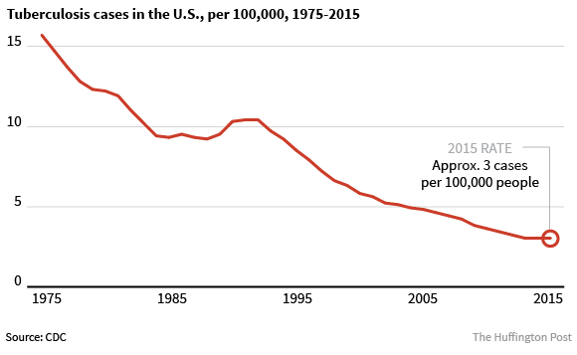
Based on this graph, do you think the number of tuberculosis cases was generally high or low before 1975? Explain why you think this?

What is the overall trend in Tuberculosis cases between 1975 and 2015?

Is this trend consistent with the data you collected? Cite evidence from the data you collected and the graph to justify your claim.

