Hobart High School
Biology
Final Exam Topic List—1st Semester
General Information: The final exam will be given on _12-19 or 12-20 2017_____. It will consist
of 75 multiple choice or matching questions, on topics from Chapters 1-7 & parts of 8& 9. Questions will require students to know and apply information about the topics listed below. Some questions may require students to interpret a diagram or graph and relate it to specific topics that have been studied in order to select the best answer. Additional questions may require students to interpret given laboratory data. Students are also expected to know the vocabulary from each chapter, as these terms will be used within questions.

Directions: Take notes for each topic in the space provided below…this may include a written description or a labeled picture. Pretend that the topics listed are questions.
Chapter 1
- What is the study of Biology

- List and describe the Characteristics of Life (see p18-19)

- The relationship between the following terms:

  - species & reproduction

  - growth & development

  - stimulus & response

  - adaptation & evolution

- Parts of a well designed, controlled experiment:

  - Hypothesis

  - Control group

  - Experimental group

  - Controlled variables (constants)

  - Independent variable

  - Dependent variable

- Read p13 and describe differentiate between a hypothesis ad a theory

- Read p20-21 and list and describe the Big Ideas in Biology
Big Idea | Description

Chapter 2: Chemistry of Life

- Draw the basic structure of an atom—nucleus (protons & neutrons) and electrons in energy levels. Identify the charge of each. (p34)

- What are valence electrons and why are they important?

- If an atom contains 4 protons, 4 neutrons, and 4 electrons, its mass number is________ and its atomic number is ___________

- Read p 37. Define how ionic and covalent bonds are formed.

- Explain the difference between an ion and an atom

- Read p 43-44. Draw the pH scale and label and give examples of an acid, base, and neutral

- What has more H+ ions , acids or bases?

- Read p51 and see your notes. Whats the difference between endothermic and exothermic reactions?

- Draw a graph showing both and endothermic and exothermic reaction below, both with and without an enzyme (p51-52) exothermic
endothermic

- What is metabolism

- The terms polar, nonpolar, hydrophilic, and hydrophobic?

- Read p46-49. Identify the monomer for each of the following and describe how living things use them?
  - Carbohydrates
  - Proteins
  - Nucleic Acids
  - Lipids (there are 2)

- The function of enzymes/catalysts and how they work

- Read p 52. What is Activation Energy

- Read p 53 and identify factors that affect enzyme activity

- The lock and key nature of enzyme-substrate complexes (p52)

Chapter 7: Cell Structure

- Contributions of van Leewenhoek, Hooke, Schleiden, Schwann and Virchow to understanding the basic nature of cells

- Parts of the Cell Theory
  - _________________________________________________________________________________________________________

  - ________________________________________________________________________________________________________

  - ________________________________________________________________________________________________________

- Draw and label the structure of a bacteria (prokaryote) in the space provided. Include a description of each of the cell parts. See p206

- The function and structure of the following cell structures…be able to identify them on a diagram: Use p 196-207

  - Chloroplast

  - Chromatin

  - Endoplasmic reticulum

  - Golgi apparatus

  - Mitochondrion

  - Nucleus

  - Plasma membrane

  - Ribosome

  - Lysosome

- Which of the organelles above are used for energy conversion in cells?
- Read p 193-194. What is a eukaryote?

- What is a prokaryote (p193-194)?

- Read p 314-217 and Define the following terms
Cell tissue organ organ system organism

- Draw and label the parts of a mitochondria

- Draw and label the parts of a Chloroplast

- Read p342-343. What is the role of DNA in a cell?

- Identify Similarities and Differences between prokaryotic and eukaryotic cells

- Understand how and why the plasma membrane is selectively permeable, and what this means

- Functions of the four types of membrane proteins

- Structure of and major parts of the plasma membrane, including phospholipids, cholesterol, membrane proteins, and hydrophilic/hydrophobic areas (pages 81/84 of text)

- Similarities & Differences between plant and animal cells Animal Cell
Plant
cell

Matter and Energy in Organisms and Ecosystems

- How does energy enter an ecosystem
- How does energy flow through an ecosystem (think food chain), what percent is passed to each trophic level, and what percent is lost as heat?

- What is the difference between the photic and the aphotic zone?

- Where would you find organisms that can do photosynthesis, the photic zone or the aphotic zone?

- Fill in the diagram below to evaluate the role photosynthesis and cellular respiration play in transforming energy as it move through ecosystems
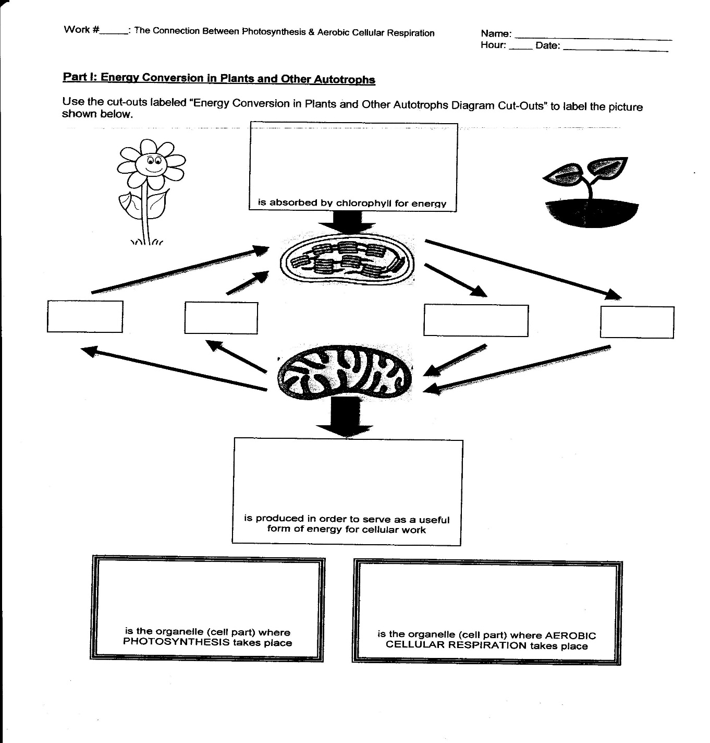
- Write out the reaction for photosynthesis, and identify the reactants and products

- Write out the reaction for cellular respiration, and identify the reactants and products

- What is the biosphere?

- What are the biotic and abiotic factors that determine carrying capacity?

- What type of population growth is exhibited before a population has reached carrying capacity? What would this look like in a graph?

- What type of population growth is exhibited after a population has reached carrying capacity? What would this look like in a graph?

- How do the following factors affect biodiversity?
  - Overexploitation
  - Invasive species
  - Habitat loss
  - Pollution
- Rotifers are an important part of the freshwater zooplankton, being a major food source and with many species also contributing to the decomposition of soil organic matter. Zebra Mussels are filter-feeding organisms. They remove particles from the water column. The zebra mussels process up to one liter of water per day, per mussel. Some particles are consumed as food, and feces are deposited on the lake floor. Use graph depicting the population of rotifers and zebra mussels in Lake Michigan to answer the following questions.
  - What is the trend in the data?

  - Based on this trend, what is the likely relationship between zebra mussels and rotifers? How do you know?

  - Zebra mussels are considered an invasive species. Based on this, what would you predict would happen to the population size of other filter feeders as zebra mussel population increases? Use a claim, evidence, reasoning format to answer this question.

Claim __________________________________________________________________________________________________________

Evidence ______________________________________________________________________________________________________ __________________________________________________________________________________________________________________

Reasoning______________________________________________________________________________________________________ ___________________________________________________________________________________________________________________

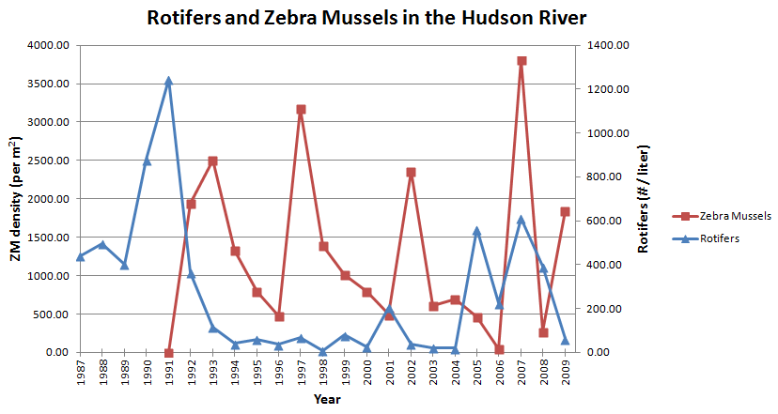

- Based on the graph below, what is happening to biodiversity between 1970-2002?

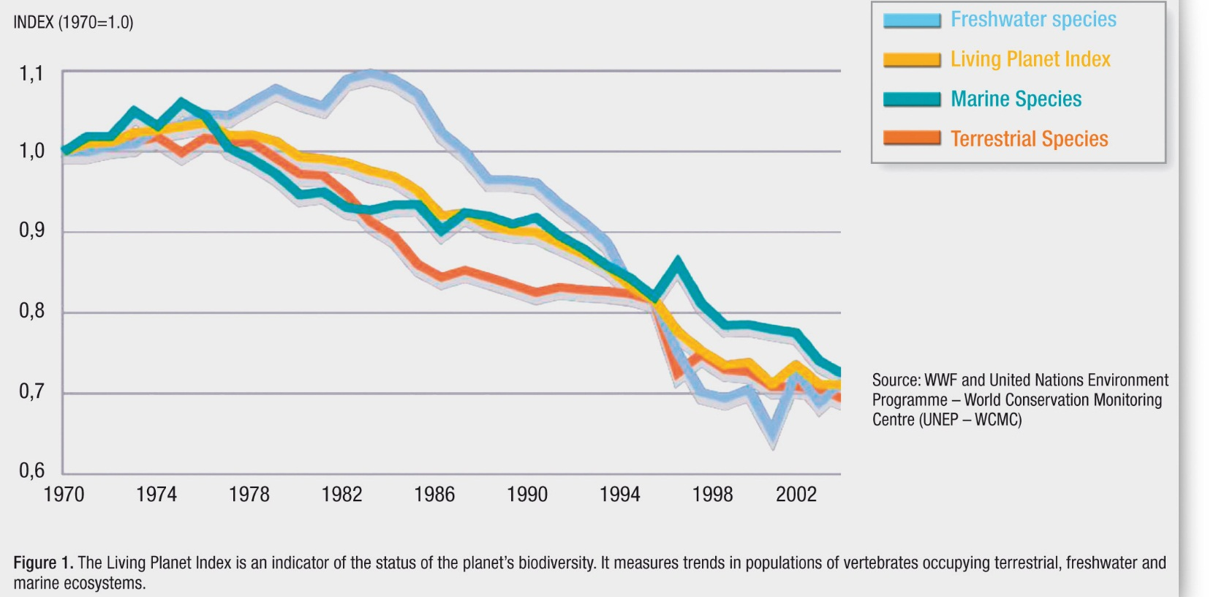

- What are things we can do to lessen the negative impact we have on biodiversity. Answer this in a claim evidence reasoning format. A claim without evidence and reasoning will not be sufficient.
  - Claim __________________________________________________________________________________________________________
Evidence ______________________________________________________________________________________________________ __________________________________________________________________________________________________________________ Reasoning______________________________________________________________________________________________________ ___________________________________________________________________________________________________________________
- Design an experiment to test your solution to the above prompt. Consider all the parts of an experiment including:
- Independent variable
- Dependent variable
- Controlled variables (constants)
- Control group
- Length of experiment
- When do we use a bar graph? When do we use a line graph?
- What is biodiversity?

