DNA: The Genetic Material
All of this information can be found in the book in chapter 8
Why Its Important Learning about DNA contributes to our knowledge of: genetic disorders, viral diseases, cancer, aging, genetic engineering, criminal investigations
Objectives | Vocabulary
- Relate Griffith’s conclusions to the observations he made during the transformation experiments.  - Summarize the steps involved in Avery’s transformation experiments, and state the results.  - Evaluate the results of the Hershey and Chase experiment. | - Vaccine  - Virulent  - Restriction enzyme  - Transformation  - Bacteriophage
DNA Review
  - What does DNA stand for?
  - What subunits make up DNA?
  - What three parts do the subunits consist of?
Transformation Griffith’s Experiments
- In 1928, Frederick _____________, a bacteriologist, carried out an experiment that led to an ________________ discovery about DNA
- He was actually trying to prepare a vaccine against the bacteria, Streptococcus pneumoniae, which causes _________________.
- A vaccine is a substance that is prepared from killed or ________________ disease-causing agents
- When administered, it is easier for your body’s immune system to ___________ off the disease and prevent ________________ infections
- For example…
  - people who get a flu vaccine every year, will easily fight off that __________ of the virus and avoid having any ______________
- Griffith was working with two strains of S. pneumoniae…
  - One enclosed in a _____________ of polysaccharides, that protects the bacterium from the body’s defense system
  - This helps make the bacterium _________, or able to cause disease
    - Smooth-edged ( )
- The other strain ___________ the polysaccharide capsule and is unable to cause disease
  - Rough – edged ( )
- In Griffith’s experiment, he injected mice with…
  - S bacteria
  - R bacteria
  - Heat-killed S bacteria
  - Heat-killed S bacteria and normal R bacteria
Note about “heat-killing”…

During Griffith’s time, it was not understood that DNA can tolerate temperatures around 90°C without being altered, but ___________ are altered at around 60°C

So “heat-killing” damages a cells proteins and ___________, but leaves DNA _________

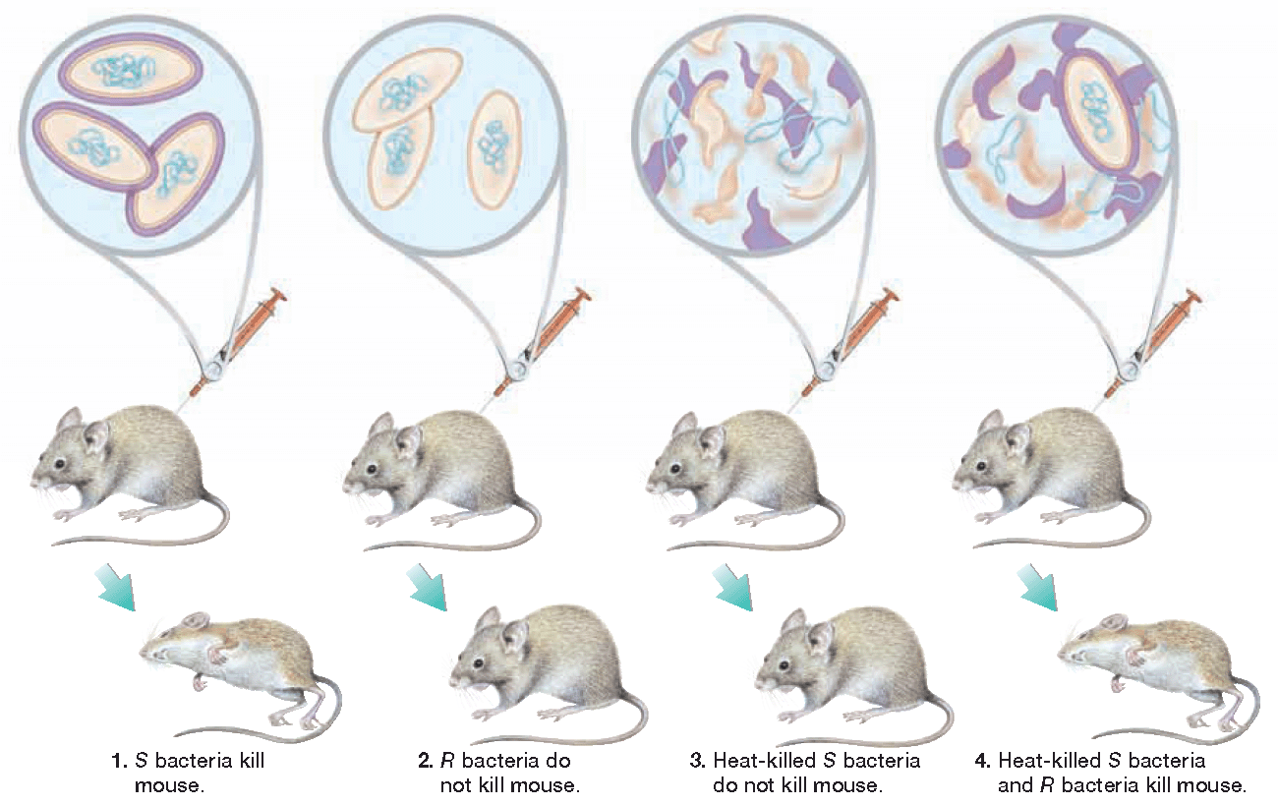
- Somehow, the harmless R bacteria had changed and become ______________
- Griffith had discovered what is now called ____________________
  - Occurs when a cell picks up new DNA from it’s _____________, changing its combination of genes, called a _________________
- Then restriction enzymes _________ and _________ the two pieces of DNA together
- But during Griffith’s time, scientists really didn’t understand transformation
- During the 1940s and 1950s, scientists were still debating over what cell part contained genetic information
- Many scientists actually thought that ___________ contained our genetic information, and not DNA.
Oswald Avery
- In 1944, a scientist named Oswald __________ conducted a transformation experiment under two different conditions…
  - Condition 1: Added an enzyme that destroyed ____________
  - Condition 2: Added an enzyme that destroyed ____________
- Result?
  - Transformation was only stopped by the enzymes that destroyed _________...so it must contain the genetic material!

- Despite Avery’s results, scientists remained _____________
- Since proteins are so important to many cell _____________ and _______________, most scientists still thought that proteins contained the genetic material
Hershey & Chase
- In 1952, Alfred ___________ and Martha _____________ set out to settle the controversy.
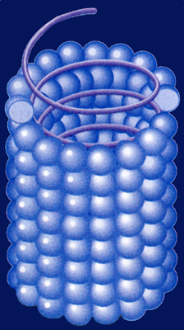
- Their experiments made use of a substance called a ___________, which attacks and infects cells
  - A virus is much _____________ than a cell and consists of ________ or ________ surrounded by a protective protein coat called a ____________
- When a virus infect a cell, it causes the cell to produce more __________ instead of carrying out its normal cell activities
- Eventually the cell ___________ open during a process called ____________, and the released viruses seek out another cell to infect

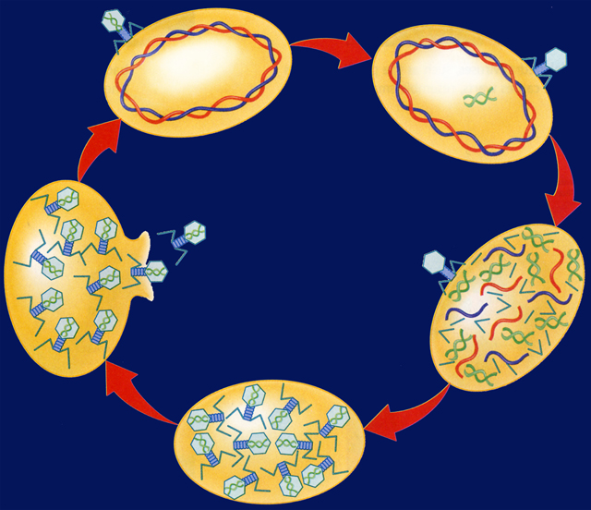
- A special type of virus that infects ________________ cells is called a __________________ or a _________ for short
- The viral DNA is contained in the ________ and the tail __________ attach to the bacteria cell
- After attachment, the DNA is injected into cell, almost like a _________
- The bacteriophage made the perfect test subject, because it was a simple substance that contained both ________ and ____________
  - Scientists knew that DNA contained a ____________ group
  - They also knew that So Hershey and Chase labeled the phages with one of the following radioactive isotopes…
  - ______, which would be found in DNA
  - ______, which would be found in the protein coat
  - proteins often contain the element __________

- These radioactive isotopes will __________ or break down into stable particles that can be ____________ with machines
- Next the labeled phages were allowed to ___________ the bacteria cells
- Hershey and Chase then checked to see which ______________ entered the bacteria cells
- First the phages that were still attached to the bacteria cells were removed with a__________________
- Then the bacteria cells and the phages were placed in test tubes and ___________ in a machine called a centrifuge
- As the centrifuge spins, the different substances settle out by _________
- The heavier bacteria cells settled at the __________ of the test tubes while the lighter phages settled at the ______
- Only the ______ isotope was found inside of the bacteria cells
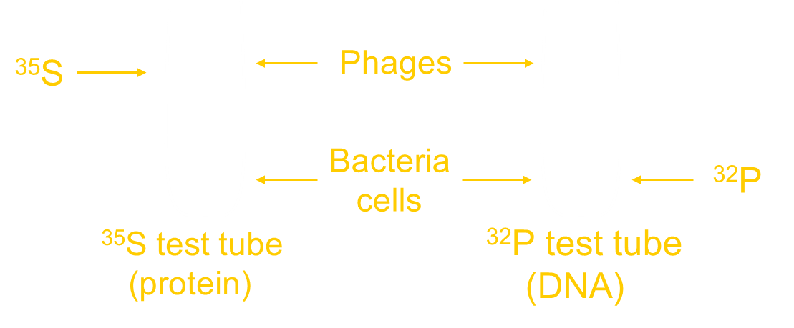
So based on these results… which substance, proteins or DNA, would you conclude is responsible for transformation?

- Relate Griffith’s conclusions to the observations he made during the transformation experiments.

- Summarize the steps involved in Avery’s transformation experiments, and state the results.

- Evaluate the results of the Hershey and Chase experiment.
Objectives | Vocabulary
- Describe the three components of a nucleotide.  - Develop a model of the structure of a DNA molecule.  - Evaluate the contributions of Chargaff, Franklin, and Wilkins in helping Watson and Crick determine the double-helical structure of DNA.  - Relate the role of the base-pairing rules to the structure of DNA.  - Summarize the process of DNA replication.  - Describe how errors are corrected during DNA replication  - Compare the number of of replication forks in prokaryotic and eukaryotic DNA. | Double helix  Nucleotide  Deoxyribose  Base-pairing rules  Complementary base pair  DNA replication  DNA helicase  Replication fork  DNA polymerase
- After the Hershey and Chase experiment, scientists were convinced that DNA contained the genetic material…
  - But how is this information ________________?
  - And how is it _____________ on?
  - To answer these questions, scientists began studying the ___________________ of DNA
- In 1953, James __________ and Francis _________ determined that a DNA molecule is a ____________ __________
  - Meaning that it consists of ______ strands __________ around each other like a winding staircase
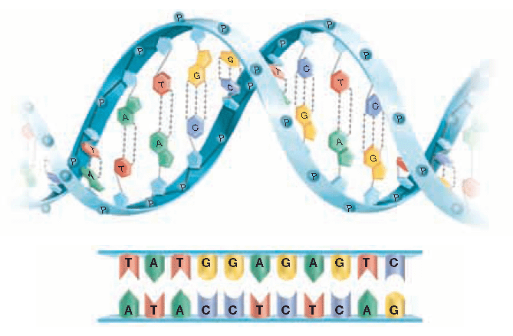
Each strand is made of ___________ nucleotides, which consist of three parts…
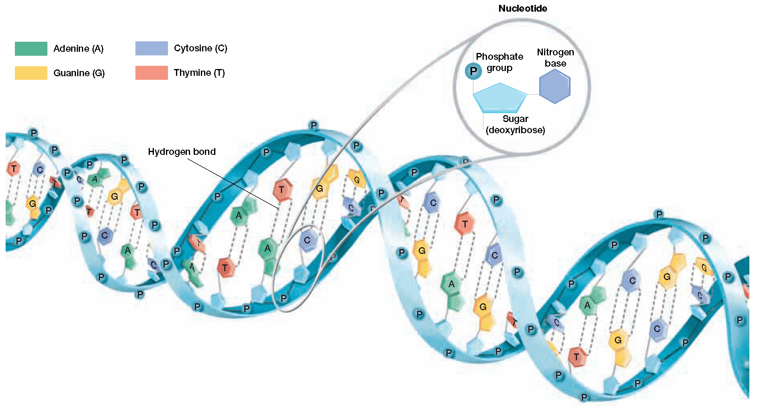
  - A phosphate group
  - A 5 carbon sugar called _____________
  - A ____________ base
- One nucleotide is circled for you…
- Circle several more nucleotides
- Label a the 5 carbon sugar deoxyribose
Note how DNA resembles a ___________________
The side rails or _________________ of each strand consist of the…
  - __________________
  - __________________

The phosphate and the sugar are held together by _________________ bonds

- The rungs of the ladder are made of the nitrogenous __________
  - They are held together by _______________ bonds
- While each DNA nucleotide contains the _______ sugar and phosphate group, the nitrogenous ____________ may be any one of the four different kinds…
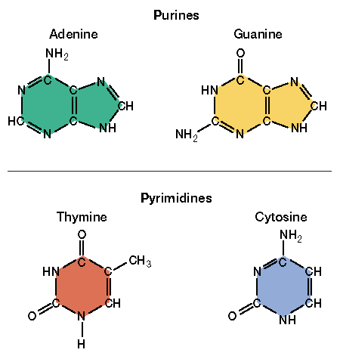
  - ____________________
  - ____________________
  - ____________________
  - ____________________
- Adenine and guanine contain ____________ rings,
which are classified as _________________
- Thymine and cytosine consist of ___________ rings,
which are classified as _________________
- Which bases look larger…
  - Purines or pyrimidines?

- How were Watson and Crick able to determine the double helical structure of DNA?
  - They based their structure on __________ acquired from ___________ scientists
Erwin Chargaff
- In 1949, Erwin Chargaff observed that for each organism he studied, the amount of adenine always equaled the amount of thymine… _______ = ______
- Likewise, the amount of guanine always equaled the amount of cytosine… _____ = _____
- However, the amount of each equal pair _________ between different organisms.
Maurice __________ and Rosalind ______________
- In 1952, they took many photographs of sections of DNA using a method called ___________ ___________________
  - In the process, X-ray beams were bounced off of DNA and the rays were diffracted or ______________ onto a piece of film
  - This method is similar to shining a light on an object and analyzing its ____________
- The X-ray photos clearly showed that DNA is composed of _____ strands that are _________
- In 1962 Watson, Crick, and Wilkins were awarded a ____________ prize for their work
- Rosalind Franklin was not recognized as a reward recipient because she had already died of cancer likely caused by too much X-ray ______________

- Based on all of the compiled data, Watson and Crick determined that a _______________ on one strand of the DNA is always paired with a ______________ on the opposite strand
- Since adenine and thymine are always found in equal amounts…___ pairs with ____
- Likewise, guanine and cytosine are found in equal amounts, so ____ pairs with ____
- A and T form ____ hydrogen bonds
- G and C form ____ hydrogen bonds
- The strictness of the base-pairing rules results in two strands that contain ______________ base pairs…
- Meaning that the order of bases on one side ___________________ the order of bases on the other side
- Determine the complementary base pairs for the DNA strand below…
A T A C G T
Roles of Enzymes in DNA Replication
- The complementary structure of DNA is also used as a basis to make ___________ copies of the DNA each time a cell ______________
- Cell division allows an organism to ________, _____________, and to _____________ old cells
- As we learned last semester, why can’t a cell simply just grow larger instead of dividing?
- The actual process of cell division is called ________________
- Why might it be a good idea for one of your body cells, like a skin cell, to make an exact copy of its DNA before it divides?
- The process of making a copy of DNA is called ___________________ or ________________
- DNA replication occurs in three steps:
  - Step 1
    - Enzymes called DNA ________________ open the double helix by breaking the ______________ bonds that link the bases together
    - The areas where the double helix separates are called replication __________.
  - Step 2
    - At the replication fork, enzymes known as DNA _______________ move along each of the DNA strands and add _________________ to the exposed nitrogen base, according to the base-pairing rules.
    - Notice that the strands of DNA are copied in ______________ directions …
      - This phenomenon is known as ___________________
      - The direction is controlled by the location of __________ atoms in deoxyribose…
      - 5th Carbon to 3rd Carbon
  - Step 3
    - DNA polymerases _______________ after two ______________ molecules are formed
    - Each new molecule consists of one _____ strand and one ______ strand
Checking for Errors
- In the course of DNA replication, errors sometimes occur and the ___________ nucleotide is added to the new strand.
- An important feature of DNA replication is that DNA polymerases have a ___________________ role.
- In the event of an error, the polymerases can _____________
- Under normal circumstances, this proofreading reduces errors in DNA replication to about ________ error per 1 _____________ nucleotides.
The Rate of Replication
- Replication does not begin at one end of the DNA molecule and end at the other because that would take too _________.
- Recall that DNA in prokaryotes is _________________.
- They usually have ______ replication forks that begin at a single point meet on the _____________ side of the DNA circle
- In eukaryotic cells, each chromosome contains a single, ____________ strand of DNA.
- Each human chromosome is replicated in about ______ sections that are 100,000 nucleotides long, each section with its own starting point.
- An entire human chromosome can be replicated in about ___ hours.
- Describe the three components of a nucleotide.

- Develop a model of the structure of a DNA molecule

- Evaluate the contributions of Chargraff, Franklin, and Wilkins in helping Watson and Crick determine the double-helical structure of DNA

- Relate the role of the base-pairing rules to the structure of DNA.

- Summarize the process of DNA replication.

- Describe how errors are corrected during DNA replication.

- Compare the number of replication forks in prokaryotic and eukaryotic DNA.

