# Chapter 3: Cell Structure

Cells are the basic building blocks for all _______________…it is important to understand their structures and functions

CH3.1

|  |  |
| --- | --- |
| **Objectives** | **Vocabulary** |
| * **Describe** how scientists measure the length of objects. * **Relate** magnification and resolution in the use of microscopes. * **Analyze** how light microscopes function. * **Compare** light microscopes with electron microscopes. * **Describe** the scanning tunneling microscope. | Light microscope  Electron microscope  Magnification  Resolution  Scanning Tunneling Microscope |

Most cells are too small to be seen with the naked eye

* Scientists were not aware of cells until they invented the __________________
* Anton van _____________________ was the first person to view single-celled organisms
  + He viewed pond water with a microscope and observed many living creatures that he called __________
* In ________, an English scientist named Robert _________ observed a thin piece of _________ using a microscope. He saw that the cork contained tiny “rooms” that reminded him of the rooms that monks lived in called ___________
  + You can also think of a ____________ cell

Cell measurements taken by scientists are expressed in ____________ units.

* The official name of the metric system is the _________________ _________________ of Measurement…abbreviated _____
* SI is a ________________ system, so all relationships between SI units are based on powers of __________
* There are seven SI base units…

|  |  |  |
| --- | --- | --- |
| Measurement | Unit | Symbol |
|  |  |  |
|  |  |  |
|  |  |  |
|  |  |  |
|  |  |  |
|  |  |  |
|  |  |  |

Most SI base units have a ____________ that indicates the relationship of that unit to a base unit

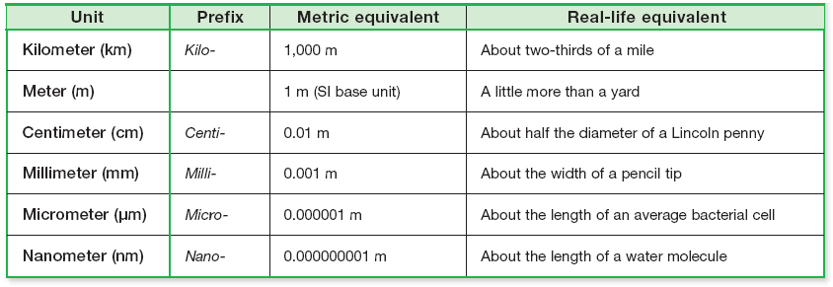

What prefix on the chart indicates the smallest size?

* What prefix is usually used for cell sizes?

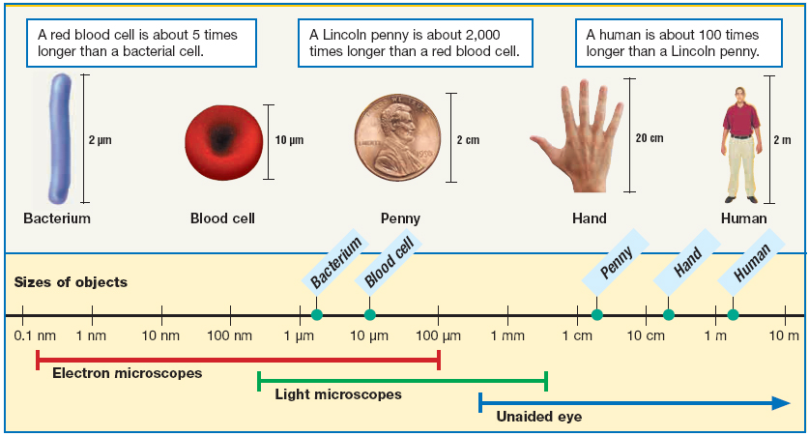

**When looking at a cell with a microscope, it is necessary to have good…**

* + ____________________ the quality of making an image appear _____________ than its actual size
  + **___________________** is a measure of the ___________ of an image

There are three main types of microscopes…

* + ____________________________________________________ microscope
  + ____________________________________________________ microscope
  + ____________________________________________________ microscope
* Light microscopes use ___________ to magnify an image
  + Simple light microscopes use _________ lens
  + Compound light microscopes use ________________ lenses
* An image produced by a microscope is called a ___________________________________________
  + They are labeled with the…
    - Specimen
    - Type of microscope
    - magnification
* Light waves are too _______ to clearly magnify objects smaller than a few __________________
* Electron beams are _____________ than light waves so electron microscopes can magnify smaller objects with better _____________________
* The electron beam and specimen must be in a _______________ so that the electron beam will not bounce off of _________ molecules.
  + This prevents ________ organisms from being viewed with an electron microscope

**____________________________________ Electron Microscope**

* The electrons that pass through strike a fluorescent screen, forming an image that allows you to see _______________ structures

**_____________________________________ Electron Microscope**

* An electron beam is focused on a specimen producing an image that shows _________________ details of the ______________ of a specimen.

**Scanning Tunneling Microscope**

* A needle-like probe measures differences in ______________ caused by electrons that leak, or ____________, from the surface of the object being viewed.
* A ________________ tracks the movement of the probe and produces a __________________ image of the surface of the specimen.
* STMs allow _______________ specimens and objects as small as ______________ to be viewed!

1. What metric prefix is used most often while measuring cells?
2. What is the difference between magnification and resolution?
3. What is the difference between a simple and compound microscope?
4. Which type of electron microscope allows you to see internal cell structures?
5. Which type of microscope allows you to observe live specimens and objects as small as an atom

CH3.2

|  |  |  |
| --- | --- | --- |
| Objectives | Vocabulary | |
| * **List** the three parts of the cell theory. * **Determine** why cells must be relatively small. * **Compare** the structure of prokaryotic cells with that of eukaryotic cells. * **Describe** the structure of cell membranes. | Cell theory  Cell membrane  Cytoplasm  Cytoskeleton  Ribosome  Prokaryote  Cell wall  Flagellum  Eukaryote | Nucleus  Organelle  Cilium  Phospholipid  Lipid bilayer |

After Robert Hooke named the “cell” in 1665, it took many scientists who were working together ______ years to understand what a cell was

* Matthias _______________________________, a German botanist, viewed many plants under a microscope
  + - In 1838, he concluded that all plant parts are made of _____________________________
* One year later, in __________________, Theodore _________________________________concluded

that all ____________________ parts are made of cells *Hint…Schwann sounds like swan*

* In 1858, Robert _____________________________ determined that all cells come from

__________________________ cells that reproduced

The work of these three scientists are the basis for the ___________________, which has three parts:

1. All living things are ________________________ of one or more cells.
2. Cells are the basic units of ___________________________ and ___________________________ in organisms.
3. All cells arise from ________________ cells.

**Cell Size**

* Cells cannot grow too large because small cells

function more ________________ than large cells

* **This is due to the fact that ____________________ increases more quickly than _________________**
* The surface area of this cube represents the cell ____________. Its volume contains all of its cell __________
* If each side of the cube is 1mm long, what is its surface area?
  + Find the area of one side and multiply by ____ to find the total area of all the sides
    - Area = 1 mm x 1mm = _________
    - Surface area = ________ x _____ =
* Find the volume of this cube
  + Volume = length x width x height
    - Volume = ____ x ____ x ____ = ______
  + So this cell’s surface area to volume ratio is…
* Find surface area and volume for a cube with sides that are 2mm long
* S.A. =
* Volume =
* So the s.a. to volume ratio of this cube is…
* Find surface area and volume for a cube with sides that are 4 mm long
* S.A. =
* Volume =
* So the s.a. to volume ratio of this cube is…

Ratios can also be written as fractions

* If a cell’s surface area–to-volume ratio is too ___________________, substances cannot enter and leave the cell well enough to meet the cell’s needs.
* So if the cell grows too big, it won’t be able to get enough food _______ or waste ______ fast enough to survive
* The same applies for food particles in a cell, so large cells end up ______________ from lack of food or being ____________________ by waste

1. Who studied plants…Schleiden or Schwann?
2. What are the three parts of the cell theory?
3. Why must cells be relatively small?

* **All cells share some common structural features, including...**
  + an outer boundary called the **__________________**
  + interior substance called **___________________**
  + genetic material in the form of **__________**
  + cellular structures that make proteins, called **__________________**

**There are 2 types of cells…**

* + **__________________________________________**
  + **__________________________________________**

|  |  |
| --- | --- |
| **Prokaryotes** | |
| Untitled-36 copy | * ______________ celled organisms * Lack a _______________ and other internal compartments * Without separate compartments, prokaryotes cannot carryout many   _________________ functions |

* Early prokaryotes lived at least _________________ years ago
* Modern prokaryotes are commonly known as ____________________
* Instead of being in a nucleus, DNA is found in single, ______________ molecule
* Ribosomes and enzymes are free to ______ around in the cytoplasm
* Prokaryotes also have an _________ cell membrane, which is also called a ________ membrane and an ________ cell wall
* The cell wall provides ______________ and ______________ for prokaryotic cells
* Other organisms, like ____________, ___________, and some _____________ have cell walls but __________________ do not!
* Some prokaryotes are also surrounded by a structure called a _____________________ which provides _____________ and enables prokaryotes to ________ to almost anything, including teeth, skin,

and food

* Prokaryotes may also have ___________ (singular = pilus) that aid in sexual reproduction and long extensions called __________________ (singular = flagellum) that aid cell movement
* Flagella move in a ____________________ or rotate

**Eukaryotes**

Eukaryotic cells have:

* A **______________________________** which contains the cell’s DNA
* Other internal compartments called **______________________________**.

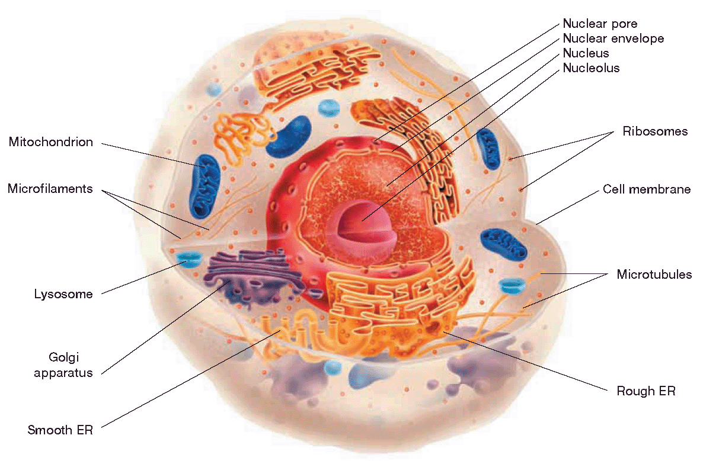

* Organelles allow eukaryotic cells to carryout many ______________ activities at once
* The first eukaryotes evolved __________________ years ago
* Eukaryotic cells are typically ___________ than prokaryotic cells and take __________ to divide
  + Prokaryote ______ minutes
  + Eukaryote _______ hours
* Eukaryotes may be unicellular, like ___________, or multicellular like ______________, ____________, and most ____________
* Single celled eukaryotes may move by using flagella or ____________
  + Cilia are _________, hair like extensions that move back and forth

|  |  |
| --- | --- |
| Specialized eukaryotic cells, such as those found along the lining of the respiratory system,  ________________ out debris and mucus from air passages |  |

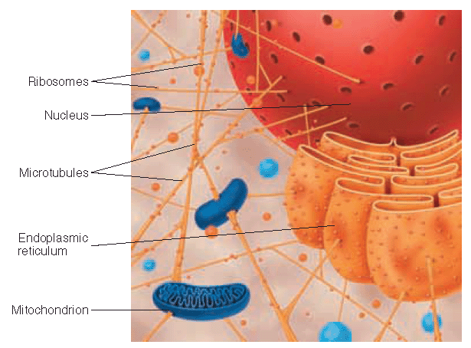

* The _________________ provides the interior _______________ of an animal cell.
* Consists of an intricate network of __________________________ fibers that are attached to the inside of the plasma membrane and other organelles. They are found throughout the cytoplasm. The fluid in the cytoplasm is

called _________________________

**Cytoskeleton**

* There are three basic kinds of cytoskeletal fibers.

1. **Microfilaments:** long slender filaments made of the protein _________________
2. **Microtubules:** __________ tubes made of the protein __________________
3. **Intermediate fibers:** thick ________ made of protein.

* Microfilaments can _____________ and ___________, which determines the shape of animal cells. Some protists also use microfilaments to move. The extensions on this amoeba are helping It to move from one location to another
  + The extensions are called ________________________________________, which means “false feet
  + This type of movement is called cytoplasmic____________________
* Microtubules act as a ________________ system for transportation of information from the nucleus to other parts of the cell
* Think of microtubules as __________________. There are ____________________ that move along the microtubules to transport different items
* Intermediate fibers provide a frame that anchors certain _____________________________________ and ribosomes to a particular region of the cell
* By keeping these enzymes in one location, the cell can organize complex___________________________ activities efficiently

**The Cell Membrane**

* The **cell membrane** is a _____________________ ____________________________ barrier that determines which substances enter and leave the cell.
* Think of a pasta strainer
  + What does the strainer “select” for, or what passes through?
  + What does not pass through?
* The **selective permeability** of the cell is mainly caused by the way _____________________ interact with water.
* A **phospholipid** is a lipid made of a ___________ group and two ____________________ chains
* The phopshate group is commonly called the ________________ and it is ____________
  + So it is ____________________

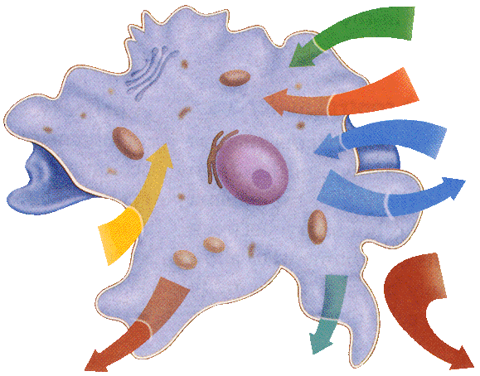

* The fatty acid chains are commonly called ________
* and they are _______________
  + So it is _________________
* ____________________ is found inside and outside of the

Cell so the tails must arrange themselves _________ from water

* Cell membranes are made of a ____________ layer of

phospholipids, called a ______________.

* The tails are on the ____________ and the heads are on the _________________________

[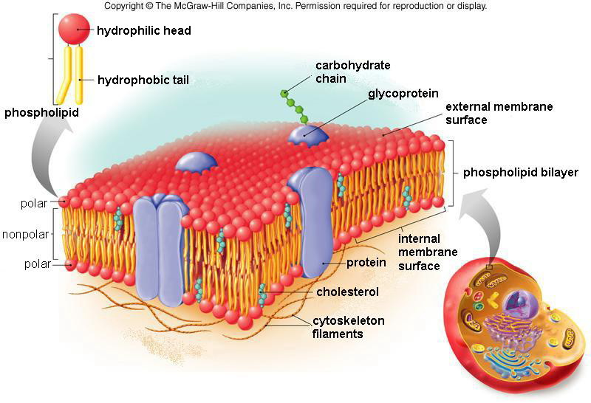](http://www.google.com/url?sa=i&rct=j&q=plasma+membrane&source=images&cd=&cad=rja&docid=M78w90ZdrzbrIM&tbnid=LXvdqB3ue_iXxM:&ved=0CAUQjRw&url=http://legacy.hopkinsville.kctcs.edu/instructors/Jason-Arnold/VLI/Module%202/m2cellstructure/m2cellstructure3.html&ei=IkN9Ut3-JY_rkQefkIDAAg&bvm=bv.56146854,d.eW0&psig=AFQjCNE2oQD_hiyiNTbG9Q69eRoCqpfkLQ&ust=1384027256057297)

This arrangement prevents ____________________________ polar molecules from moving freely through a cell membrane because they are _________________ by nonpolar tails

The cell membrane also contains various proteins which are made up of _____________________

As we learned in chapter 2, some amino acids are ________________ and some are _____________

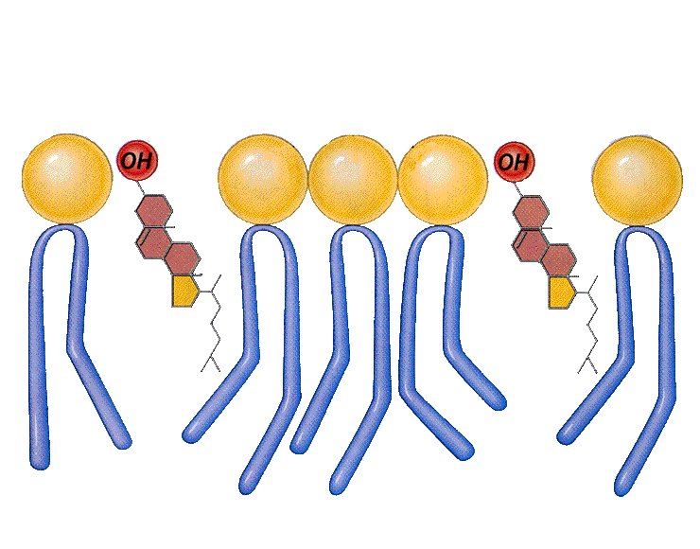

|  |  |
| --- | --- |
| Types of Cell Membrane Proteins | Function |
|  |  |
|  |  |
|  |  |
|  |  |

Fluid Mosaic Model:

* The cell membrane contains many parts…like a _________________
* It is also not _____________, it is fluid and moves
* ____________________ molecules are also found throughout the cell membrane
  + They prevent the nonpolar tails from __________ to each other
  + Without cholesterol, the cell membrane could become rigid and ________________

1. Which cell part do prokaryotes lack?
   * DNA
   * Plasma membrane
   * Nucleus



* + Ribosomes

1. What are the long extensions in this picture called?
2. Which part of the cytoskeleton can expand and contract?
   1. microfilaments
   2. microtubules
   3. Intermediate fibers
3. Are the polar heads in a phopholipid on the inside or outside of the bilayer?



1. What type of cell membrane protein is in the picture?
   1. Transport protein
   2. Receptor protein
   3. Enzyme
   4. Marker protein

Color & label the parts of the plasma membrane according to the instructions below

Phospholipid heads green

Phospholipid tails yellow

Cholesterol orange

Marker (Glycoproteins) blue

Other proteins red

[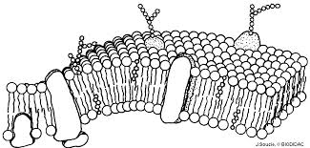](http://www.google.com/url?sa=i&rct=j&q=plasma+membrane&source=images&cd=&cad=rja&docid=VeTy8nj62icEyM&tbnid=TPkrCrNhWK2NPM:&ved=&url=http://biodidac.bio.uottawa.ca/thumbnails/filedet.htm?File_name%3DCELL004B%26File_type%3DGIF&ei=90J9UobXKInRkQf2hYHYAg&bvm=bv.56146854,d.eW0&psig=AFQjCNE2oQD_hiyiNTbG9Q69eRoCqpfkLQ&ust=1384027256057297)

CH3.3

|  |  |
| --- | --- |
| Objectives | Vocabulary |
| * **Describe** the role of the nucleus in cell activities. * **Analyze** the role of internal membranes in protein production. * **Summarize** the importance of mitochondria in eukaryotic cells. * **Identify** three structure in plant cells that are absent from animal cells. | Endoplasmic reticulum  Vesicle  Golgi apparatus  Lysosome  Mitochondrion  Chloroplast  Central vacuole |

In this section, we are studying eukaryotic cell organelles… Why are we no longer studying prokaryotes?

**The _________________________________**

* ____________ most functions of a eukaryotic cell
* Located in the _______________ of animals cells and towards the __________ of plant cells
* The nucleus is surrounded by a ___________ membrane called the **nuclear _______________.**
* There is a dense region in the center of the nucleus called a _______________
  + It makes ____________, which are the site of ____________ synthesis
  + Ribosomes don’t have a membrane, they are made of compact strands of **_________________** & ____________
* The nuclear envelope also contains small openings called ________________________. These pores allow substances made inside the nucleus, like ribosomes, to _________ and go to the rest of the cell
* DNA is also found inside the nucleus
  + When the cell is ________ dividing, the DNA is found in long thin strands called ____________.
  + When the cell is dividing, the chromatin bundles up into rod-shaped objects called ______________

**_____________________________________________________ (ER)**

* After ribosomes leave the nucleus, they may travel to the endoplasmic reticulum
  + It is an extensive system of internal membranes that are kind of like ____________________
* The ER carries out chemical ______________ and ____________ proteins through the cell. The many hallways of the ER provides more _________________ _________________ for chemical reactions to occur
* **The portion of the ER with attached ribosomes is called the ________________________ ER.** The rough ER helps to _____________ and ______________ proteins that are made by the attached ribosomes.When the protein is completed, the portion of the ER containing the protein pinches to form a ____________________**.** A vesicle is a small membrane bound ____________ that transports substances throughout the cell**.** These proteins made in the rough ER will eventually _____________________________ the cell
* **The portion of the ER without attached ribosomes is called the __________________ ER**
  + It makes ______________ and breaks down __________ substances

**_____________________ Ribosomes**

* Ribosomes are also found ___________ in the cytosol so they are called “free”
* Free ribosomes make proteins that will stay ______________ the cell, such as those used to make new _______________

**___________________________________ Apparatus**

* Before a protein can do its specific job, it must be ______________ and ___________ correctly
* Vesicles carry proteins to the golgi apparatus, which is kind of like the ______ plant and animal of the cell
* The Golgi apparatus is a set of _____________, membrane-bound sacs that serve as the packaging and distribution center of the cell.

_________________________________

* Special _______________ found only in __________ cells that leave the golgi apparatus
* They contain digestive _____________
* These enzymes break down….
  + Worn out _______________
  + _________ particles
  + ___________ and _______________
* When these substances are fully digested, vesicles ___________ them from the cell

_______________________________________

* Another cell part found only in ____________________ cells. Occurs in ____________________.
* Help with cell ________________________________

___________________________________________________

* Organelles that make energy in the form of _______ from organic compounds that you eat, like _______________________. Similar to the nucleus, mitochondria have _____ membranes
  + The outer membrane is ____________
  + The inner membrane is ____________, allowing more surface area for chemical reactions to occur
* Mitochondria have their own _________ so they can ________________ on their own, independently of the cell. Their DNA is similar to the DNA of _____________ cells. Because of this, mitochondria are thought to be __________________ of primitive prokaryotes
* **One theory, called the __________________________________ theory, hypothesizes that mitochondria were ________________ into larger cells, eventually forming a eukaryote**

**Structures of Plant Cells**

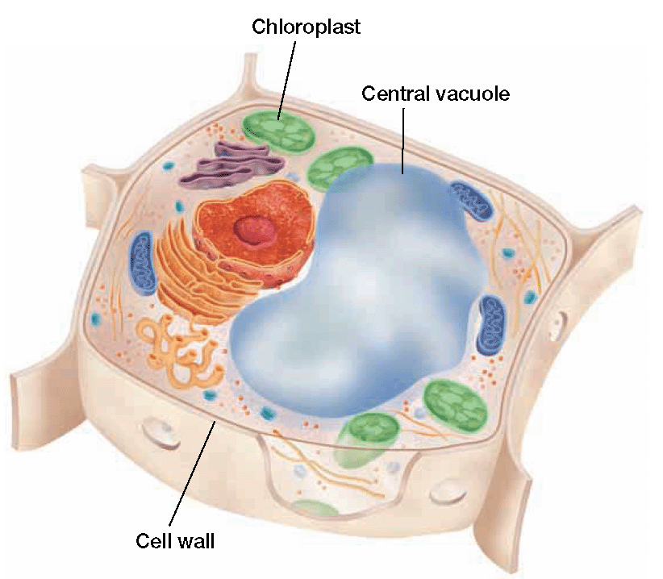

Plants have three unique structures that are not found in animal cells:

-_____________________________

-____________________________

-_____________________________

Cell Wall

* Made of __________________________
* Functions
  + helps _________ and __________ the shape of the cell
  + ____________ the cell from damage
  + ___________ plant cells with adjacent plant cells

Chloroplasts

* Organelles that use _________ energy, ______, and _______ to make food called ____________
* Has…
  + ____ membranes
  + Series of stacks called __________, that contain ______________
* A __________ membrane surrounds the grana
  + It is called the __________________ membrane
* Like mitochondria, scientists propose that chloroplasts are ______________ of ancient prokaryotes and are a part of the _____________ theory

Central Vacuole

* Takes up most of the __________ of a plant cell…pushes the __________ to the side
* The central vacuole stores…
  + ______________________________ & ______________________________________
  + _______________________________& _______________________________

1. Label the parts of the cell below

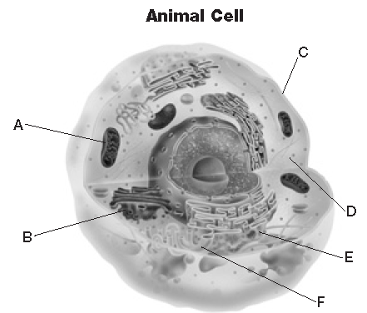

1. Which structures in this cell are also found in prokaryotic cells?

A. *A* and *B*

B. *C* and *D*

C. *E* and *F*

D. *A* and *E*

1. Which features of plant cells are missing from this cell?

F. cell wall and chloroplasts

G. Golgi apparatus and mitochondria

H. rough ER and lysosomes

J. smooth ER and nucleus

1. What is the function of the structure labeled A?

A. making ATP

B. making carbohydrates

C. making proteins

D. moving proteins through the cell

1. Which of the following organelles does not have at least 2 membranes?

A. chloroplast

B. nucleus

C. golgi apparatus

D. mitochondria

1. Which of the following organelles are only found in animal cells?

A. nucleus and ER

B. centrioles and lysosomes

C. cell wall and cell membrane

D. ribosomes and mitochondria

