Chapter 8.4 How Proteins are Made
Objectives | Vocabulary
- Compare the structure of RNA with that of DNA.  - Summarize the process of transcription.  - Relate the role of codons to the sequence of amino acids that results after translation.  - Outline the major steps of translation.  - Discuss the evolutionary significance of the genetic code. | Ribonucleic acid (RNA)  Uracil  Transcription  Translation  Gene expression  RNA polymerase  Messenger RNA | Codon  Genetic code  Transfer RNA  Anticodon  Ribosomal RNA  Decoding the Information in DNA  Ribonucleic Acid
Decoding the Information in DNA
- Traits, such as eye color, are determined by _____________ that are built according to instructions ________ in DNA.
- The instructions for making each protein are contained in small segments of our DNA called _______________
- A single molecule of DNA has thousands of genes lined up like __________ ________.
- Proteins, however, are not built directly from DNA…ribonucleic acid or _______ is also involved.
- Like DNA, RNA is a nucleic acid—a molecule made of _________________ linked together.
- RNA differs from DNA in ______ ways
  - RNA consists of a ____________ strand of nucleotides
  - In place of thymine, RNA contains the nitrogenous base _____________
  - In place of deoxyribose, RNA nucleotides contain the five-carbon sugar _______________The only difference between the two sugars is that deoxyribose contains one less ___________
    - So, deoxyribose is said to be ___________________
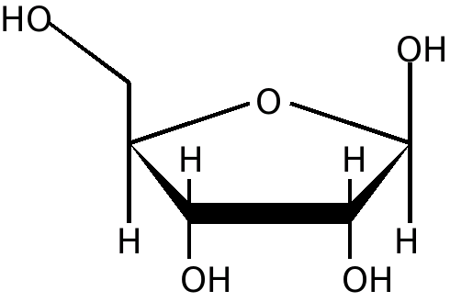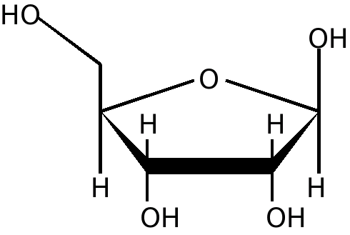
H
Types of RNA
- Additionally, there are three types of RNA
  - Messenger RNA (_________)
  - Transfer RNA (_________)
  - Ribosomal RNA (__________)
Messenger RNA
- mRNA is a _________ strand of RNA nucleotides that is used to acquire DNA’s genetic code
- In a eukaryotic cell, mRNA carries the code ______ of the nucleus in order to make a protein
- Why might it be important for DNA to stay inside of a eukaryotic cell’s nucleus?
Transfer RNA
- tRNA loops up on itself to take on a _________ leaf shape
- This shape is held together by _____________ bonds
- It is used to ___________ amino acids
Ribosomal RNA
- rRNA joins with ______________ to make a structure called a __________________
- Free ribosomes are the __________ or location of protein synthesis
- The instructions for making a protein are ___________ from a gene in DNA to an RNA molecule in a process called _________________. Cells then read the instructions on the RNA molecule to put together the sequence of __________ ___________ that make up the protein in a process called __________________________. The entire process by which proteins are made based on the information encoded in DNA is called gene _______________, or protein _____________.
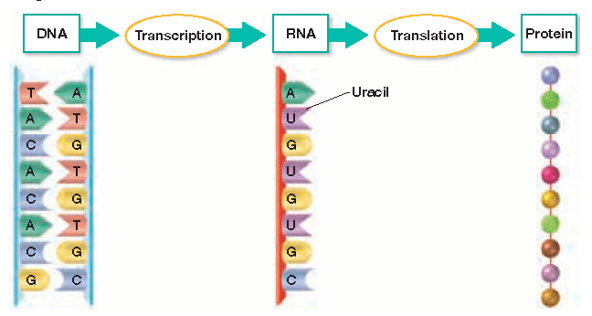

Transcription occurs in three steps
Step 1
______ polymerase, an enzyme that adds complementary RNA nucleotides, binds to a gene’s ________________ site. This site on DNA promotes or _______________ the start of transcription
Step 2
RNA polymerase___________________ and_______________ the DNA strands
Step 3
As it moves along DNA, RNA polymerase adds _________________ RNA nucleotides in order to form __________. Notice that only __________ strand of DNA is used to make RNA…this strand is called the ___________________. As it moves along DNA, RNA polymerase adds _________________ RNA nucleotides in order to form _______________Notice that only _______ strand of DNA is used to make RNA…this strand is called the _____________
- So let’s practice transcribing a strand of mRNA
make complementary mRNA base pairs with the DNA strand below…Remember…RNA does NOT have thymine!
DNA G C A T A C G T A
RNA
- In eukaryotic cells, there are typically about ______ RNA polymerase molecules working on one gene
- The mRNA being transcribed fans out to give the DNA a _______________ appearance
- Also in a eukaryotic cell, the mRNA has to leave the nucleus and enter the ___________________ in order to find a free _________________, which is where a protein will be _________________
- How does mRNA get out of the nucleus?
- In prokaryotic cells, transcription occurs in the cytoplasm, and not in a nucleus…why?

- Compare the structure of RNA with that of DNA

- Summarize the process of transcription.

Objectives
- Relate the role of codons to the sequence of amino acids that results after translation.
- Outline the major steps of translation.
- Discuss the evolutionary significance of the genetic code.
The Genetic Code: Three-Nucleotide “Words”
- In order for a protein to be made, the code stored in mRNA must be __________________
- The code is stored in a series of ________ nucleotide sequences on mRNA called _______________
- Each codon codes for a specific __________ _________ that will be placed in a protein
Codes in mRNA
To determine which amino acid is coded for, find the area on the chart where all three of the nucleotides in a codon _______
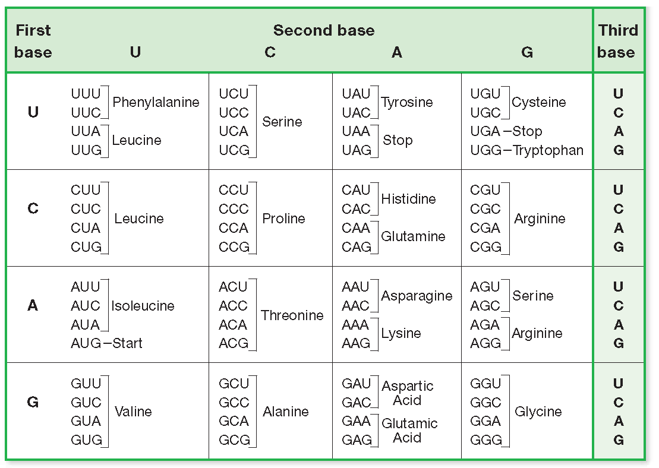
- Practice…What does AUG code for?
- So AUG is a ________ codon, that signals the beginning of translation
  - It codes for the amino acid _________________, abbreviated _____
  - It is found at the beginning of most proteins, but is often ___________ after translation
- What does CCC code for?
- What does GGU code for?
- What does UAU code for?
- What does UGA code for?
  - UGA is a _______________ codon that terminates protein synthesis
- What are the other two stop codons?

- _____ codons signal for the _____ amino acids found in proteins
Why are there so many codons?
- If codons only contained a combination of ____ nucleotides, mathematically there would not be ____________ codons to signal for twenty different amino acids. To determine the amount of nucleotide combinations, you must know how many bases are ______________ and how many bases will be in a _____
- So, how many RNA bases are there?
- If there was only ____ base in a codon, you would raise the number of ______________ bases to the 1st power
4¹ ⁼
- If there are ____ bases in a codon, you raise the number of available bases to the ________ power
4² or 4 x 4 =
- How many different codons are possible if they contain three bases?

- So several different codons code for the _______ amino acid, but each codon only codes for _____ specific amino acid
Translation
- Translation occurs when the three types of RNA work __________________ to assemble a protein
- Recall that a ribosome consists of ______ and ________________. It also consists of _____subunits
- The ribosome will read the codons in ______ as it passes between the
two subunits
- The ribosome also contains two different_______, labeled ____and ____
which hold____________ RNA molecules
- Recall that tRNA molecules are single strands of RNA that _______
up on themselves
- One side of tRNA has an ______________ site that temporarily
carries a specific _______ ____________
- The other end contains an _____________, which is
a series of three nucleotides that will base pair with codons on _______

Steps of Translation
Step 4 The tRNA in the P site ___________ and leaves its amino acid behind. Scientists have recently discovered that there is an additional site, the ___ site or _______ site, from which the tRNA molecules actually leave
Step 5 The tRNA in the A site ______ to the P site and a _______ tRNA molecule brings in another amino acid. If the new codon in the A site reads CAG, what amino acid will it code for?
What tRNA anticodon will bind with it?
Step 6 Another peptide _______ is formed between the two amino acids, and the tRNA in the _____ site detaches and leaves its amino acid behind.
Step 7 The process is repeated until a ________ codon is reached. The ribosome complex falls __________ and the newly made protein is ____________.

- With few exceptions, the genetic code is the _______ in all organisms
  - For example, the codon GUC codes for the amino acid ___________ in bacteria, birds, plants, and humans
  - For this reason, the genetic code is often said to be ______________
  - From an evolutionary standpoint, it appears that all organisms share a _____________ ancestor with a __________ genetic code
- Relate the role of codons to the sequence of amino acids that results after translation.

- Outline the major steps of translation.

- Discuss the evolutionary significance of the genetic code.

