Biology Chapter 2 Worksheet
Name: _______________________________________________ Class: _______________
- What are the monomers that make up the following organic polymers?
  - Carbohydrates_____________________________
  - Proteins __________________________________
  - Lipids_____________________________________
  - Nucleic Acids_______________________________
- What is an isotope?

- What is an isomer?

- Glucose &Fructose are pictured below. What is the main difference between them and why are glucose and fructose considered isomers?
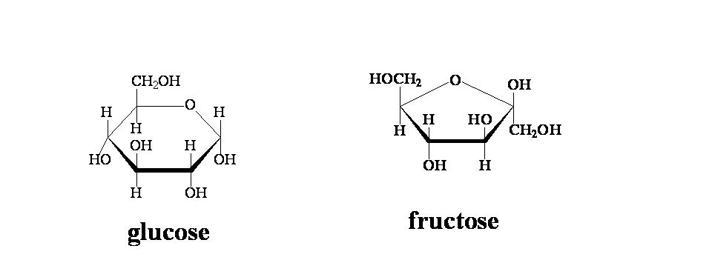

- What does ATP Stand for?

- ATP is created by living things because it stores a lot of energy. Where in ATP is the energy stored?

- Sketch a picture depicting how ATP is hydrolyzed to ADP to released energy, and how ATP is reformed

- Label the pH scale below with base, acid, & neutral. Also, draw the H+ ions in showing where they are most concentrated

0----------------------------------7--------------------------------14

- Label the following in the graphs below with:
Activation energy time energy reactants products

- What is an enzyme?

- What is the active site of an enzyme, and why is it important?

- What model do we use to explain how enzymes and substrates fit together?

- What would happen if you changed the shape of the active site of an enzyme by putting in the wrong amino acid?

- What 3 things will affect the function of an enzyme?

