- The cell membrane is a _____________________ ____________________________ barrier that determines which substances enter and leave the cell.
- Think of a pasta strainer
  - What does the strainer “select” for, or what passes through?
  - What does not pass through?
- The selective permeability of the cell is mainly caused by the way _____________________ interact with water.
- A phospholipid is a lipid made of a ___________ group and two ____________________ chains

- The phopshate group is commonly called the ________________ and it is ____________
  - So it is ____________________
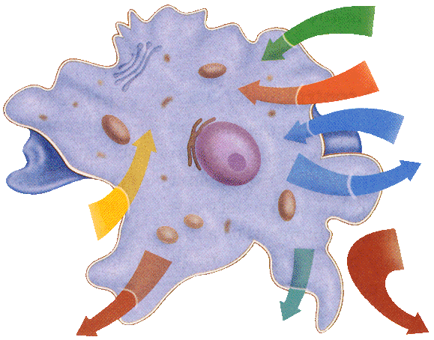
- The fatty acid chains are commonly called ________
- and they are _______________
  - So it is _________________
- ____________________ is found inside and outside of the
Cell so the tails must arrange themselves _________ from water
- Cell membranes are made of a ____________ layer of
phospholipids, called a ______________.
- The tails are on the ____________ and the heads are on the _________________________
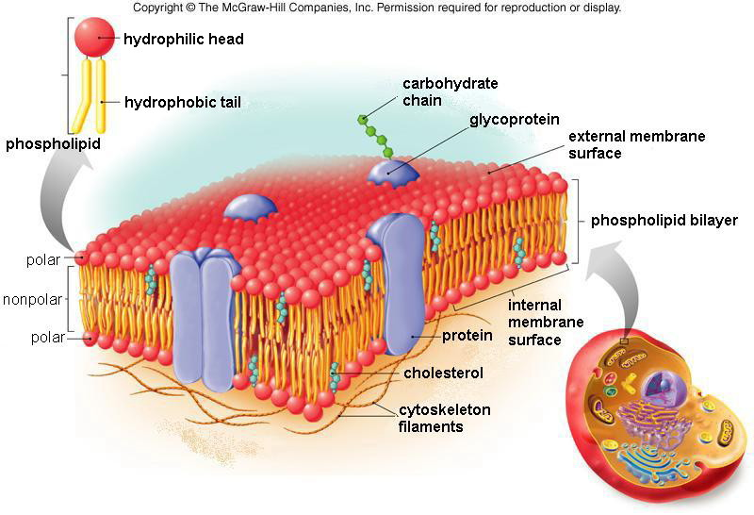
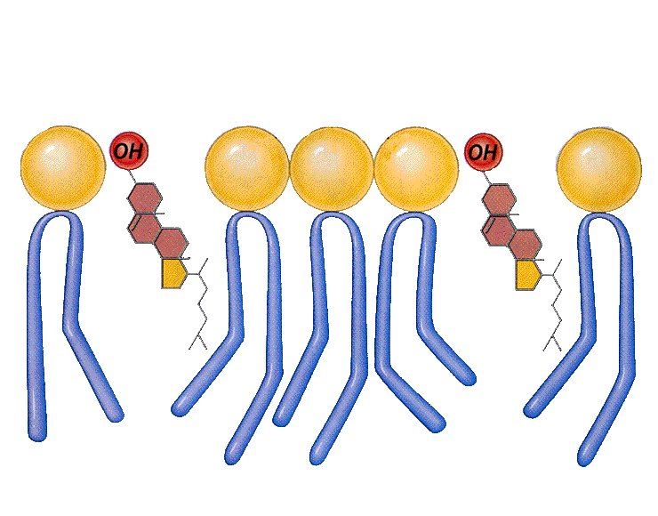
This arrangement prevents ____________________________ polar molecules from moving freely through a cell membrane because they are _________________ by nonpolar tails

The cell membrane also contains various proteins which are made up of _____________________

As we learned in chapter 2, some amino acids are ________________ and some are _____________

Types of Cell Membrane Proteins | Function
Fluid Mosaic Model:
- The cell membrane contains many parts…like a _________________
- It is also not _____________, it is fluid and moves
- ____________________ molecules are also found throughout the cell membrane
  - They prevent the nonpolar tails from __________ to each other
  - Without cholesterol, the cell membrane could become rigid and ________________
Color & label the parts of the plasma membrane according to the instructions below
Phospholipid heads green Phospholipid tails yellow Cholesterol orange Marker (Glycoproteins) blue
Other proteins red
