CH2.3 Carbon & Organic Molecules
KEY CONCEPT: Carbon atoms have unique bonding properties.
Objectives | Vocabulary
- Describe the bonding properties of carbon atoms  - Compare carbohydrates, proteins, lipids, and nucleic acids | - Monomer  - Polymer  - Carbohydrate  - Monosaccharide  - Lipid  - Phospholipid  - Starch  - Cellulose  - Protein  - Amino acid | - Peptide bond  - Nucleic acid  - Nucleotide  - Glycogen  - Chitin  - Primary structure  - Secondary structure  - Tertiary structure  - Quaternary structure
- How many electrons does a carbon atom have?
- How many of those electrons are valence electrons?
- How many more electrons does carbon need to be stable?
- How many covalent bonds do you think carbon will make to accomplish this?
- Carbon forms covalent bonds with up to four other atoms, including other carbon atoms. Carbon-based molecules have three general types of structures.
  - ____________________________
  - ____________________________
  - ____________________________
- Many carbon-based molecules are made of many small subunits called monomers bonded together to form polymers.
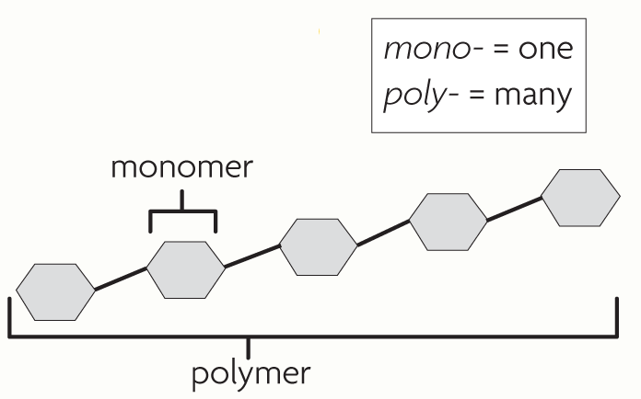
  - ______________________ are the individual subunits.
  - ______________________ are made of many monomers.

- What is the relationship between a polymer and a monomer

- How are carbohydrates and lipids similar? How are they different

- Explain how the bonding properties of carbon atoms result in the large variety of carbon-based molecules in living things

- Why might fatty acids, amino acids, and nucleic acids increase the hydrogen ion (H+) concentration of a solution? Explain your answer.

Four main types of carbon-based molecules are found in living things.
Organic Polymer | Monomer | Examples & What they’re used for
Carbohydrate
Lipid |  | 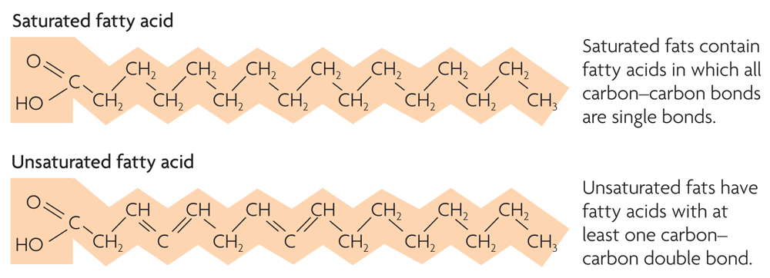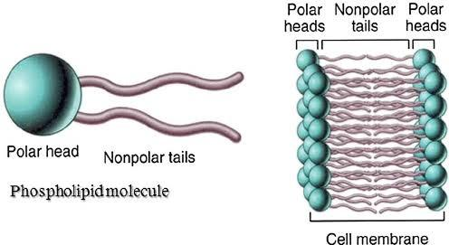
Protein | 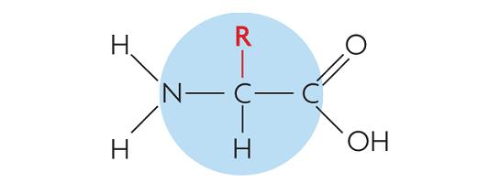 | 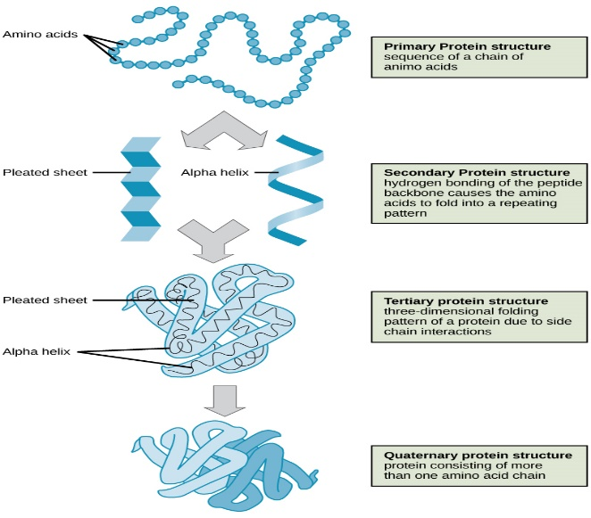
Nucleic Acid | 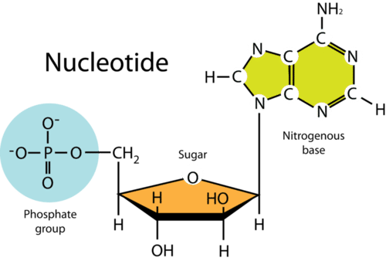 | 