CH2.4 Chemical Reactions
KEY CONCEPT: Enzymes are catalysts for chemical reactions in living things.
Objectives | Vocabulary
- Describe how bonds break and reform during chemical reactions  - Explain why chemical reactions release or absorb energy  - Explain the effect of a catalyst on activation energy  - Describe how enzymes regulate chemical reactions | - Chemical reaction  - Reactant  - Product  - Bond energy  - Equilibrium  - Activation energy | - Endothermic  - Exothermic  - Catalyst  - Enzyme  - Substrate  - Active site
- Bonds break and form during chemical reactions.
  - Chemical reactions change substances into different ones by breaking and forming chemical bonds.
    - _________________________________________ are changed during a chemical reaction.
    - ________________________________________ are made by a chemical reaction.
  - Bond energy is the amount of energy that breaks a bond.

CO₂ + H₂O H₂CO₃

    - Energy is added to _________________________ bonds.
    - Energy is _________________________ when bonds form.
  - Chemical reactions release or absorb energy.
    - _______________________________________ is the amount of energy that needs to be absorbed to start a chemical reaction.
      - _______________________________ reactions release more energy than they absorb.
        - ____________________ have ________________ bond energies than products.
        - Excess energy is ____________________________ by the reaction.
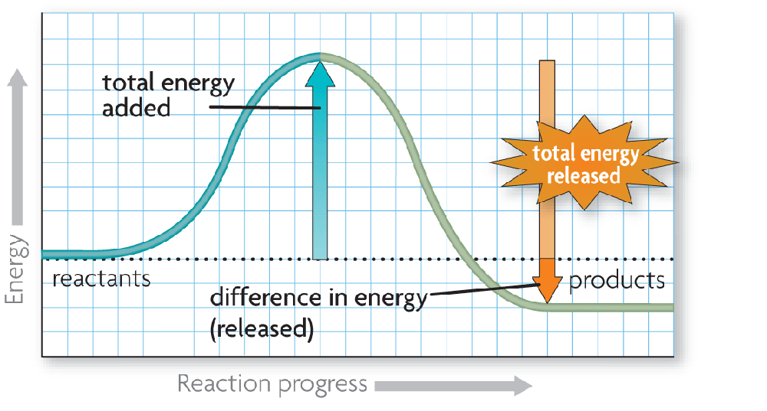
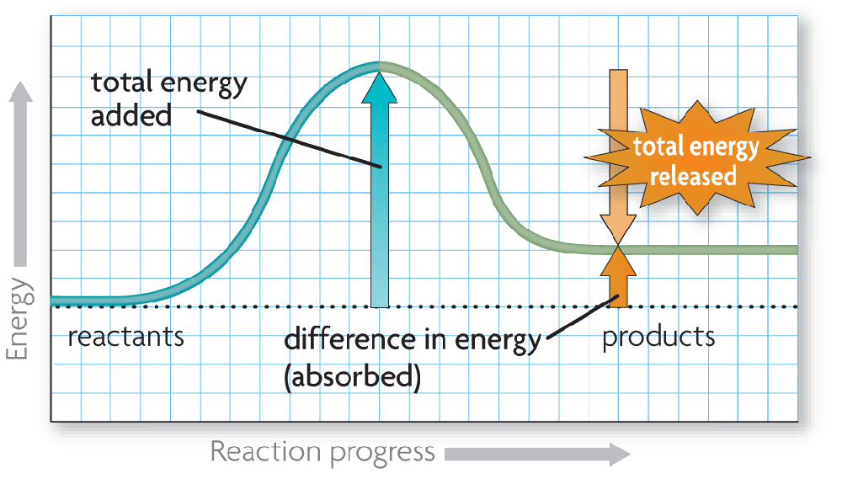
      - _________________________ reactions absorb more energy than they release.
        - _____________________ have _______________ bond energies than products.
        - ____________________ is absorbed by the reaction to make up the difference.
  - A catalyst lowers activation energy.
    - Catalysts are substances that speed up chemical reactions.
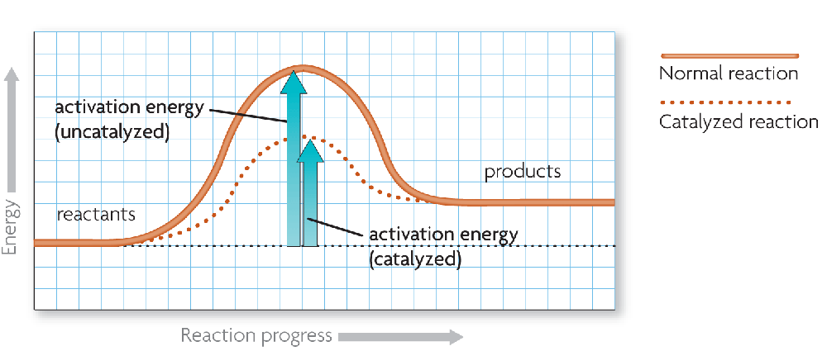
      - decrease activation energy
      - increase reaction rate

  - Enzymes allow chemical reactions to occur under tightly controlled conditions.
    - ______________________ are __________________________ in living things.
      - Enzymes are needed for almost all processes.
      - Most enzymes are _____________________________.
    - Disruptions in __________________________________ can prevent enzymes from functioning.
      - Enzymes function best in a small range of conditions.
      - Changes in _________________________ and __________ can break _______________ bonds.
      - An enzyme’s _____________________ depends on its ___________________________.
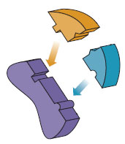
    - An enzyme’s _____________________ allows only certain __________________ to bind to the enzyme.
      - substrates
      - active site

    - The ___________________________________________ helps illustrate how enzymes function.
      - substrates brought together
      - ____________________ in substrates weakened

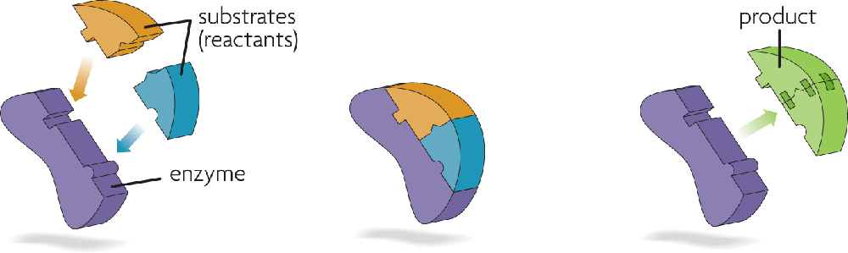
Substrates bind to an
enzyme at certain places called active sites.
The enzyme brings
substrates together and weakens their bonds.
The catalyzed reaction forms a product that is released from the enzyme.

- Hydrogen peroxide (H₂O₂) breaks down into water (H₂O) and oxygen (O₂). H₂O₂ H₂O + O₂
A) Explain why this is a chemical reaction.
B) what are the reactants?
C) what are the products?
- How do endothermic and exothermic reactions differ?

- The process below is exothermic. What must be true about the bond energies of the reactants and the products? Explain.
6O₂ + C₆H₁₂O₆ 6CO₂ + 6H₂O
- How does a catalyst affect the activation energy and rate of a reaction

- Describe how the interaction between an enzyme and its substrates changes a chemical reaction

- Some organisms live in very hot or acidic environments. Would their enzymes function in a persons cells? Why or why not?

- Suppose that the amino acids that make up an enzymes active site are changed. How might this change affect the enzyme?

