15.1 Life in the Earth Systems
Objectives
- Describe the interactions of the biosphere, hydrosphere, and geosphere
- Describe the interactions of biotic and abiotic factors in the biosphere
Vocabulary
- Atmosphere
- Biosphere
- Biota
- Geosphere
- Hydrosphere
The __________________________________ is the portion of Earth that is inhabited by ____________.
- The biosphere includes all ________________________________.
- includes the ________________, all the living things in the biosphere
- There are three other Earth systems.
_________________________ and ____________________________ factors interact in the biosphere.
All four Earth systems are interconnected. The ________________________________________ considers Earth as a kind of living organism.
  - Earth systems interact to yield a biosphere capable of supporting life.
  - It was developed by James Lovelock and Lynn Margulis.
- What is the relationship between the biota and the biosphere?
- How does the Gaia hypothesis explain the interaction between biotic and abiotic factors in the biosphere

- The interactions between the atmosphere, geosphere, biosphere, and hydrosphere are like the interactions of an organisms vital organs
- How might a rise in global temperatures affect the biosphere?

- Explain how feedback loops, such as those described by the Gaia hypothesis might apply to predator prey relationships

Climate
Objectives
- Differentiate between weather, climate, and microclimates
- Identify factors that determine Earths climate zones
Vocabulary
- Microclimate
- Climate
Climate is the prevailing weather of a region.
- Climate is _____________________________________________________________________.
  - average _______________________________
  - ______________________________________
  - relative ________________________________
- Key factors shape an area’s climate:

- A _____________________________ is the climate of a small specific place within a larger area.
Earth has three main climate zones. The three main zones are the polar, tropical, and temperate climates.
  - _____________________________: the far northern and southern regions of Earth
  - _____________________________: surrounds the equator
  - _____________________________: the wide area in between the polar and tropical zones
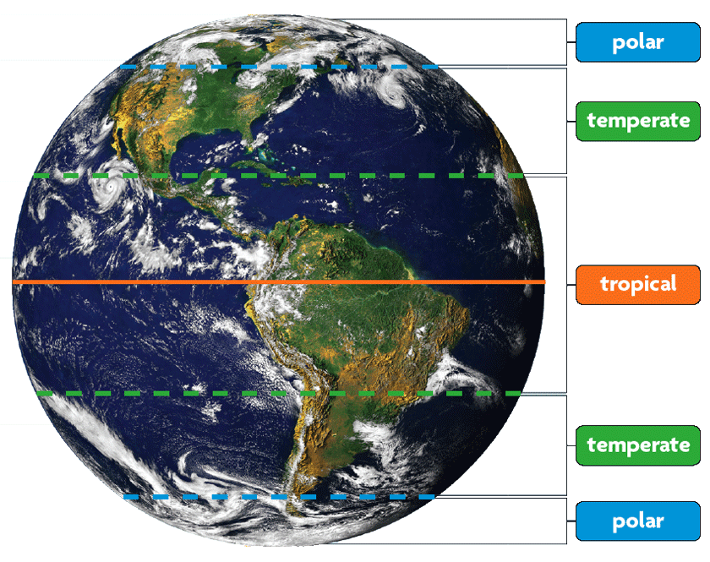
- The _______________________________________________ help determine an area’s climate.
- Earth’s ______________________ on its axis plays a role in _______________________ change.
  - ________________________________________________
  - ______________________________________ precipitation

Oceans shape coastal climates.
  - ____________________________________________
  - ____________________________________________
  - ____________________________________________
Mountains have an effect on climate.
  - ______________________________________ occurs on the side of the mountain facing the ________.
  - On the downwind side, drier and cooler air produce a ________________________________________. A rain shadow is an area of decreased precipitation
- Many organisms survive in a specific climate due to their _________________________________________.
- What is the difference between climate and weather

- What are the 3 different climate zones, and where are they located?

- Would areas along the shores of the Great Lakes have warmer summers and colder winters than other inland areas? Explain.

- Would you expect an area with several microclimates to have more or fewer ecological niches? Explain.

15.4 Marine Ecosystems
Objectives
- Identify the 4 major ocean zones and organisms unique to each zone
- Describe the unique habitats of coastal waters
Vocabulary
- Intertidal zone
- Neritic zone
- Abyssal zone
- Plankton: a tiny free floating organism that lives in the water
- Zooplankton
- Phytoplankton
- Coral reef
- Kelp forest
- Bathyal zone
- The ocean can be divided into zones.
  - neritic zone—_________________________________________________________________
  - bathyal zone—__________________________________________________________________
  - abyssal zone –___________________________________________________________________
- The _________________________________ zone harbors more ___________________ than any other zone. __________________________________ make up most of the biomass.
  - Zooplankton___________________________________________________________
  - Phytoplankton__________________________________________________________

- Coastal waters contain unique habitats.
- Coral reefs are found in warm waters.
  - _________________________________________ climate zone
  - great amount of __________________________________
- Kelp forests are found in _____________________________, nutrient-rich waters.
- What criteria do scientists use to divide the ocean into different zones?

- What conditions account for the development of highly diverse habitats in coastal waters?

- A red tide occurs when a bloom of plankton causes a reddish discoloration of coastal ocean waters. What might cause such an increase in plankton populations?

