16.1 Human Population Growth & Natural Resources
Objectives
- Summarize the current state and effects of human population growth
- Explain the importance of effective resource management
Vocabulary
- Nonrenewable resource
- Renewable resource
- Ecological footprint
Earth’s human population continues to grow.
- Earth’s human _______________________________________________ is _______________________.
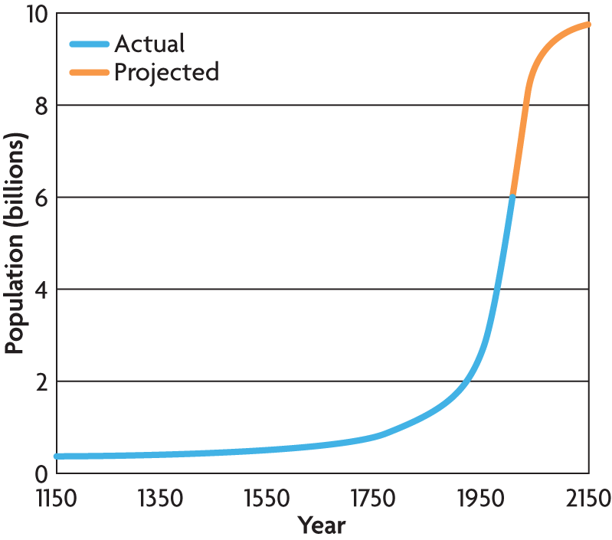

_______________________________________ has helped to increase Earth’s carrying capacity.

The growing human population exerts pressure on Earth’s
____________________________________.

- ___________________________________________ resources are used faster than they form.
- Renewable resources cannot be used up or can _____________________ themselves over time.
- An ______________________________________ is the amount of land needed to support a person. The land must produce and maintain enough
  - ___________________________ & ________________________________ & _________________________________________ & ____________________________
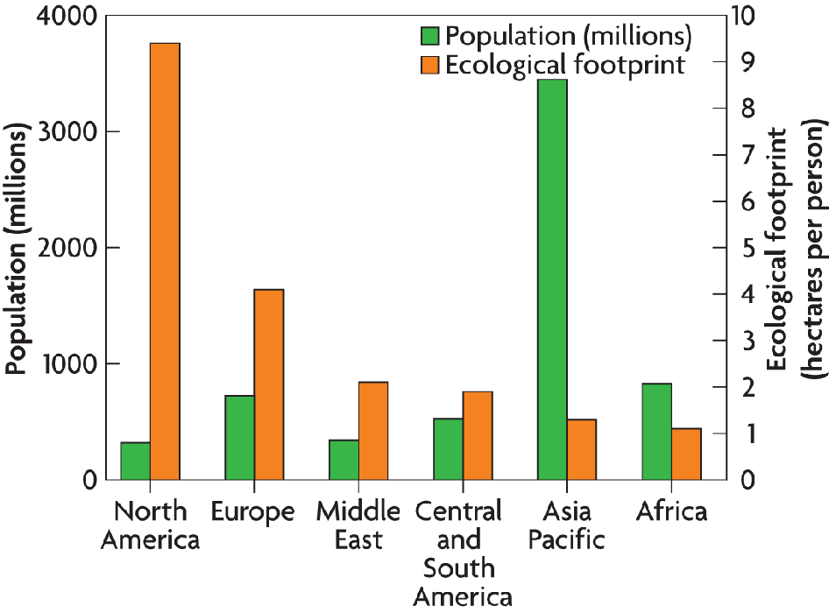
Several factors affect the size of the ecological footprint.
  - ___________________________________________
___________________________________________

  - ___________________________________________

- Give 3 examples of how technology has influenced human population growth

- What is the difference between renewable and nonrenewable resources

- What factors can limit the growth of the human population?

16.2 Air Quality
Objective
- Describe the sources, types, and effects of pollution
- Explain how air pollution contributes to acid rain
Vocabulary
- Pollution
- Smog
- Particulate
- Acid rain
- Greenhouse effect
- Global warming
Pollutants accumulate in the air.
- ___________________________________________ is any undesirable factor added to the air, water, or soil.
- __________________________ is one type of air pollution.
  - ___________________________________ interacts with pollutants in the _________________
  - pollutants produced by __________________________________________ emissions
  - made of ________________________ and ____________________________________________
- Smog can be harmful to human health.
Acid rain is caused by fossil fuel emissions produced when pollutants in the ___________________________ cause rain pH to _______________________
  - can lower the pH of a lake or stream & can harm trees

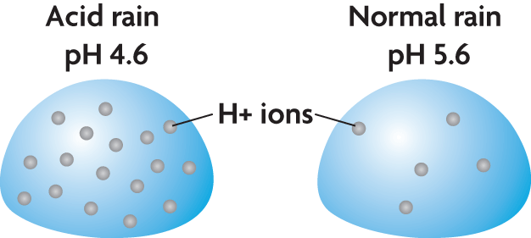
Air pollution is changing Earth’s biosphere.
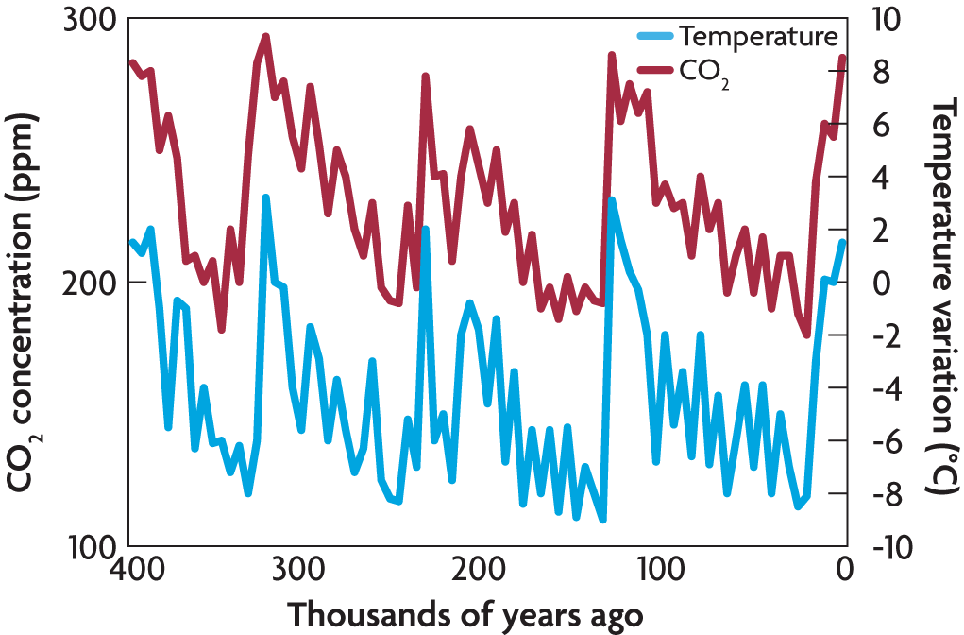
The levels of _________________________________ ______________________________________________ rise and fall over time.

High levels of carbon dioxide are typical of Earth’s ____________________________ periods.

The greenhouse effect slows the release of __________________________ from Earth’s _____________________.
Sunlight penetrates Earth’s atmosphere

_____________________ is ___________________
and reradiated as _________________

greenhouse gases absorb longer wavelengths
Greenhouse gas molecules rerelease infrared radiation

CH₄
H₂O
CO₂
- Global warming refers to the trend of increasing global temperatures.
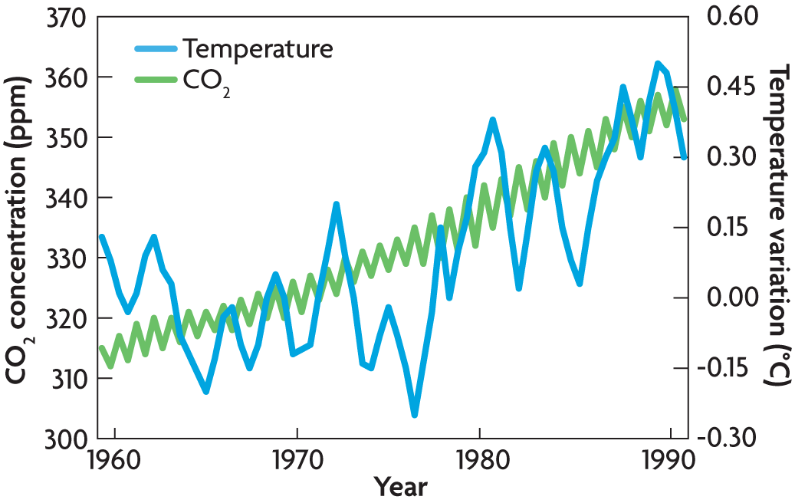
- Name and describe 2 ways in which pollution affects ecosystems

- How does the greenhouse effect keep Earth warm?

- Explain how a build-up of CO2 in the atmosphere could increase Earths global temperature.

- Greenhouse gasses are found close to earths surface and high above in the atmosphere. Name 2 important functions of greenhouse gasses at Earths surface.

- Ocean producers such as phytoplankton are an important part of food webs, but they require a specific temperature range to survive. How might increased water temperature affect these ocean food webs?

16.3 Water Quality
Objectives
- Describe how water pollution affects ecosystems
- Explain how biomagnification causes accumulation of toxins in food chains
Vocabulary
- Indicator species
- biomagnification
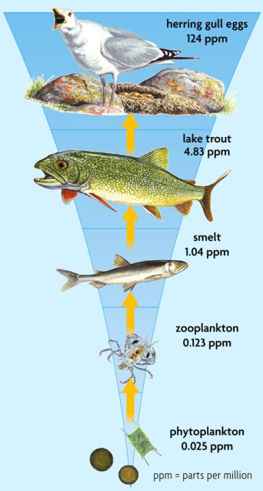

Biomagnification causes ________________________________ of _______________________________ in the ______________________ _______________.

___________________________________ can move up the food chain when predators eat contaminated prey, and pollution accumulates at each stage of the food chain.
Top consumers, including humans, are ___________________________________.

 | PCBs | DDT
What is it
What effects do they have on the environment?

- How do PCBs affect bird populations through biomagnification?
- Would a buffalo or a mountain lion be more affected by biomagnification? Why?
- How does the biomagnification pyramid compare with the energy pyramid?

16.4 Threats to Biodiversity
Objectives
- Assess the consequences of loss of biodiversity
- Explain how loss of habitat and introduced species affect ecosystems and biodiversity
Vocabulary
- Habitat fragmentation
- Introduced species
Preserving biodiversity is important to the future of the biosphere.
- The loss of biodiversity has long-term effects.
  - loss of __________________________ and ___________________________________ advances
  - ______________________________ of species
  - loss of _________________________________
- Loss of habitat ________________________________ _____________________________.
- Habitat fragmentation prevents an organism from accessing its entire home range.
  - occurs when a __________________________________ forms within the habitat
  - often caused by ________________________________________________
- ____________________________________________ are a solution to the problem. Corridors can be road overpasses or underpasses. Habitat Corridors allow species to move between different areas of habitat
Introduced species can ___________________________________________________________ in an ecosystem.
- An introduced species is one that is brought to an ecosystem by humans.
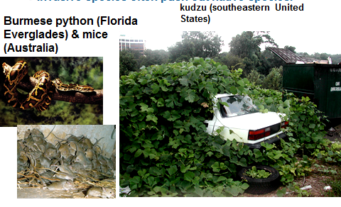
Invasive species can have an
__________________________ and economic impact.

Invasive species often push out ______________________________

- List reasons that biodiversity is important to humans

- How does habitat fragmentation affect migrating bird populations?

- What types of damage can introduced species cause?

- How could continued fragmentation reduce biodiversity?

COOL IT
- What is the amount of the proposed request for research & development (R&D) for technologies to help reduce climate change?______________________________________________________
- How much are the potential benefits of this R&D?___________________________________________
- How much will each cloud brightening ship cost? ______________________________________________
- How many ships would be needed to make a difference in reflecting enough light back into space?________
- List 3 ways climate change will negatively impact the world
- _____________________________________________________________________________
- ______________________________________________________________________________
- ______________________________________________________________________________
- In addition to cloud brightening, list and describe 5 other ways the video discusses to reduce climate change:
- ______________________________________________________________________________________________________________________________________________________________________
- _____________________________________________________________________________________________________________________________________________________________________
- ______________________________________________________________________________________________________________________________________________________________________
- ______________________________________________________________________________________________________________________________________________________________________
- ______________________________________________________________________________________________________________________________________________________________________
What are the numbers of Professor Lomborgs proposed budget for change?
R&D for green energy
R&D for geoengineering
Adaptation for sea level rise
Adaptation for inland flooding
Adaptation for cooler cities
Health
Hunger
Water
Education
Total Amount

