Chapter 18 Notes: Classification
Learning Goal: Students will be able to: Classify organisms and explain modern evolutionary classification
Objectives | Vocabulary
- Describe the goals of binomial nomenclature & systematics  - Identify the taxa in the classification system devised by Linnaeus  - Explain the difference between evolutionary classification & Linnaean classification  - Describe how to interpret and make a cladogram  - Explain the use of DNA sequences in classification  - Name the 6 kingdoms of life as they are currently identified  - Explain what the tree of life represents | Binomial nomenclature  Cladogram  Domain  Kingdom  Class  order | family  genus  species  taxonomy  taxa  derived character  tree of life
- Each species is assigned a two part scientific name
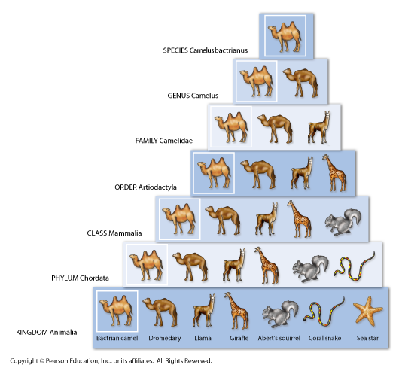
  - 1st – _____________________
  - 2nd – ____________________
- Organize living things into groups that have
biological meaning
- Taxonomy –

-the groups are called ________
Linnaeus classification
- Classification system that includes 7 hierarchical
taxa: Species, genus, family, order, class, phylum,
Kingdom
CheckPoint
- What are the goals of binomial nomenclature
and systematics?

- What are the taxa in Linnaeus classification system?

Goal of evolutionary classification
- To group ______________________________ into larger categories that reflect lines of __________________ ______________________________________________, rather than overall similarities & differences
- Linnaeus had 2 groups: plants & animals – his groups depended on characteristics – similarities & differences.
- Evolutionary Classification uses Cladograms to show relationships between different species
- Cladograms link groups of organisms by showing how evolutionary lines branched off from common _____________ (traits shared with ancestors). Each branch point is when a ___________________ takes place(one species splits into 2). The bottom or root is the _______________________ ancestor
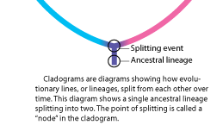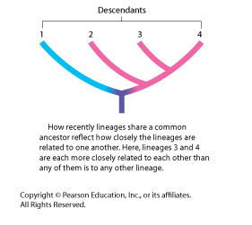
We can also use DNA to build Cladograms in Classification
- The more ____________________________ characters 2 species share the more recently they shared a _______________________ __________________________ and the more closely they are related evolutionary
- Derived characters:______________________________________________________________________ ___________________________________________________________________________________________
- The more closely related species are the more ________________ their _________ will be. As more time passes between speciation, there will be more mutations and so more differences in species DNA sequences
- What is the difference between evolutionary and Linnaean classification?
- How would you create and read a cladogram?
- How are DNA sequences used in classification?
3 Domains & 6 Kingdoms
Domains | Eubacteria | Archae-Bacteria | Eukarya
Kingdoms
Characteristics
Tree of Life
- The tree of life shows current _____________________ regarding _________________________________ among the _______________ within the 3 domains of life
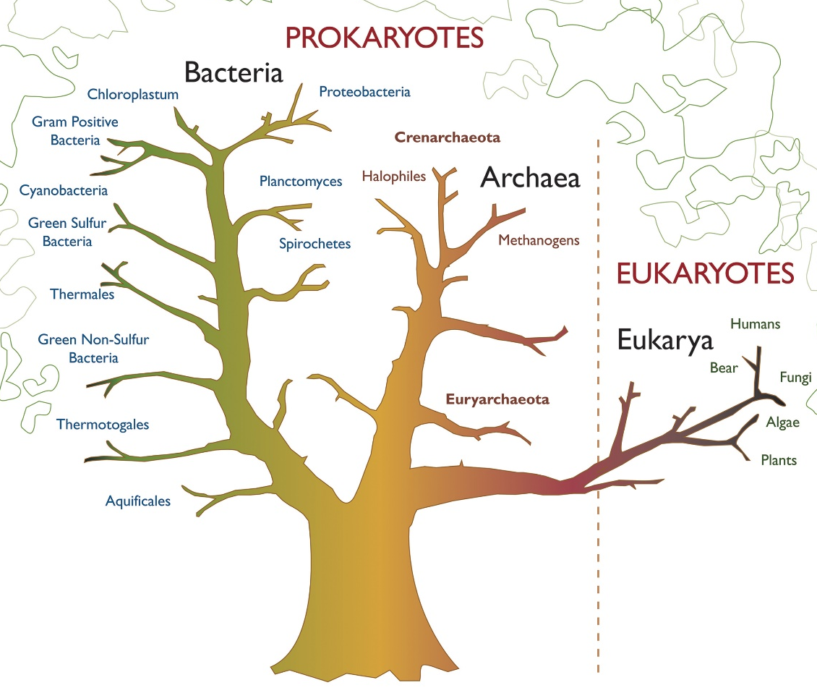
- 3 domains: eubacteria, archaea, eukarya
- Name the 6 kingdoms of life

- Explain what the tree of life represents

