Chapter 1: The Nature of Life

CH1.1Science is a way of thinking, questioning, and gathering evidence.
Objectives | Vocabulary
- Identify the different elements of scientific inquiry  - Create testable hypotheses  - Differentiate between independent variables and dependent variables  - Explain the importance of a control group  - Discriminate between negative and positive control | Science  Hypothesis  Observation  Inference  Controlled experiment  Control group | Positive control  Negative control  Independent variable  Dependent variable  Constants
- What is Science
  - Science is an organized way of gathering and analyzing evidence about the natural world
    - Science deals only with the ___________________________________________________
    - Scientists collect and organize information in an orderly way, looking for patterns and connections
    - Scientists propose explanations based on ________________________________, not belief
  - The goals of science are to provide natural explanations for events in the natural world. Science aims to use those explanations to understand patterns in nature and to make useful ______________________ about natural events
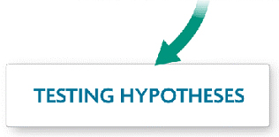
- Biology is a Process of Inquiry

- Inferring and Forming a Hypothesis
  - An ____________________ is a conclusion or opinion that is formed because of known facts or evidence
  - Inferences and creative imagination lead to the formation of a hypothesis
  - A __________________________ is a scientific explanation for a set of observations that can be tested
- Designing Controlled Experiments
  - Experimental studies allow scientists to determine what causes a phenomenon
  - A hypothesis should be tested by an experiment in which only 1 variable is changed, everything else should be kept constant
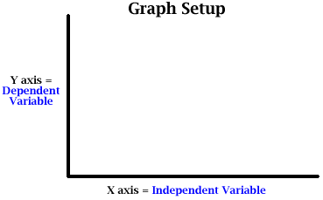
  - Constants are conditions that are kept the same.
  - There are 2 types of variables scientists focus on in experiments
  - Independent Variables: are manipulated.
  - Dependent Variables: are observed and measured

- Tips for Writing a Good Hypothesis
  - A hypothesis is a statement, not a question. Your hypothesis is not the scientific question in your project. The hypothesis is an educated, testable prediction about what will happen.
  - Make it _______________________. A good hypothesis is written in clear and simple language. Reading your hypothesis should tell a teacher or judge exactly what you thought was going to happen when you started your project.
  - Identify the ____________________________. A good hypothesis defines the variables in easy-to-measure terms, like who the participants are, what changes during the testing, and what the effect of the changes will be.
  - Make sure your hypothesis is "___________________________________." To prove or disprove your hypothesis, you need to be able to do an experiment and take measurements or make observations to see how two things (your variables) are related. You should also be able to repeat your experiment over and over again, if necessary. To create a "testable" hypothesis make sure you have done all of these things:
    - Thought about what experiments you will need to carry out to do the test.
    - Identified the variables in the project.
    - Included the independent and dependent variables in the hypothesis statement.
- Designing a Controlled Experiment
  - Control Groups are groups that you compare your experimental group to, to see if your hypothesis is supported or rejected
  - Scientists typically use at least 2 control groups
    - ____________________ control: A positive control gives the desired outcome of an experiment
    - ______________________ control: A negative control is designed to NOT give the desired outcome of the experiment
- What role do hypotheses play in scientific inquiry?

- What is the difference between an independent variable and a dependent variable?

- What is the Independent variable and the dependent variable in the graph below? How do you know?
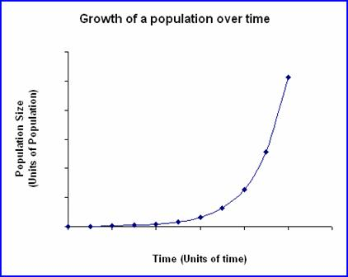
- What is the Independent variable and the dependent variable in the graph below? How do you know?
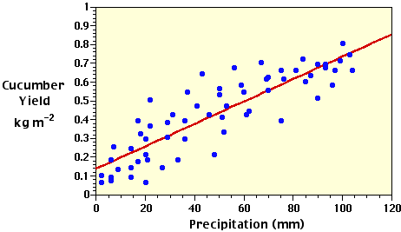
- For each pair, identify which hypothesis is better and explain why
- Hypothesis 1:
  - When there is less oxygen in the water, rainbow trout suffer more lice.
  - Our universe is surrounded by another, larger universe, with which we can have absolutely no contact.
- Hypothesis 2:
  - Aphid-infected plants that are exposed to ladybugs will have fewer aphids after a week than aphid-infected plants which are left untreated.
  - Ladybugs are a good natural pesticide for treating aphid infected plants.
- Use the following experiment for the next few questions
  - In the experiment outlined in the table, 5 identical tomato seedlings are planted in 5 identical pots, placed in the same location, and watered on identical schedules.
Identify the following:
Independent variable
Dependent variable
Positive control
Negative control
Constant
Write a hypothesis for this experiment

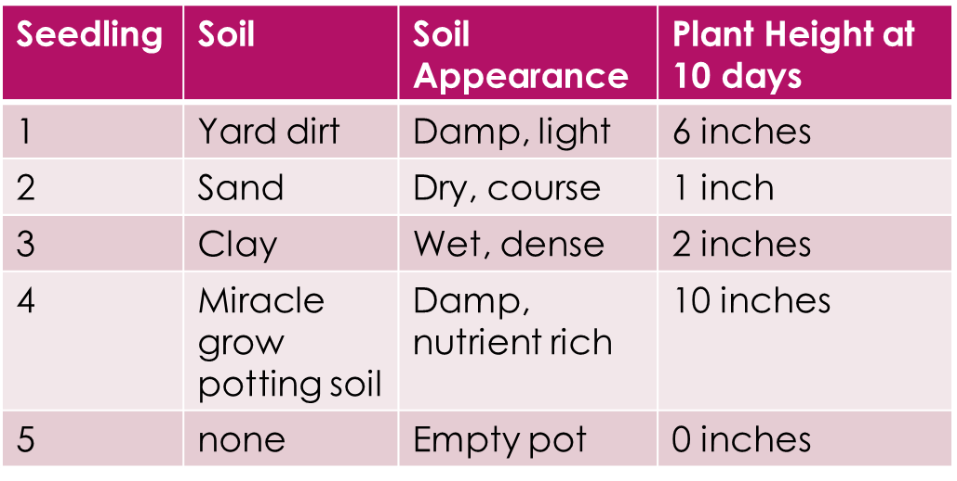

Chapter 1.2 Science in Context

Technology continually changes the way biologists work.
Objectives | Vocabulary
List attitudes important to science  Describe the usefulness of peer review in evaluating scientific literature  Differentiate between theories and hypotheses  Evaluate the importance of biology in making informed decisions  Summarize the benefits and risks of the application of biotechnology  Explain how advances of technology might affect the future of biology. | Scientific Theory  Peer Review  Bias  Scientific Law  DNA  Biotechnology  Transgenic
- Good scientists share scientific attitudes, or habits of mind, that lead them to exploration & discovery
  - ________________________________________: good scientists question everything and refuse to accept explanations without evidence
  - _________________________________________: Good scientists are willing to accept different ideas, even when they disagree with their hypothesis, as long as they are supported by evidence
  - ____________________________________: researchers need to think creatively to design experiments
- Communicating Results: Reviewing & Sharing Ideas
  - Scientists share their finding by publishing articles that have undergone __________________________
  - In peer review, scientific papers are reviewed by _______________________, _____________________
- Scientific Theories
  - Evidence from many scientific studies may support several related hypotheses in a way that inspires researchers to propose a scientific theory that ties those hypothesis together
  - It is important to note, the word theory is used different in science than it is in everyday life
    - Every day life “I have a theory” means little more than “ I have an idea”
  - In science, the word theory applies to a well tested explanation that unifies a broad range of observations and hypotheses and that enables scientists to make accurate predictions in new situations
  - No theory is considered absolute truth. As new evidence is uncovered, a theory may be revised or replaced by a more useful explanation
Theories | Laws
More ______________________ & complex  Encompass a greater number of ideas and hypotheses  Are constantly fine-tuned as new discoveries are made  Examples:  _______________________________  Theory of Evolution  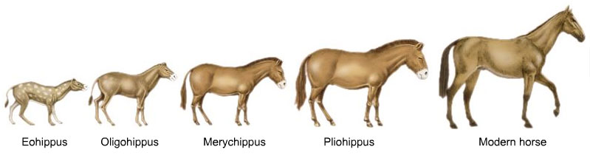 | 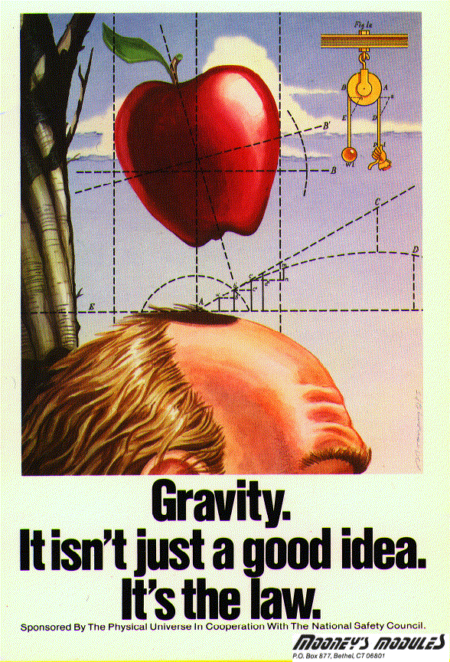

Using science involves understanding its context in society and its limitations
- Pure science does not include __________________________ or _______________________ view points. Science can tell us how certain knowledge or technology can be applied, but not whether it should
- Avoiding ________________________: Science aims to be objective, but scientists may make recommendations that are not in the best public interest due to bias. A bias is a particular preference or point of view that is personal, rather than scientific .The public must be educated enough to understand science to make certain it is applied in ways that benefit humanity
- Understanding biology helps us realize that we can predict the consequences of our actions and take an active role in directing our future and that of our planet. In our society, scientists make recommendations about big public policy decisions, but they don’t make decisions. Citizens of our democracy make decisions by voting for elected officials who influence public policy. This is why it is so important we all understand how science works and appreciate both its power and limitations
- Your health and the health of the environment depend on your knowledge of biology.
  - ___________________________
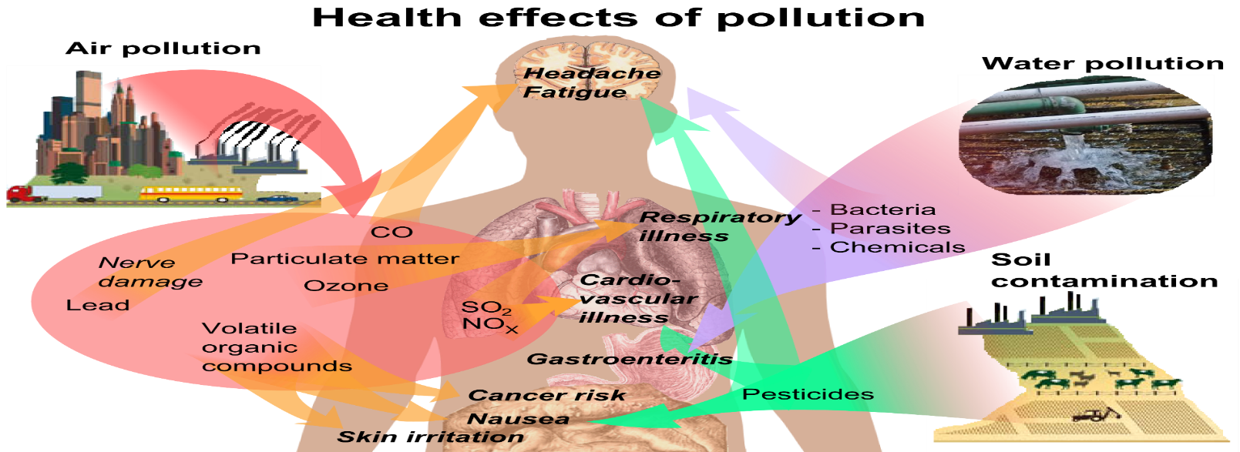
  - potential effects of obesity
  - ______________________
  - Effects of alcohol, tobacco,
and other drugs

- Knowledge of biology can help you understand environmental issues
  - Interactions in ______________________________
  - Pollution
  - ____________________________________
- Biotechnology offers great promise but also raises many issues.
  - _______________________________ is the use and application of living things and biological processes.
    - _________________ testing in medicine and forensics
    - transgenic (genetically modified) crops
    - _____________________________________ bacteria
- Questions are raised about the use of biotechnology.
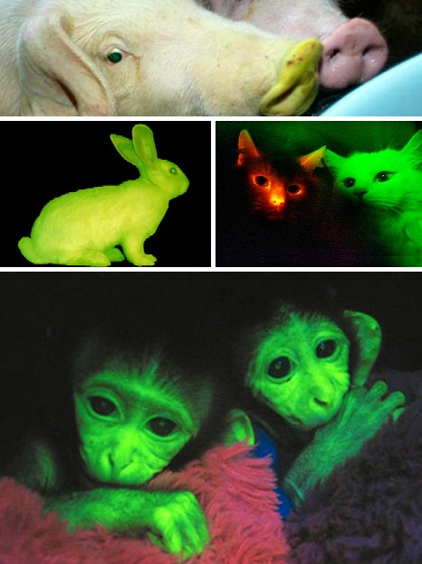
  - __________________________ of genetically modified crops
  - _____________________________ of undesirable genes
  - decrease in biodiversity
  - ethical considerations
- Why is peer review so important to science?

- How is the meaning of theory in science different from the typical use of the every-day term
- How are hypotheses and theories related?

- Give 3 examples of ways in which biology can help you make everyday decisions

- What are some of the potential benefits and risks of biotechnology?

- Scientists disagree on whether genetically modified foods are safe to eat. Design an experiment to test the safety of genetically modified foods. Your experimental design must include the following
  - Hypothesis
  - Independent variable
  - Dependent variable
  - Positive control
  - Negative control

Chapter 1.3 Biology: The Study of Life

Characteristics of Living things & biological levels of organization
Objectives | Vocabulary
- Define and give examples of Earths’ biodiversity  - Summarize the characteristics of all living things  - List the levels of biological organization that biologists study  - Identify four major unifying themes in biology  - Convert between units in the metric system | Biology  DNA  Stimulus  Sexual Reproduction  Asexual Reproduction  Homeostasis | Cell  Evolution  Universal Genetic Code  Population  Community  Metabolism

All organisms share certain characteristics.
- Biology is the scientific study of all forms of life.
- An organism is any individual living thing.

Characteristics of Living Things
  - __________________________________________________________________________________
    - Cells are the smallest unit considered fully alive
    - Cells can grow, respond to their surroundings, and reproduce
    - Some living things have only 1 cell, while others like humans have about 100 trillion
  - _____________________________________________________________________________________
    - All organisms store the complex information they need to live, grow, and reproduce in a genetic code written in a molecule called DNA. That information is copied and passed from parents to offspring through the process called heredity
    - The genetic code is almost identical for every single living thing
  - _____________________________________________________________________________________
    - Every organism has a particular pattern of growth and development. During development, a single fertilized egg divides again and again. As these cells divide, they differentiate, which means they begin to look different and perform different functions
  - __________________________________________________________________________________
    - Organisms detect and respond to stimuli from their environment
  - ___________________________________________________________________________________
    - Most plants and animals engage in sexual reproduction, where the cells from 2 parents (egg and sperm) unite to form the 1st cell of a new organism
    - Bacteria and some fungi and protists reproduce through asexual reproduction, in which a single parent produces offspring that is an exact copy of itself
  - ____________________________________________________________________________________
    - All organisms must take in materials and energy to grow, develop, and reproduce
    - The combination of all the chemical reactions an organism builds up or breaks down substances
is called _____________________________________
  - _____________________________________________________________________________________
    - Over generations, groups of organisms evolve, or change over time
    - Evolutionary change links all forms of life to a common origin more than 3.5 billion years ago
    - Evidence of this shared history is found in all aspects of living and fossil organisms, from physical features to the structure of proteins, to the sequences of information in DNA
  - ____________________________________________________________________________________
    - All organisms need to keep their internal environment relatively stable, even when external conditions change dramatically.
    - ___________________________________________ is the process by which organisms maintain stable internal conditions suitable for life

Biology Studies Life at Different Levels
- Biologists study life at different levels, from as small as the atoms and molecules necessary for life, to as large as the entire planet
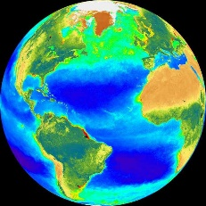
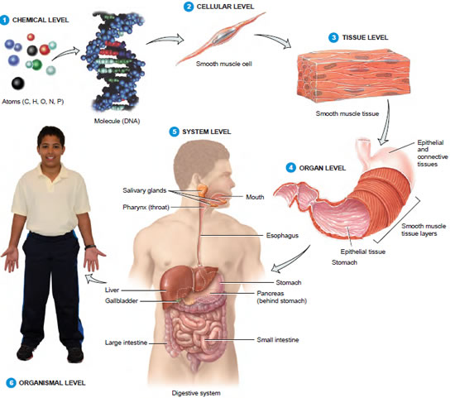
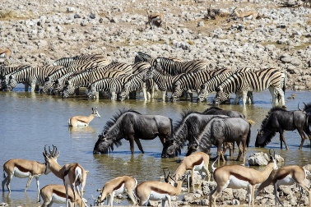
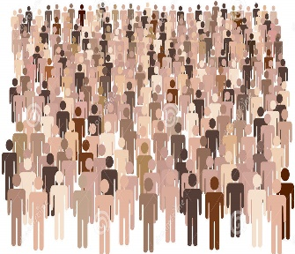
- A ______________________________ is one particular type of living thing. Members of a species can interbreed to reproduce fertile offspring. There are about 2 million different living species have been identified.

Earth is home to an incredible diversity of life
- The __________________________________ is the portion of Earth that supports life and includes all living things and all the places they are found. Every part of the biosphere is connected with every other part. The biosphere includes many environments.
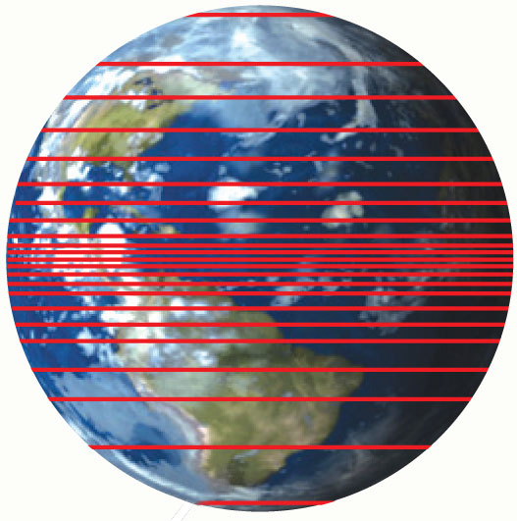
- ______________________________ is the variety of life in a particular area
    - Biodiversity generally increases from the poles to the _____________.
    - Biodiversity is greater in areas with consistently warm temperatures.
- How are species related to the concept of biodiversity

- Summarize the characteristics of all living things

  - Living things are made up of basic units called ______________________, are based on a universal _____________________________________, obtain and use materials and ____________________, __________________________ and __________________________, ________________________, respond to their _________________________, maintain a stable _____________________________ __________________________________, and _______________________________ over time
- How do the characteristics of living things contribute to an organisms’ survival

- Describe the relationship between cells and organisms

- How does biodiversity depend on a species ability to reproduce?

- Why is homeostasis essential for living things?

- Some opponents of the theory of evolution dismiss the ideas as being “just a theory.” Why is this NOT a very good argument against the theory of evolution?

- Which characteristic of living things is important to the survival of a group of animals rather than an individual member of this group? Why?

- What are some ways in which all living things are similar at the molecular level?

Unifying themes connect concepts from many fields of biology
Objectives | Vocabulary
Identify four major Unifying Themes/ Big Ideas in biology | DNA  Evolution  Genetic Code | Natural Selection  Chromosome  Positive Feedback | Heredity  Adaptation  Negative Feedback

4 Big Ideas in Biology
- Big Idea 1: __________________________________________________________________________.
Evolution is the change in the genetic makeup of populations of living things over time.
Evolution can occur through _________________________ _______________________________ of adaptations.
_________________________ are beneficial inherited traits that are passed to future generations through DNA.

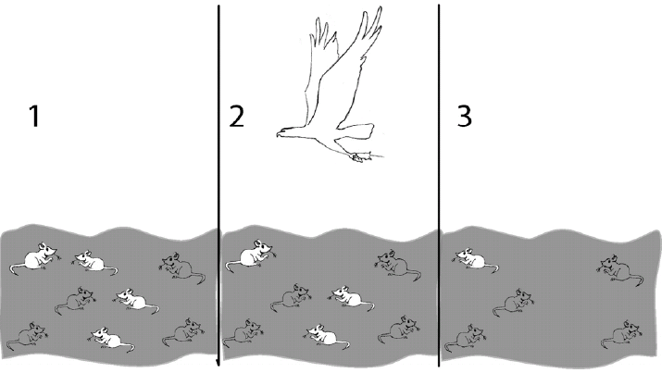

- Big Idea 2: Biological systems utilize _________________________ and _______________________ building blocks to grow, to reproduce and to maintain ___________________________________________________
  - All levels of life have systems of related parts. A ___________ is an organized group of interacting parts.
    - A cell is a system of chemicals and processes.
    - A body system includes organs that interact.
    - An ecosystem includes living and nonliving things that interact.
  - Living systems require energy and matter to maintain order, grow and reproduce. Organisms employ various strategies to capture, use and store energy
  - Organisms also have feedback mechanisms that maintain dynamic homeostasis by allowing them to respond to changes in their internal and external environments.
    - ________________________________________ loops maintain optimal internal environments
    - ____________________________________________________ mechanisms amplify responses.
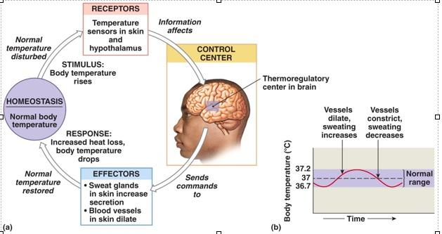
- Big Idea 3: Living systems store, retrieve, transmit and respond to information essential to life processes.
  - Heritable information is packaged into ___________________________________________ that are passed to daughter cells.
  - ____________________________________________________ contains instructions necessary for the survival, growth and reproduction of the organism.
  - Genetic ____________________________________ is almost always advantageous for the long-term survival and evolution of a species
  - Genetic information provides for __________________________ of life and, in most cases, this information is passed from _____________________ to ________________________ via ________
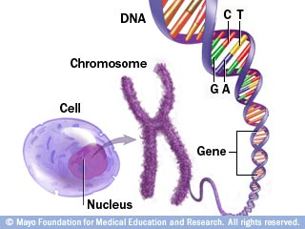
  - To function in a biological system, cells communicate with other cells and respond to the external environment.

- Big Idea 4: __________________________________________________________________________________.
  - All biological systems are composed of parts that interact with each other. These interactions result in characteristics not found in the individual parts alone.
  - In other words, “the whole is greater than the sum of its parts.” All biological systems from the molecular level to the ecosystem level exhibit properties of biocomplexity and diversity.
- What is Evolution

- What is meant by the term “Natural Selection”

- What is the relationship between adaptations and natural selection?

- How is the process of natural selection involved in evolution?

- Give an example of an adaptation that’s helpful in 1 environment but would be harmful in another

- How are structure and function related to adaptations?

- Homeostasis is said to be both “stable” and “dynamic” How can it be both

- Can you think of a time when in order to maintain homeostasis your body deviates from 98.6 degrees?

- Feedback loops are used to maintain homeostasis. When women give birth they release a hormone called oxytocin that causes the uterus to contract and push the baby out. Every time the uterus contracts, more oxytocin is released, causing the contractions to get stronger and occur more frequently. Is this an example of negative feedback or positive feed back? Explain

