Name: | Date:
Course: Biology | Teacher: McQuade
The Circle of Life
Glucose oxygen carbon dioxide water Energy from the sun
Energy for work (ATP) mitochondria chloroplast Plants Animals autotrophs
Heterotrophs photosynthesis cellular respiration
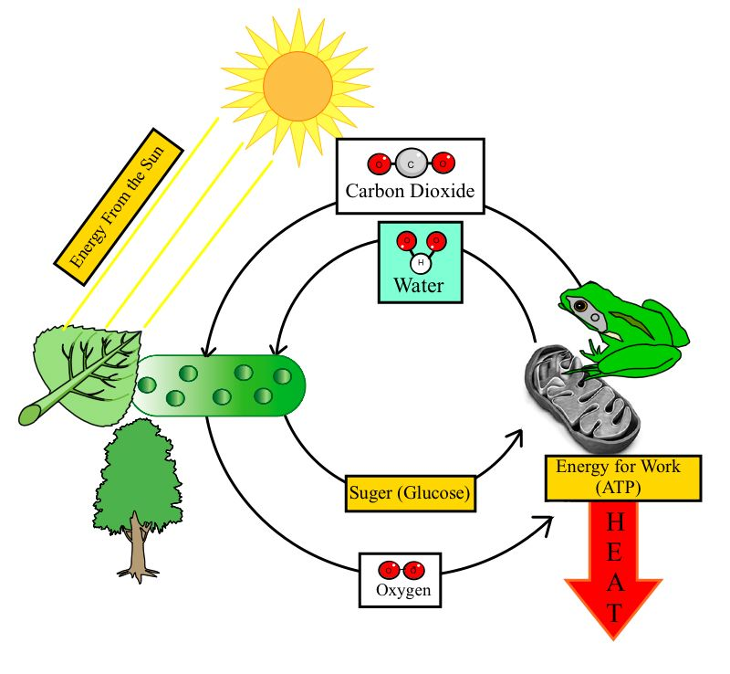

Energy in Ecosystems
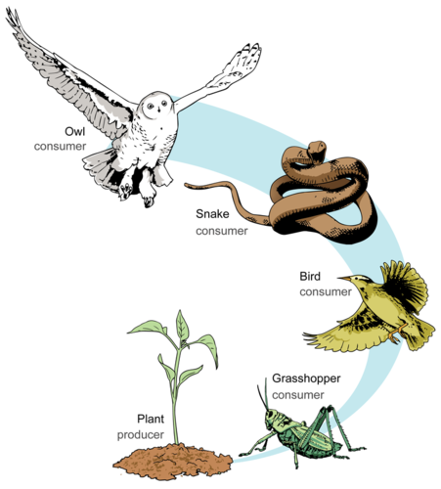
Directions: Label each picture using the following words. Each word can be used more than once, and each picture will have more than 1 label
Primary consumer Secondary consumer Tertiary consumer Quaternary consumer
Herbivore Carnivore
Autotroph Heterotroph

- Which organisms in the picture do photosynthesis?

- Which organisms in the picture do cellular respiration?

- Which organisms in the picture have chloroplasts?

- Which organisms in the picture have mitochondria?

- How does energy enter an ecosystem?

- Which organisms rely on ATP for energy?

- Which organisms will store excess glucose in the form of starch?

- If the plant has 98 calories of energy, how much energy will the grasshopper have? The bird? The snake? The owl?

