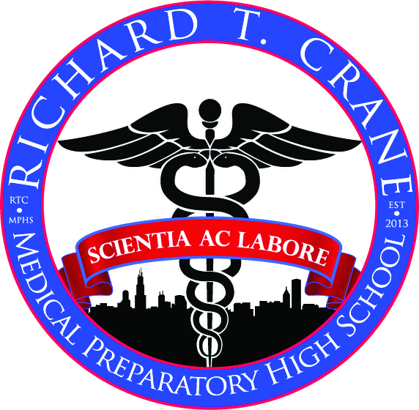
Course Title: Biology
Teacher: Ms. McQuade
Website: www.mcquadesbioconnect.weebly.com
Email: jlmcquade@cps.edu

Course Description
Honors Biology is a required for all RTC Medical Preparatory students. It will provide students with the foundation necessary to pursue a career in the medical sciences. The explosion of information that occurred since the elucidation of the structure of DNA exemplifies the connections among the sciences. Students in this course will examine cell structure and function, energy relations within and among cells, genetics, evolution and the relationship between organisms and their environment. The threads that unite the sciences will be emphasized and students will be encouraged to make connections with prior knowledge

Textbook
Miller & Levine Biology: 2010 On-Level, Student Edition (9780133669510): Kenneth R. Miller, Joseph S. Levine

Supplies
3 Ring Binder with at least a 2” spine
Bound composition notebook
Pens/ pencils
Scissors

Course Expectations
The major objective is to have all students learn and be successful in class. No students has the right to interfere in any way with my ability to teach students to learn.
- All students are expected to follow the RTC Medical Preparatory code of Conduct.
- All students are expected to have a Laboratory Safety Contract with parent signature on file before beginning any lab work.
- All students are expected to follow specific class rules that will be outlined below.

Classroom Rules
- Arrive on time. If you’re late to class you must have a hallpass to enter.
- Be respectful of other people. This includes (but is not limited to) their opinions, ideas, clothing, and questions.
- Come to class prepared to learn. (Pencils sharpened, pen, paper, and notebooks)
- Respect all property. (School property, personal property, and other's property)
- SLANT
  - Sit up: Both feet should be flat on the floor, your back straight, your head up and facing the speaker, and your hands on top of your desk. Sitting with proper posture helps you pay better attention to lessons, and interact more with discussions and activities.
  - Listen: Leaning forward will show you are interested in the lesson and you are listening.
  - Ask & answer questions: Stay on the topic and ask meaningful, interested questions about the discussion and activities. Your question might help others understand the lesson better too.
  - Nod your head and take notes during lecture: Nodding your head shows the teacher you understand the lesson. It is a non-verbal conversation between you and the teacher
  - Track the teacher: Communicate with the teacher both during and after class to make sure you understand, get extra help, check on your progress, or get missed assignments. If you are confused about something, ASK the teacher. Also attend tutorials ~ they are there to help you.

Grade Determination
Exams/ Quizzes 40%
Labs/ Projects 30%
Homework 10%
Classwork 20%

Semester Formula
First Quarter 45% of Semester Grade
Second Quarter 45% of Semester Grade
Final Exam 10% of Semester Grade

Grading Scale
89.5-100 =A
79.5-89.49 =B
69.5-79.49 =C
59.5-69.49 =D
0-59.5 =F

