Movie: The Evolutionary Arms Race Name:______________________________________ 4 5 7 8
Anchor Yourself: Below is a list of concepts that you should understand before watching the movie. For each concept write a definition from the book for each item, and create a cartoon. The first one is done for you.
Word/ Concept | Picture
Resistance gene: A piece of DNA either inherited or caused by a mutation in a bacteria that creates a protein that makes it immune to antibiotics so that antibiotics can’t kill or hurt it. | 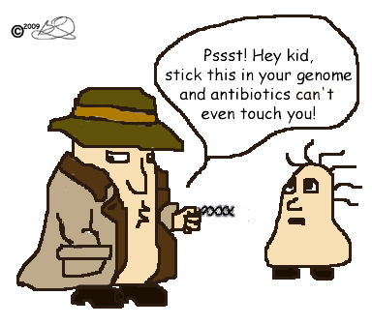  Bacteria
Adaptation:

Evolution:

Natural Selection:

Heredity:

Use your text book to label and color the following picture of a tuberculosis bacterium. Use the following terms and use your book to write a brief description of what they do: Capsule, flagella, cell wall, pili (pilus), cell membrane, DNA, ribosome, cytoplasm,
: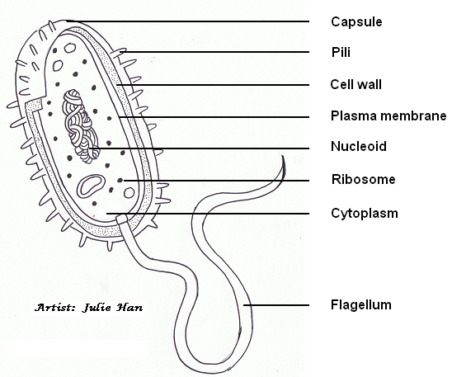

The title of the movie we are watching is called The Evolutionary Arms Race
Making Predictions: Thinking about the title of the movie, explain what you know about the terms “evolutionary” and “arms race”________________________________________________________________________________________________________ ____________________________________________________________________________________________________________________________________________________________________________________________________________________________________________________________________________________________________________________________________
Make a prediction about what you think this movie will be about. Explain why you think this is what the movie will be about. __________________________________________________________________________________________________ _________ ________________________________________________________________________________________________________________________________________________________________________________________________________________________________________________________________________________________________________________________________________________________________________________________________________________________________________________________________________________________________________________________________________________________________________________________________________________________________________________________________________
Watching the Movie:
Please record any words, lines, or imagery from the movie that “stick out” to you. These might be important, puzzling, curious, provocative- whatever grabs your attention

Reactions/ Connections: What are your feelings and responses as you watch the movie? Does anything remind you of past experiences, people, or events in your life? Does it make you think of anything happening in the news, around school, from the articles we’ve been reading, in other stories you’ve read or movies you’ve watched? How so? What themes or major ideas are popping out?

“I wonder…”/ Questions: What questions came to mind while you watched this movie? Were there things you wondered about, doubted, or didn’t understand? What would you ask the characters or writers if you could talk to them?

Written Reflection
- Were any of your predictions correct? What clues or information turned out to be the most helpful?
_______________________________________________________________________________________________________________________________________________________________________________________________________________________________________________________________________________________________________________
- How were the following scientific concepts depicted in the movie?
  - Adaptation: ________________________________________________________________________________________ ____________________________________________________________________________________________________________________________________________________________________________________________________
  - Evolution: _________________________________________________________________________________________ ____________________________________________________________________________________________________________________________________________________________________________________________________
  - Natural Selection: __________________________________________________________________________________ ___________________________________________________________________________________________________________________________________________________________________________________________________
- Pretend your best friend was absent from school and missed the movie. Write a summary of the movie. Be sure to explain the major ideas and include any examples or important imagery so that they aren’t behind.
______________________________________________________________________________________________________________________________________________________________________________________________________________________________________________________________________________________________________________________________________________________________________________________________________________________________________________________________________________________________________________________________________________________________________________________________________________________________________________________________________________________________________________________________________________________________________________________________________________________________________________________________________________________________________________________________________________________________________________________________________________________________________________________________________________________________________________________
- Antibiotic resistance is developing more quickly than new antibiotics, causing a significant public health threat. The government wants to fund advocacy, research, and public education aimed at the development of new antibiotics or the stewardship of existing antibiotic resources by using a percentage of the tax revenue they collect from citizens like you. Some people argue that this is a waste of tax payer money. Use a claim, evidence reasoning format below to try to convince these people that this would be a good use of funds.
Claim 1: The government should use taxes to fund advocacy, research, and public education aimed at the development of new antibiotics or the stewardship of existing antibiotic resources to combat antibiotic resistant bacteria.
Evidence: Identify the specific evidence you have found that supports your claim. You must directly quote and cite the text/ movie. Only quote evidence you will analyze. The reader needs to understand how the quoted material works as evidence (how it supports the claim). If you do not discuss the material you quote, the reader will not understand what the purpose of the quotation is. Keep your evidence separate from your claim and analysis.
_______________________________________________________________________________________________________________________________________________________________________________________________________________________________________________________________________________________________________________________________________________________________________________________________________________________________________________________________________________________________________________________________________________________________________________________________________________________________________________________________________
Reasoning: This must be the longest section of the paragraph. It is not enough to assert that the evidence reveals something; you need to show how it does so and connect it to big ideas in biology such as: structure & function, heredity, matter & energy (metabolism), interacting systems…. If you overestimate how clearly and fully you have explained the connection between evidence and analysis, the result will be an unconvincing argument. A good claim and appropriate evidence require extensive analysis. To do this you must make a connection to the concept of evolution by natural selection.
____________________________________________________________________________________________________________________________________________________________________________________________________________________________________________________________________________________________________________________________________________________________________________________________________________________________________________________________________________________________________________________________________________________________________________________________________________________________________________________________________________________________________________________________________________________________________________________________________________________________________________________________________________________________________________________________________________________________________________________________________________________

