DNA: The Genetic Material
All of this information can be found in the book in chapter 8
Why Its Important Learning about DNA contributes to our knowledge of: genetic disorders, viral diseases, cancer, aging, genetic engineering, criminal investigations
Objectives | Vocabulary
- Relate Griffith’s conclusions to the observations he made during the transformation experiments.  - Summarize the steps involved in Avery’s transformation experiments, and state the results.  - Evaluate the results of the Hershey and Chase experiment. | - Vaccine  - Virulent  - Restriction enzyme  - Transformation  - Bacteriophage
DNA Review
  - What does DNA stand for?
  - What subunits make up DNA?
  - What three parts do the subunits consist of?

Friedrich Miescher
- DNA was first identified as far back as ________ by a Swiss scientist named Friedrich ____________
- He extracted DNA from the _________ of pus cells found on surgical bandages
- At first DNA was called __________ because it was a substance found in the nucleus
- Miescher was also able to separate the substance into two basic parts…
  - The phosphate groups, also called phosphoric _________, were slightly acidic, so DNA belongs to a class of substances called ___________ __________
  - Throughout the next century, scientists made many exciting discoveries about the ____________ and ______________ of DNA
Transformation Griffith’s Experiments
- In 1928, Frederick _____________, a bacteriologist, carried out an experiment that led to an ________________ discovery about DNA
- He was actually trying to prepare a vaccine against the bacteria, Streptococcus pneumoniae, which causes _________________.
- A vaccine is a substance that is prepared from killed or ________________ disease-causing agents
- When administered, it is easier for your body’s immune system to ___________ off the disease and prevent ________________ infections
- For example…
  - people who get a flu vaccine every year, will easily fight off that __________ of the virus and avoid having any ______________
- Griffith was working with two strains of S. pneumoniae…
  - One enclosed in a _____________ of polysaccharides, that protects the bacterium from the body’s defense system
  - This helps make the bacterium _________, or able to cause disease
    - Smooth-edged ( )
- The other strain ___________ the polysaccharide capsule and is unable to cause disease
  - Rough – edged ( )
- In Griffith’s experiment, he injected mice with…
  - S bacteria
  - R bacteria
  - Heat-killed S bacteria
  - Heat-killed S bacteria and normal R bacteria
Note about “heat-killing”…

During Griffith’s time, it was not understood that DNA can tolerate temperatures around 90°C without being altered, but ___________ are altered at around 60°C

So “heat-killing” damages a cells proteins and ___________, but leaves DNA _________

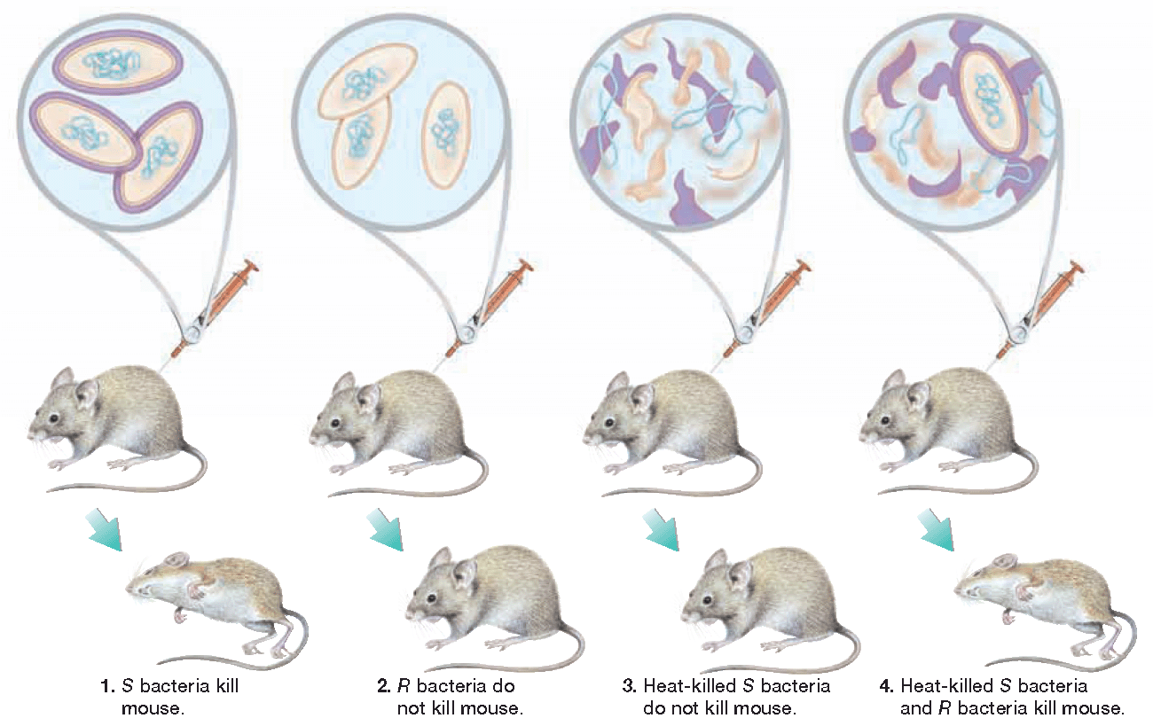
- Somehow, the harmless R bacteria had changed and become ______________
- Griffith had discovered what is now called ____________________
  - Occurs when a cell picks up new DNA from it’s _____________, changing its combination of genes, called a _________________
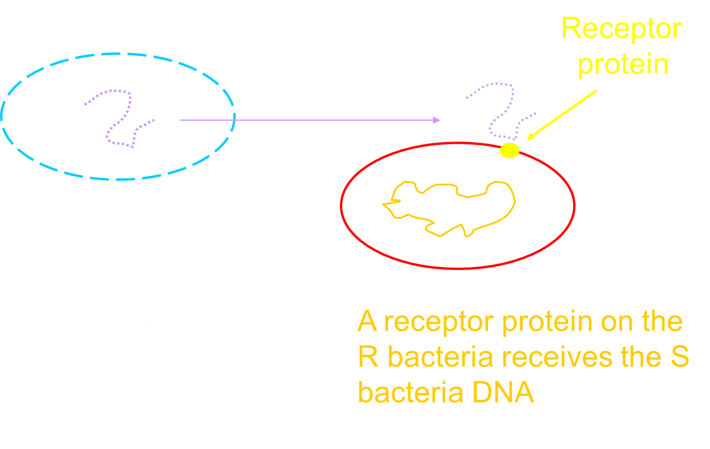
Then restriction enzymes _________ and _________ the two pieces of DNA together
But during Griffith’s time, scientists really didn’t understand transformation
During the 1940s and 1950s, scientists were still debating over what cell part contained genetic information
Many scientists actually thought that ___________ contained our genetic information, and not DNA.

Oswald Avery
- In 1944, a scientist named Oswald __________ conducted a transformation experiment under two different conditions…
  - Condition 1: Added an enzyme that destroyed ____________
  - Condition 2: Added an enzyme that destroyed ____________
- Result?
  - Transformation was only stopped by the enzymes that destroyed _________...so it must contain the genetic material!

- Despite Avery’s results, scientists remained _____________
- Since proteins are so important to many cell _____________ and _______________, most scientists still thought that proteins contained the genetic material
Hershey & Chase
- In 1952, Alfred ___________ and Martha _____________ set out to settle the controversy.
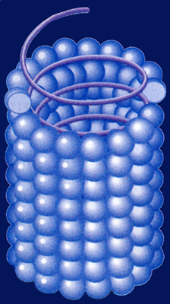
- Their experiments made use of a substance called a ___________, which attacks and infects cells
  - A virus is much _____________ than a cell and consists of ________ or ________ surrounded by a protective protein coat called a ____________
- When a virus infect a cell, it causes the cell to produce more __________ instead of carrying out its normal cell activities
- Eventually the cell ___________ open during a process called ____________, and the released viruses seek out another cell to infect

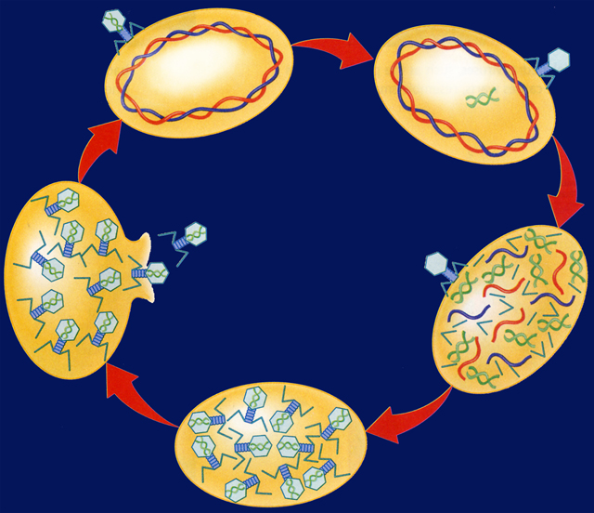
- A special type of virus that infects ________________ cells is called a __________________ or a _________ for short
- The viral DNA is contained in the ________ and the tail __________ attach to the bacteria cell
- After attachment, the DNA is injected into cell, almost like a _________
- The bacteriophage made the perfect test subject, because it was a simple substance that contained both ________ and ____________
  - Scientists knew that DNA contained a ____________ group
  - They also knew that So Hershey and Chase labeled the phages with one of the following radioactive isotopes…
  - ______, which would be found in DNA
  - ______, which would be found in the protein coat
  - proteins often contain the element __________

- These radioactive isotopes will __________ or break down into stable particles that can be ____________ with machines
- Next the labeled phages were allowed to ___________ the bacteria cells
- Hershey and Chase then checked to see which ______________ entered the bacteria cells
- First the phages that were still attached to the bacteria cells were removed with a__________________
- Then the bacteria cells and the phages were placed in test tubes and ___________ in a machine called a centrifuge
- As the centrifuge spins, the different substances settle out by _________
- The heavier bacteria cells settled at the __________ of the test tubes while the lighter phages settled at the ______
- Only the ______ isotope was found inside of the bacteria cells
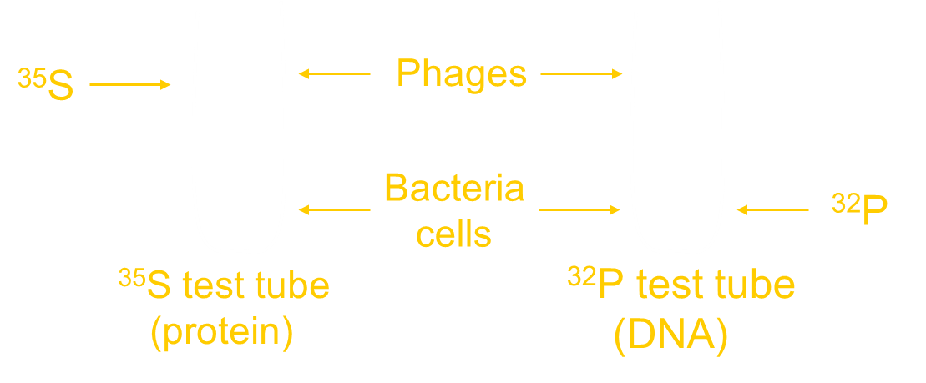
So based on these results… which substance, proteins or DNA, would you conclude is responsible for transformation?

- Relate Griffith’s conclusions to the observations he made during the transformation experiments.

- Summarize the steps involved in Avery’s transformation experiments, and state the results.

- Evaluate the results of the Hershey and Chase experiment.

Objectives | Vocabulary
- Describe the three components of a nucleotide.  - Develop a model of the structure of a DNA molecule.  - Evaluate the contributions of Chargaff, Franklin, and Wilkins in helping Watson and Crick determine the double-helical structure of DNA.  - Relate the role of the base-pairing rules to the structure of DNA.  - Summarize the process of DNA replication.  - Describe how errors are corrected during DNA replication  - Compare the number of of replication forks in prokaryotic and eukaryotic DNA. | Double helix  Nucleotide  Deoxyribose  Base-pairing rules  Complementary base pair  DNA replication  DNA helicase  Replication fork  DNA polymerase
- After the Hershey and Chase experiment, scientists were convinced that DNA contained the genetic material…
  - But how is this information ________________?
  - And how is it _____________ on?
  - To answer these questions, scientists began studying the ___________________ of DNA
- In 1953, James __________ and Francis _________ determined that a DNA molecule is a ____________ __________
  - Meaning that it consists of ______ strands __________ around each other like a winding staircase
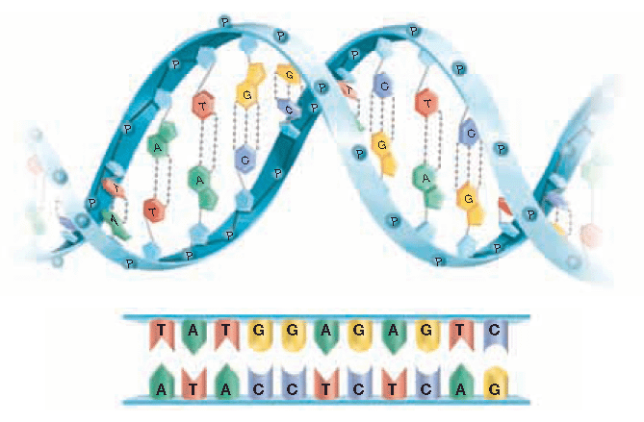
Each strand is made of ___________ nucleotides, which consist of three parts…
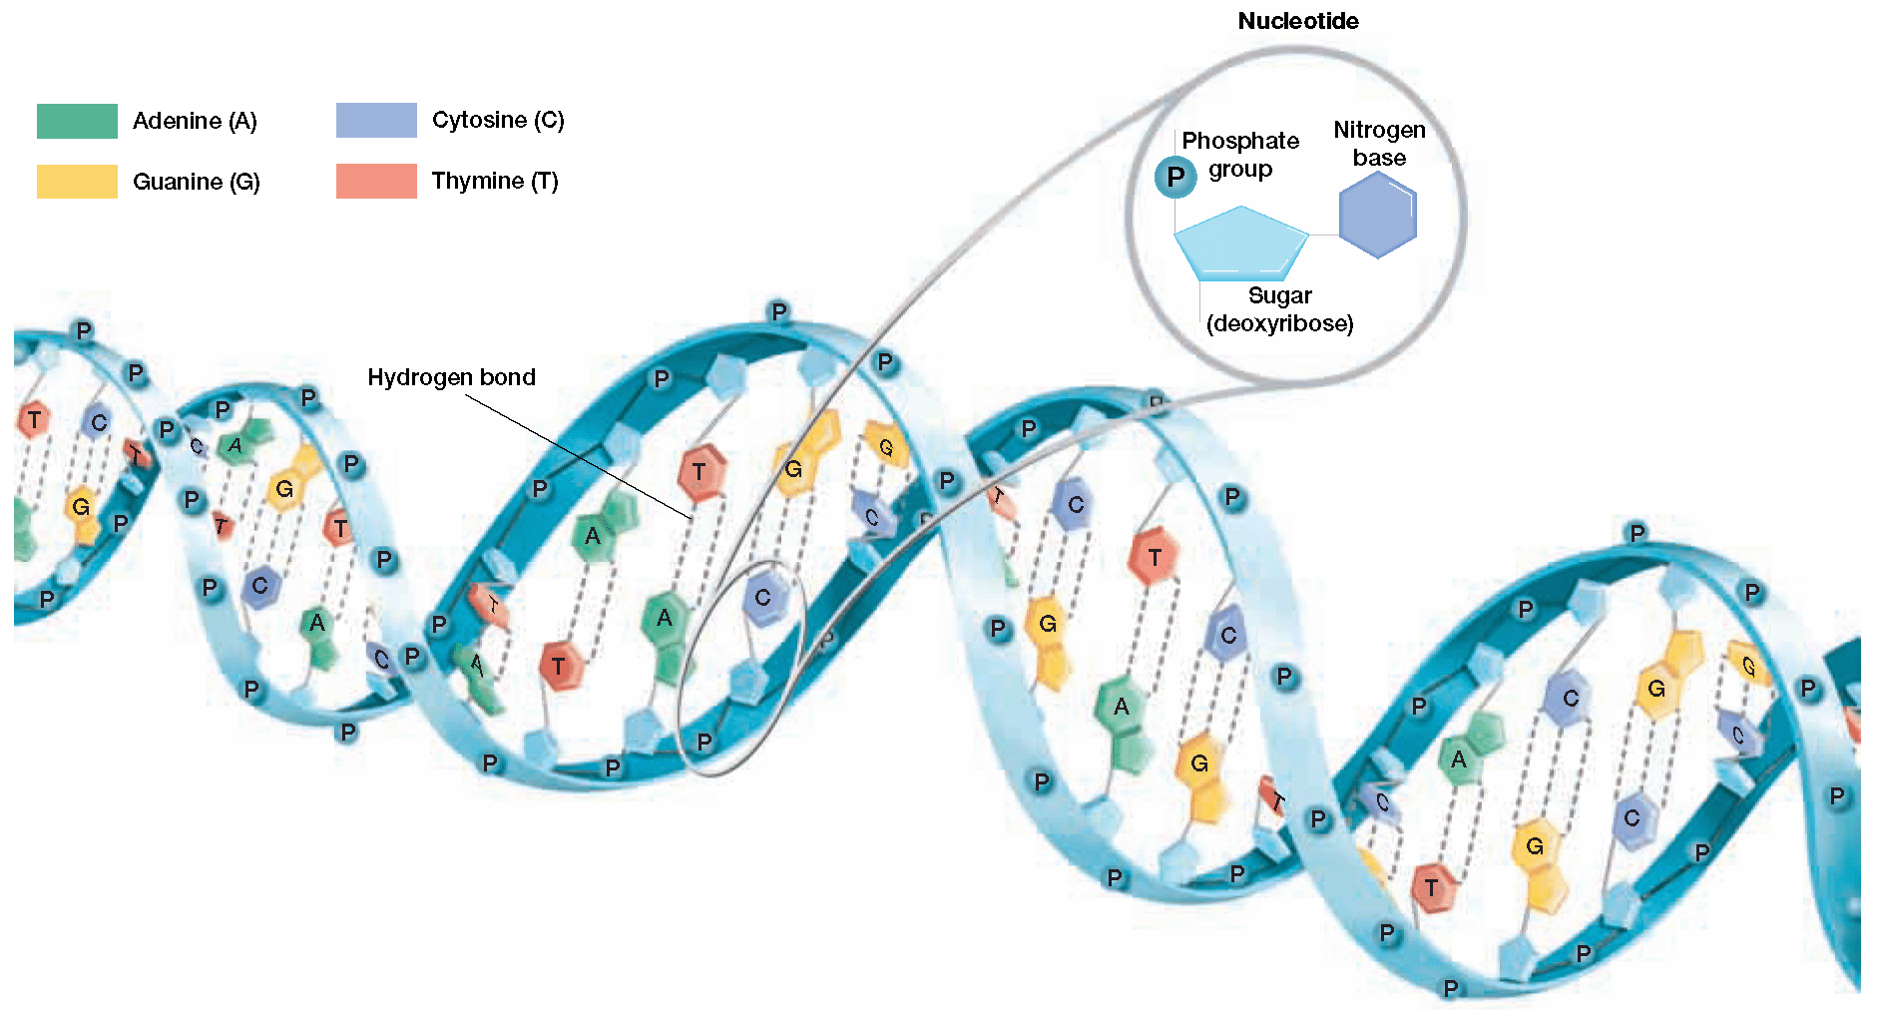
  - A phosphate group
  - A 5 carbon sugar called _____________
  - A ____________ base
- One nucleotide is circled for you…
- Circle several more nucleotides
- Label a the 5 carbon sugar deoxyribose
Note how DNA resembles a ___________________
The side rails or _________________ of each strand consist of the…
  - __________________
  - __________________

The phosphate and the sugar are held together by _________________ bonds

- The rungs of the ladder are made of the nitrogenous __________
  - They are held together by _______________ bonds
- While each DNA nucleotide contains the _______ sugar and phosphate group, the nitrogenous ____________ may be any one of the four different kinds…
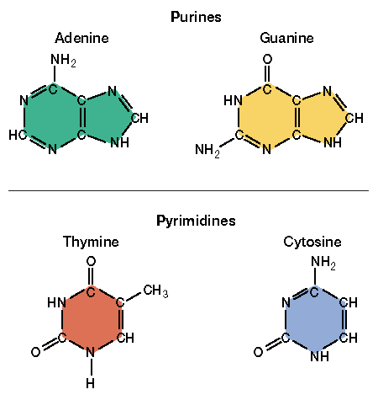
  - ____________________
  - ____________________
  - ____________________
  - ____________________
- Adenine and guanine contain ____________ rings,
which are classified as _________________
- Thymine and cytosine consist of ___________ rings,
which are classified as _________________
- Which bases look larger…
  - Purines or pyrimidines?
- How were Watson and Crick able to determine the double helical structure of DNA?
  - They based their structure on __________ acquired from ___________ scientists
Erwin Chargaff
- In 1949, Erwin Chargaff observed that for each organism he studied, the amount of adenine always equaled the amount of thymine… _______ = ______
- Likewise, the amount of guanine always equaled the amount of cytosine… _____ = _____
- However, the amount of each equal pair _________ between different organisms.

Maurice __________ and Rosalind ______________

- In 1952, they took many photographs of sections of DNA using a method called ___________ ___________________
  - In the process, X-ray beams were bounced off of DNA and the rays were diffracted or ______________ onto a piece of film
  - This method is similar to shining a light on an object and analyzing its ____________
- The X-ray photos clearly showed that DNA is composed of _____ strands that are _________
- In 1962 Watson, Crick, and Wilkins were awarded a ____________ prize for their work
- Rosalind Franklin was not recognized as a reward recipient because she had already died of cancer likely caused by too much X-ray ______________

- Based on all of the compiled data, Watson and Crick determined that a _______________ on one strand of the DNA is always paired with a ______________ on the opposite strand
- Since adenine and thymine are always found in equal amounts…___ pairs with ____
- Likewise, guanine and cytosine are found in equal amounts, so ____ pairs with ____

- A and T form ____ hydrogen bonds
- G and C form ____ hydrogen bonds

- The strictness of the base-pairing rules results in two strands that contain ______________ base pairs…
- Meaning that the order of bases on one side ___________________ the order of bases on the other side
- Determine the complementary base pairs for the DNA strand below…
A T A C G T

Roles of Enzymes in DNA Replication
- The complementary structure of DNA is also used as a basis to make ___________ copies of the DNA each time a cell ______________
- Cell division allows an organism to ________, _____________, and to _____________ old cells
- As we learned last semester, why can’t a cell simply just grow larger instead of dividing?
- The actual process of cell division is called ________________
- Why might it be a good idea for one of your body cells, like a skin cell, to make an exact copy of its DNA before it divides?
- The process of making a copy of DNA is called ___________________ or ________________
- DNA replication occurs in three steps:
  - Step 1
    - Enzymes called DNA ________________ open the double helix by breaking the ______________ bonds that link the bases together
    - The areas where the double helix separates are called replication __________.
  - Step 2
    - At the replication fork, enzymes known as DNA _______________ move along each of the DNA strands and add _________________ to the exposed nitrogen base, according to the base-pairing rules.
    - Notice that the strands of DNA are copied in ______________ directions …
      - This phenomenon is known as ___________________
      - The direction is controlled by the location of __________ atoms in deoxyribose…
      - 5th Carbon to 3rd Carbon
  - Step 3
    - DNA polymerases _______________ after two ______________ molecules are formed
    - Each new molecule consists of one _____ strand and one ______ strand
Checking for Errors
- In the course of DNA replication, errors sometimes occur and the ___________ nucleotide is added to the new strand.
- An important feature of DNA replication is that DNA polymerases have a ___________________ role.
- In the event of an error, the polymerases can _____________
- Under normal circumstances, this proofreading reduces errors in DNA replication to about ________ error per 1 _____________ nucleotides.
The Rate of Replication
- Replication does not begin at one end of the DNA molecule and end at the other because that would take too _________.
- Recall that DNA in prokaryotes is _________________.
- They usually have ______ replication forks that begin at a single point meet on the _____________ side of the DNA circle
- In eukaryotic cells, each chromosome contains a single, ____________ strand of DNA.
- Each human chromosome is replicated in about ______ sections that are 100,000 nucleotides long, each section with its own starting point.
- An entire human chromosome can be replicated in about ___ hours.
- Describe the three components of a nucleotide.

- Develop a model of the structure of a DNA molecule

- Evaluate the contributions of Chargraff, Franklin, and Wilkins in helping Watson and Crick determine the double-helical structure of DNA

- Relate the role of the base-pairing rules to the structure of DNA.

- Summarize the process of DNA replication.

- Describe how errors are corrected during DNA replication.

- Compare the number of replication forks in prokaryotic and eukaryotic DNA.

