History of Life on Earth
Why Its Important :
Learning about the history of life gives us a basis for studying and understanding the theory of ___________________
Objectives | Vocabulary
- Summarize how radioisotopes can be used in determining Earth’s age.  - Compare two models that describe how the chemicals of life originated.  - Describe how cellular organization might have begun.  - Recognize the importance that a mechanism for heredity has to the development of life. | - Radiometric Dating  - Radioisotopes  - Half-life  - Microsphere
Review: What is a scientific theory?
The age of earth
- Scientists estimate that the earth formed approximately 4.5 _______________ years ago
  - Other texts say ______ billion years ago
- When it first formed, it was probably a fiery ball of _____________ rock.
- Eventually, scientists hypothesize that the planet’s surface __________ enough to form a rocky crust
- Many volcanoes may have released gases that helped to form earth’s early _________________
- Water vapor in the atmosphere _______________, leading to millions of years of _________ and ________________
- This rain collected to form vast ______________
- What is water vapor?
  - What is it’s chemical formula?
  - Will physical changes like evaporation, condensation, or freezing change this chemical formula?
- So the oxygen in water vapor is not considered __________ oxygen (O₂) until a chemical reaction splits water
  - We have studied this before….
    - during ____________________, water is split to release oxygen in a process called _______________
- So if early earth was very hot and contained no life forms, is it likely that oxygen gas (O₂) was present?
Measuring Earths Age
- Scientists have estimated the age of Earth using a technique called _________________ dating.
  - A process that determines the age of an object by measuring its content of certain _________________________ isotopes.
    - Also called ____________________
- A radioisotope has an ____________ nucleus that breaks down or ___________ and give off energy in the form of charged particles or __________________
- As the radioisotopes decay, they turn into other isotopes that are more ____________
- Tracking the presence of radioisotopes is helpful for aging layers of rock, ______ cores, and ________________
- Example
  - Certain rocks contain traces of the radioisotope ________________
    - Over time, it decays into ______________ and _______________
- The time it takes for one-half of a given amount of a radioisotope to decay is a ___________ ____________.
  - The half-life of potassium-40 is ________________ years

How much potassium - 40 is left after 1 half life?  How much potassium-40 is left after 2 half lives?  If only 1/8 of potassium-40 is remaining, how old is the rock? | 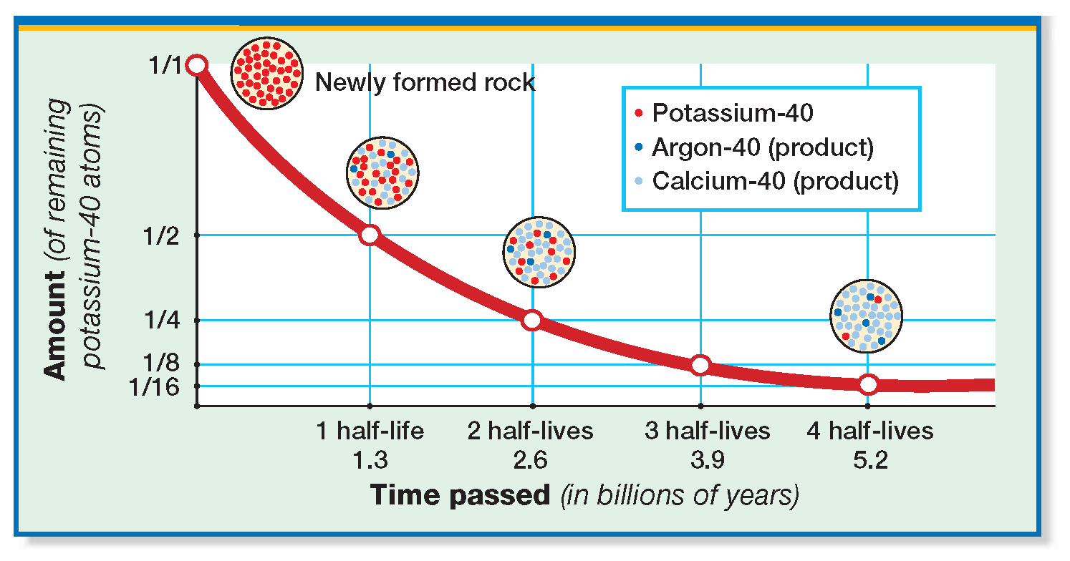

- The half-life of carbon-14 is 5,730 years…if 1/16 of carbon-14 is present, how many half-lives have occurred?
- How long did this take?
- The oldest rocks found and dated are ______ billion years old
- Why is it impossible to date rocks from the earliest history of the planet?
  - The rocks were too _____________
  - Rocks __________ away
- Another dating method called _________________ dating compares the _____________ of rock layers to determine a relative age.
  - Since sediment layers build on top of each other, younger layers should be found at the ________, while older layers should be found at the __________________
- Most scientists think that life originated in the __________________
- While scientists have _______ been able to determine how life originated, they have done many studies focusing on the _______________ needed to support life
Formation of the Basic Chemicals of Life
- It is thought that the path to the development of living things began when the molecules of ______________ matter reacted chemically to produce many different, ______________ organic molecules
- What element must organic molecules contain?
- Next these simple organic molecules went through further reactions to __________________ and form _______________ organic molecules
- What are the four types of complex organic molecules that are essential for life?
- There are two models explaining how these organic molecules ended up in the oceans…
  - _____________________ theory
  - _______________ theory
Primordial Soup Model
- Suggested in the 1920s by the Russian scientist Alexander _______________ and the British scientist John _______________
  - Basically, they thought that energy from the _______, ________________, and earth’s own __________ triggered ____________________ gases to go through chemical reactions, forming ______________ molecules
  - These organic molecules were then washed into the oceans by _________
- Oparin and Haldane thought this scenario was similar to how a _________ is filled by many vegetables and meats
- At the time, scientists also proposed that earth’s atmosphere lacked ______________ but was rich in other gases such as…
  - Nitrogen gas _____
  - Hydrogen gas _____
  - Water vapor _____
  - Ammonia ____
  - Methane _____
- Energy may have _______________ electrons in these gases, allowing them to form a variety of organic compounds
Miller Urey Experiment
- In 1953, the primordial soup model was tested by Stanley ____________ and Harold ___________
- In the laboratory, they tried to recreate the ____________ on early earth to see if organic molecules would form
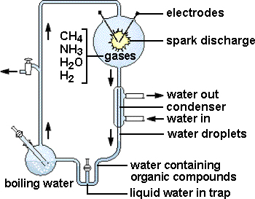 | - Heated water to recreate _______________ temps. and form water ______________________  - Added ___________________________________ gases  - Added ____________________ sparks to simulate lightning  - Condensed steam to form _______________________  - Tested the solution and it ________________________ organic molecules!
Recent discoveries have caused scientists to_________________ the Miller-Urey experiment
- The mixture of gases used in Miller’s experiment could not have _____________ on early Earth.
- Four billion years ago, Earth did not have a protective layer of __________ gas, which consists of _____.
- Without ozone, ultraviolet radiation would have destroyed _______________ and ________________, preventing the production of organic molecules
The Bubble Model
- In 1986, the geophysicist Louis __________ suggested that the key processes that formed the chemicals needed for life began in underwater ________________ that were protected from __________________ radiation
- These bubbles contained gases that came from underwater ___________________
Precursors of 1st Cells
- Most scientists accept that under certain conditions, the basic molecules of life could have formed spontaneously through simple _______________.
  - The formation of organic molecules is sometimes called __________________ evolution
- Interestingly enough, scientists have also been able to make short chains of _______ form spontaneously in water
- What do we know about RNA?
- In the 1980s, Thomas _______ and Sidney ___________ hypothesized that RNA was the first self _______________ molecule rather than ______
- This is supported by the fact that some viruses contain only ________, which is actually used to create DNA in a host cell….this is done by a process called ___________ transcription
- Experiments have also shown that organic molecules tend to ____________ together in water, forming droplets that look like ________
  - For example, when a lipid, like oil, is added to water, what does the oil do?
- Similar experiments have shown that short chains of __________ ___________ gather in water to form droplets called _____________________
- Microspheres resemble cells and can ___________, but they are not actual cells
  - Sometimes they are called _________________ and were discovered by Sidney _______ in 1992.
  - Another similar droplet, formed from linked amino acids and sugars is called a ___________________.
  - Some scientists think that protocells may have evolved into real cells, but there is ____ scientific data to support this…
  - But still, scientists hypothesize that if protocells acquired ______, they could pass on characteristics to new protocells
- Back in chapter 1, we discussed how the theory of biogenesis replaced the theory of spontaneous generation
- What did these theories state…
  - Spontaneous generation?
  - Biogenesis?
- So if protocells really did evolve into actual cells, which theory does this align with?
- Summarize how radioisotopes can be used in determining Earth’s age.

- Compare two models that describe how the chemicals of life originated.
  - Primordial Soup Model

  - Bubble Model

- Describe how cellular organization might have begun.

- Recognize the importance that a mechanism of heredity has to the development of life.
The Evolution of Cellular life
Objectives | Vocabulary
- Distinguish between the two groups of prokaryotes.  - Describe the evolution of eukaryotes.  - Recognize an evolutionary advance first seen in protists.  - Summarize how mass extinctions have affected the evolution of life on Earth.  - Relate the development of ozone to the adaptation of life to the land.  - Identify the first multicellular organisms to live on land.  - Name the first animals to live on land.  - List the first vertebrates to leave the oceans | Fossil  Cyanobacteria  Eubacteria  Archaebacteria  Endosymbiosis  Protist  Extinction  Mass Extinction | Mycorrhizae  Mutualism  Arthropod  vertebrate  Continental drift

When did the 1st Organisms form?
- To find out, scientists study ________________
  - which may be…
    - preserved or mineralized remains of __________, ___________, or ___________
    - an _____________ of an organism that lived long ago.
- Based on the types of fossils present in earth’s rock layers, scientists have created a timeline of earth’s history, called the __________________ time scale
- The time scale is made up of four main divisions called…  - _________________ time  - _________________ era  - _________________ era  - _________________ era  - These eras are further subdivided into ____________ according to the _________ of organisms living during that time  The Precambrian  - First and __________________ division  - Comprises _____% of earth’s history  - Scientists have discovered __________________ fossils of ____________________ from this time  - The first prokaryotes were probably ______________ _________________ that ate the ______________ molecules in the “primordial soup”  - When this food source began running out, _______________ bacteria may have evolved next  - What can autotrophs do?  - The first autotrophs were probably ____________________, meaning that they made food while using the energy stored in chemical _________  - Chemosynthetic prokaryotes may have been similar to modern day __________________, which can survive in ___________ environments like hot springs and deep sea ________  - Another group of bacteria, called __________________ live in more common environments  - They contain a complex carbohydrate in their cell walls called ____________________, while archaebacteria contain unique ______________ in their cell walls.  - Scientists have hypothesized that these two groups of prokaryotes _______________ early | 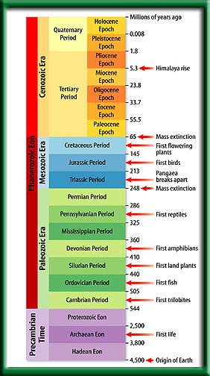
- Approximately _______ billion years ago, _____________________ autotrophs evolved
  - For example, scientists have found fossils of marine cyanobacteria (blue green) in mounds called _____________________
- What gas do photosynthetic organisms release into the atmosphere?
  - This would allow ______________ cells to exist and the ________________ layer, consisting of _______ to form
The Evolution of Eukaryotes
- About _____ billion years ago, the first eukaryotes appeared.
- A eukaryotic cell is much _____________ than a prokaryote is, has a complex system of _____________ membranes, and its DNA is enclosed within a ________________.
- Almost all eukaryotic cells have _____________________, while eukaryotic plant cells have _____________________
- So how did eukaryotic cells acquire all of these extra organelles?
  - Scientists hypothesize that ancient ____________ began working together in _______________ relationships, and eventually became ________________ upon one another
- For example, a large prokaryote may have ingested a smaller _________________ prokaryote that started acting as a ____________________
- They also may have ingested photosynthetic bacteria, which started acting as ________________
- This idea is called the theory of __________________ and was proposed by Lynn ________________ in the 1960s
  - “Endo” means ______ and refers to smaller prokaryotes moving into larger ones
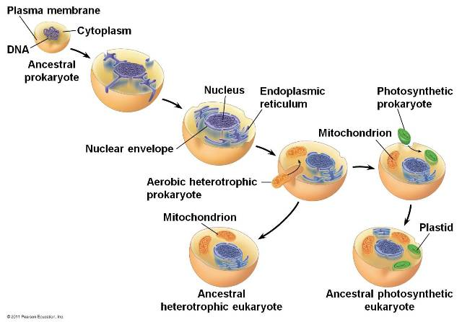
Endosymbiosis
The following four observations support the theory of endosymbiosis
1. Mitochondria are about the same _______ as most eubacteria, and chloroplasts are the same size as some cyanobacteria.
2. Mitochondria and chloroplasts have _________________ DNA similar to the DNA found in bacteria.
3. Mitochondria and chloroplast both have _______________ that are similar to bacterial ribosomes.
4. Like bacteria, chloroplasts and mitochondria _____________ by simple ___________. This replication takes place __________________ of the cell cycle of the host cell.

Multicellularity
- Towards the ________ of Precambrian time, multicellular life evolved
- While the unicellular body plan has been very successful, multicellularity has several __________________
- Multicellular organisms contain ________________ cells that can carry out more ____________ activities
- For example, specialized cells are used to….
- ______________ off disease
- Prevent ______________ out
- Find __________ or _____________
- Multicellular life was first present in Kingdom __________________
- Most protists are unicellular _________________, but some multicellular organisms, like __________________ are classified as protists
Paleozoic Era
- The Paleozoic era began with the ______________ period
- This era is marked by an explosion of ___________, or the evolution of many ______________
  - As a result the Cambrian period is often called the Cambrian _________________
- Many unusual marine organisms lived in the shallow Cambrian _________
- Their fossils have been found in an area of Canada called the _______________ Shale
- The ______________ period followed the Cambrian period…
  - Many different animals continued to abound in the seas , including __________
  - At the end of this period, the _____ of five ______ extinctions occurred, meaning that a ___________ number of different species became extinct at the same time
- Mass extinctions are observable in rock layers when fossils _________________ from one layer to the next
- Scientists speculate that global events and _____________ changes cause mass extinctions
- It is also argued that a sixth mass extinction is occurring _____________ due to the destruction of the __________ ______________ and all of the species that it contains
The Ozone Layer
- Earth’s ________ gradually became a _____________
place to live because the ozone layer protects the
earth from the sun’s _____________________ rays
- The first multicellular organisms
to live on land appeared _____
______________ years ago
- They are thought to have been _______________ and ______________ living together in a ______________ symbiotic relationship. In mutualism, _______ species living together benefit
- Early plants and fungi formed _________________, which enabled them to live on the harsh habitat of bare _____________ Fungi living on plant roots
Arthropods
  - The first ________________ to successfully invade land from the sea were arthropods
  - An arthropod is a kind of animal with a hard outer skeleton, called an _________________, a ________________ body and paired, jointed ______
  - They do not have a backbone so they are classified as ________________
  - Examples of arthropods are __________, __________, _______________, and ____________
  - The first ________________ to successfully invade land from the sea were arthropods
  - An arthropod is a kind of animal with a hard outer skeleton, called an _________________, a ________________ body and paired, jointed ______
  - They do not have a backbone so they are classified as ________________
  - Examples of arthropods are __________, __________, _______________, and ____________
  - Insects were the first ________________ animals
  - Allowed them to efficiently search for ___________, ____________, and ________sites
  - Also lead to a partnership between insects and ________________ plants
  - The first vertebrates to inhabit the land did not come out of the sea until _____ million years ago
  - They were early _____________________, which are ___________- skinned, four-legged animals that today include frogs, toads, and salamanders
Reptiles
- Reptiles evolved after amphibians and are better suited to dry land because their ______________ skin slows the loss of _______________
- Reptiles also have a water-tight _______ which can survive on land
Mesozoic Era
- Consists of three periods
  - _______________
  - _______________
  - _______________
  - At the beginning of this era, reptiles with complex ____________ and legs positioned __________ their bodies gave rise to _______________ around the same time _______________ evolved
Mammals &Birds
- Birds may have evolved from _____________ dinosaurs during or after the Jurassic period.
- After the dinosaurs became extinct, birds and mammals became the _________________ vertebrates on land
- After mass extinctions, competition temporarily _________________, allowing different organisms to survive and evolve
- Both extinctions and continental ___________ played important roles in evolution
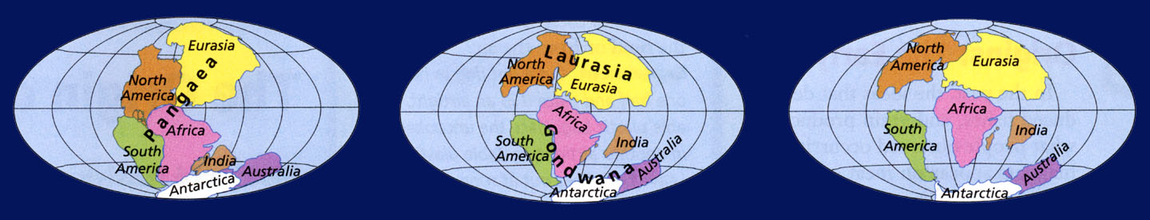
Continental drift is the movement earth’s land masses over Earth’s surface through geologic time
Based on the theory of ___________ ___________, which states that earth consists of rigid ___________ slowly moving over a _____________ layer of rock
- At the beginning of the Mesozoic, the continents were grouped together into one super continent called _______________
- By the _______ of the Mesozoic, the continents were much closer to their modern positions

Cenozoic Era
- ____________ and shortest era so far
- The modern human species, __________
___________
may have appeared as recently as ___________ years ago
- Distinguish between the two groups of prokaryotes
  - Archaebacteria
  - Eubacteria
- Describe the evolution of eukaryotes

- Recognize an evolutionary advance first seen in protists.
- Summarize how mass extinctions have affected the evolution of life on earth
- Relate the development of ozone to the adaptation of life on land
- Identify the first multicellular organisms to live on land
- Name the first animals to leave the oceans
- List the first vertebrates to leave the oceans

