**Chapter 4: Photosynthesis and Cellular Respiration**

Why It’s Important: Every cell in your body needs ______________ to function. This energy is acquired through photosynthesis and cellular respiration

|  |  |  |
| --- | --- | --- |
| Objectives | Vocabulary | |
| * **Analyze** the flow of energy through living systems. * **Compare** the metabolism of autotrophs with that of heterotrophs. * **Describe** the role of ATP in metabolism. * **Describe** the experiments that led to an understanding of photosynthesis * Summarize how energy is captured from sunlightin the first stage of photosynthesis. * **Analyze** the function of electron transport chains in the second stage of photosynthesis. * **Relate** the Calvin cycle to carbon dioxide fixation in the third stage of photosynthesis. * **Identify** three environmental factors that affect the rate of photosynthesis. | Section 4.1   * ATP * ADP * Chemosynthesis * Photosynthesis * Autotroph * Heterotroph * Cellular respiration   Section 4.2   * Pigment * Chlorophyll * Carotenoid * NADP+ * NADPH | * Thylakoid * Granum / grana * Stroma * Thylakoid * Light-dependent reactions * Light-independent reactions   Section 4.3   * Photosystem * Electron Transport chain * ATP synthase * Calvin Cycle |

* What is metabolism?

|  |  |
| --- | --- |
| Energy in Living Systems | |
| Untitled-1 copy | Directly or indirectly, almost all of the energy in living systems needed for metabolism comes from the ____________ |

* **Metabolism** involves either _____________________ molecules or _________________ down molecules in which energy is stored.
* **Photosynthesis** is the process by which ___________ energy is converted to _____________ energy
  + This chemical energy is stored in the organic compound _____________, which is a plant’s _______
  + Often, plants convert glucose to ___________, which can be stored in ________ and ________ for later use
  + Organisms that carry out photosynthesis are called ___________________

**Equation for Photosynthesis**

______________ + ______________

______________ + ______________

* What are the reactants? What are the products? Which substance acts a catalyst?
* How did we learn about photosynthesis?
  + The work of three major scientists has led to our understanding of photosynthesis
    1. _________________________
       - ______ century Dutch physician who devised an experiment to find out where the _______ of a growing tree comes from

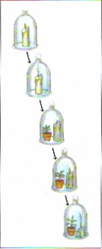

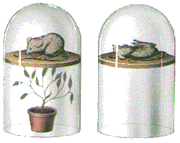

* + - * Carefully found the mass of a pot of dry ______ and a small ___________
      * Planted the seedling in the pot of soil, took care of it and _________ it for five years.
      * At the end of five years, the seedling had grown into a small tree. The tree gained a mass of about 75 kg, while the mass of the soil was almost unchanged
      * Conclusion 🡪 The mass of a tree comes from ________ because it was the only thing he added to the soil
    1. _________________________
       - English scientist who conducted an experiment nearly _______ years after Van Helmont
       - Placed a glass jar over a burning candle & watched as the flame gradually _______ out and concluded that something in the air was needed for the candle to continue burning
       - Priestley ran the experiment again with a small __________ in the container
       - After a few days, Priestley attempted to relight the candle with a burning ___________.
       - It _______________!
       - Conclusion🡪 Plants produce _____________, which allowed the candle to burn
       - Priestley did similar experiments with plants and ________…he discovered that oxygen is also necessary to sustain animal life. While unintentionally cruel, this discovery was very important. Previously, scientists believed that “air” was an element and did not know that it contained ______________ gases
    2. _________________________
       - Dutch scientist who conducted Priestley’s experiment in the presence and absence of ________________________.
       - Observed similar results only in the presence of ________________
       - Conclusion🡪 __________________ is necessary for plants to produce oxygen
  + The work of Van Helmont, Priestley, and Ingenhousz constructed part of the chemical equation for photosynthesis

Light Energy

____ + H20 ------------------- > C6H1206 + O2

* + What reactant(s) was/were contributing to the carbon and oxygen and in glucose?
  + In the 1950s, scientists placed radioactive _______, or tags on the ____________ in CO2 and H20 to track their reactions during photosynthesis
  + Result 🡪 The oxygen in CO2 was incorporated into _________________ and the oxygen in H20 was released as a ______
* The **chemical energy** in organic compounds can be transferred to other organic compounds or to organisms that _______________ food.
* Organisms that must get energy by consuming other organisms are called **____________________**
* Examples… Rabbits consume _________________ & A fox consumes _____________
* Both plants and animals need a way to ___________ down their food so that it can be _______ to carry out cellular activities. Organisms do so in a process called ________________________ _______________________
  + This process converts the chemical energy stored in glucose or starch into a _____________ form of energy called _________

**Cellular Respiration Equation**

______________ + ______________

______________ + ______________

* What are the reactants?
* What are the products?
* Which substance acts as a catalyst?

How are the equations for cellular respiration and photosynthesis related?

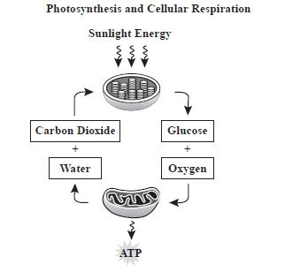

* **Transfer of Energy to ATP**
  + When cells break down food molecules, some of the energy in the molecules is released as _______, while the remaining energy is stored in ATP.
  + Like money, ATP is a portable form of energy _______________ inside cells
  + It delivers energy wherever energy is needed in a cell
* Breakdown of Starch

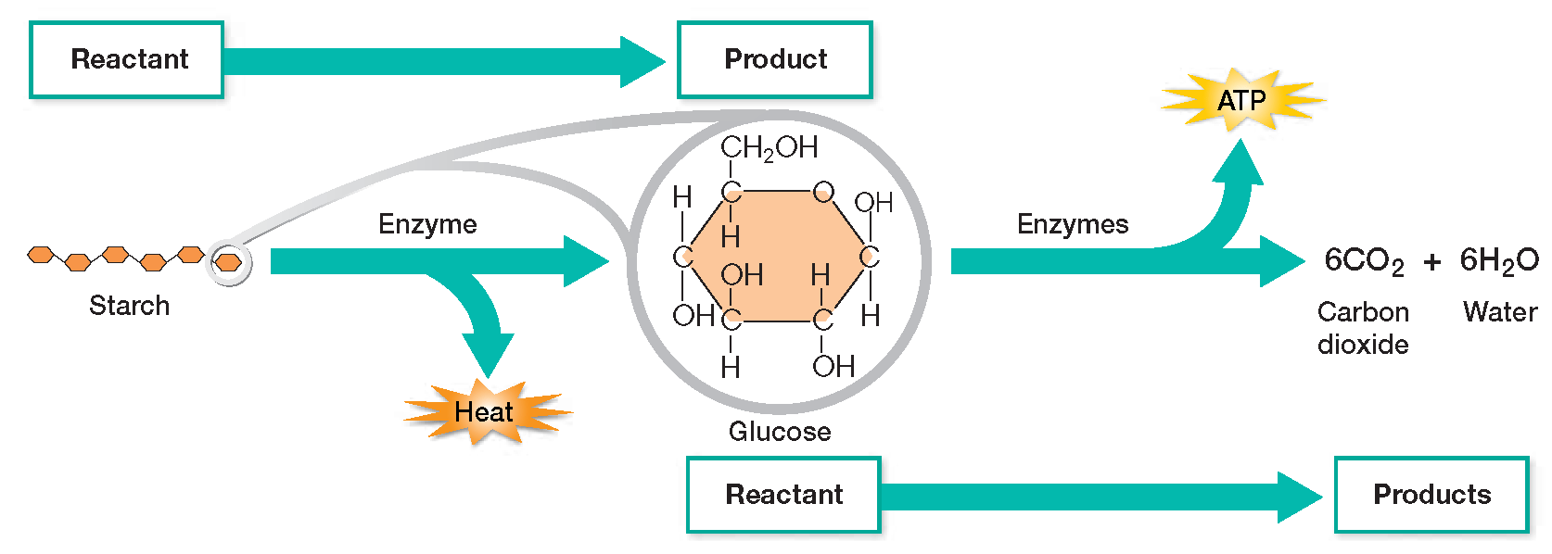

**ATP**: , which stands for ______________ ________________, is actually a ___________ with __________ extra energy-storing phosphate groups.

* **What are the three basic parts of a nucleotide?**
* Where is energy stored in ATP?
* So ATP is made up of a….
  + _____________________(ribose)
  + ______________________________
  + ______ phosphate groups
* Energy is released when the bonds that hold the phosphate groups together are _____________
* The removal of a phosphate group from ATP produces ADP, which stands for ______________________ __________________
* H2O + ATP 🡪 ADP + P + energy
* ATP Releases Energy

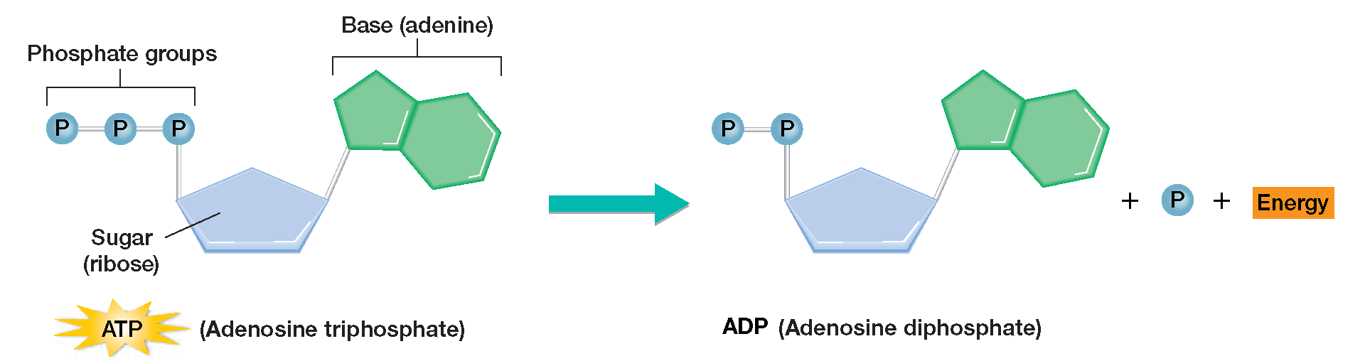

**Photosynthesis occurs in three stages**

* **The Light-dependent reactions**
  + **Stage 1** Energy is _________________________ from sunlight.
  + **Stage 2** Light energy is converted to chemical energy, which is temporarily stored in ___________ and the electron carrier molecule _____________________.
* **The Light-Independent reactions/Calvin cycle**
  + **Stage 3** The chemical energy stored in ATP and NADPH powers the formation of _______________ ___________, using ____________.

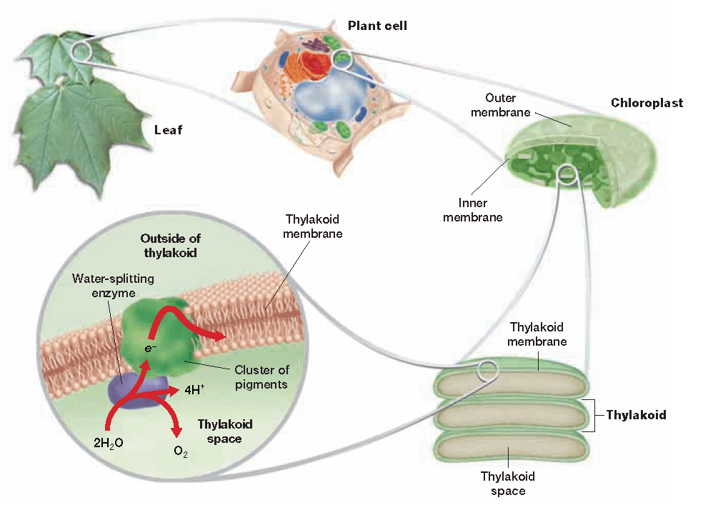

These stages occur in different parts of the _________________

Each green stack inside the chloroplast is called a

__________________

The grana are made up of individual

_____________ which have their own membranes

called ______________membranes

**Photosynthesis**

Stages 1 & 2 occur in the _________________________,while stage 3 occurs outside of the grana in the space called the ___________

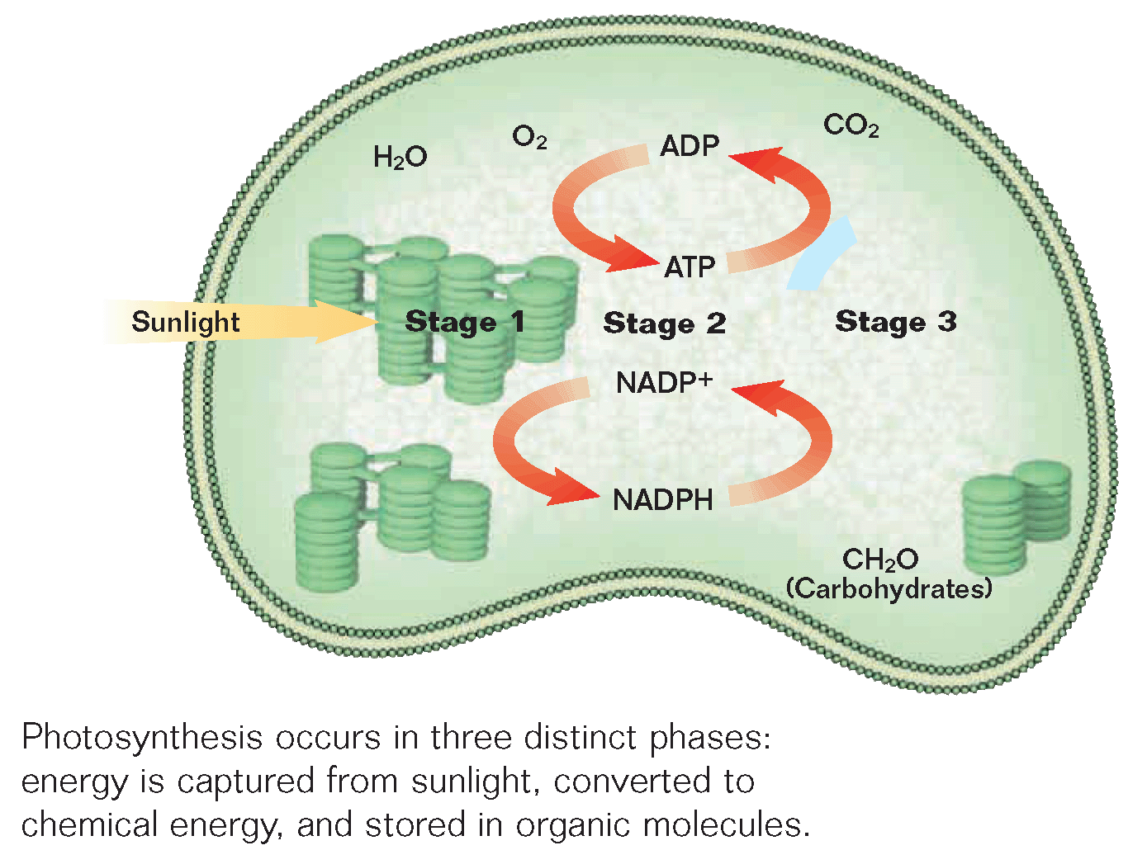

* **Stage One: Capture of Light Energy**
  + Sunlight contains a mixture of all the _______________ (colors) of visible light
  + When sunlight passes through a _________, the prism separates the light into different colors.
  + According to increasing frequency, the wavelengths are…

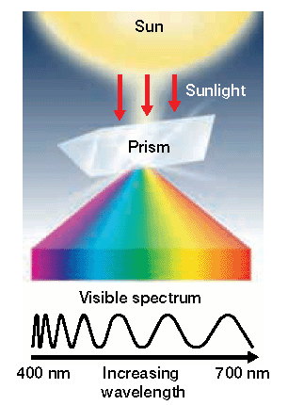

* + - Red
    - Orange
    - Yellow
    - Green
    - Blue
    - Indigo
    - Violet
  + Hint…___________________________
  + Wavelengths that are seen are ________________
    - Think of mirror…what is the image called that you see?

Increasing frequency (energy)

* + - Wavelengths that are not seen are ______________
  + Leaves contain light-absorbing substances called ______________________
    - Chlorophyll ____
    - Chlorophyll ____
      * __________________

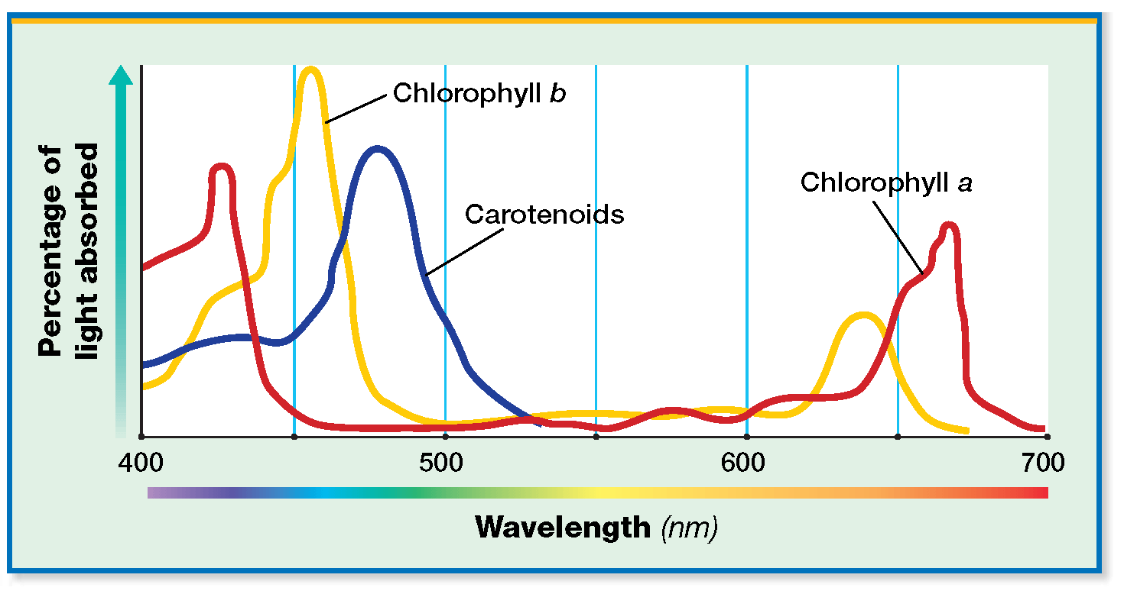

* What colors do chlorophyll b and a absorb?
* So chlorophyll reflects…
* What colors do carotenoids reflect that chlorophyll does not?
* These pigments are embedded in the _____________ membrane which surround the ____________When light strikes the membrane, energy is transferred to _____________ in chlorophyll molecules. This energy transfer causes the electrons to jump to a _________ energy level.
  + When electrons are at the lowest energy level they are at the ____________________ state
  + When they absorb energy, they become _________________ and move to _______________ energy levels
  + Plants first ____________ the sun’s energy when electrons in their chlorophyll molecules absorb its wavelengths
  + Excited electrons eventually move back _______ to the ground state
  + As they do, they release their absorbed _______

Question 1: What molecule that contains chemical energy is produced in photosynthesis?

A. O2

B. CO2

C. C6H12O6

D. H20

Question 2: What is the difference between autotrophs and heterotrophs?

Question 3: An ATP molecule is a nucleotide with two more…

A. Nitrogenous bases

B. Phosphate groups

C. Sugars

D. Glycerol molecules

Question 4: Do chlorophyll molecules reflect or absorb green light?

Question 5: In order of increasing frequency, what do the first letter of each color in visible light spell?

Question 6: Which scientist determined that the process of photosynthesis requires light?

A. Jan van Helmont

B. Joseph Priestley

C. Jan Ingenhousz

**Stage Two: Conversion of Light Energy**

* The absorbed light energy in electrons is used to make three different products…
  + ______________________
  + ______________________
  + ______________________
  + Since these substances need light to be produced, stage two is referred to as the ____________ _________________ reactions
  + First an excited electron _______ to a nearby molecule in the thylakoid membrane.
  + Then the electron is passed down a series of molecules along the membrane called an _____________ _______________ ____________ (ETC)
  + As electrons move down the molecules, they release ____________…
  + Similar to how a bucket brigade loses water

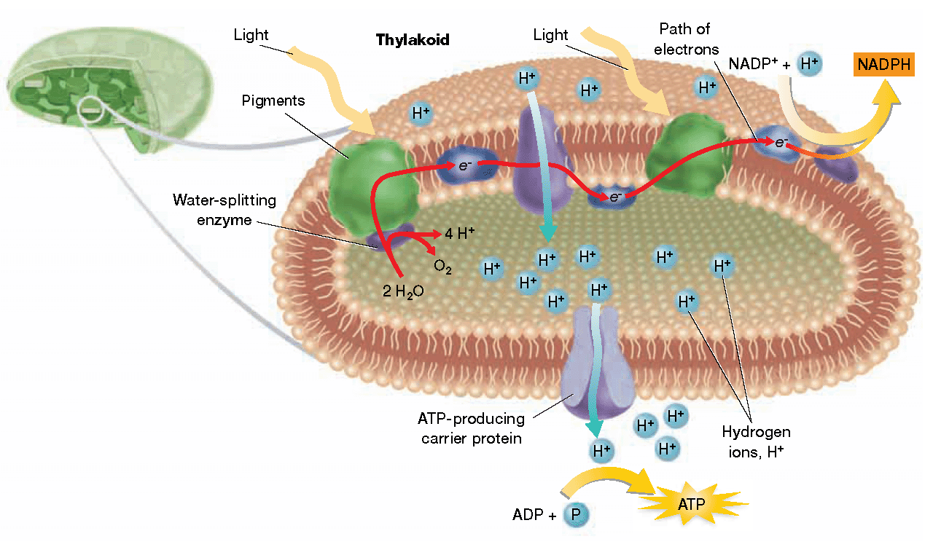

The first electron

transport chain lies between the two green ___________ of pigment molecules

The first pigment cluster is called _________________ (PSII) because it was the second one discovered

-It absorbs energy and releases an excited ______

* The excited electron jumps to the next molecule in the electron transport chain, releasing ____________. This energy is used by a membrane pump that pumps ___________________ ions _______ the thylakoid. This creates a __________ ____ of hydrogen ions inside the thylakoid
* This concentration gradient causes hydrogen ions to ________________ through a transport protein _____ of the thylakoid into the ___________
* The flow of hydrogen ions causes the transport protein to __________
* The spinning action creates a __________ that binds a phosphate group to ADP, producing _______
* Since this transport protein produces ATP, it is called _____________________
* The energy released from the electrons also allows an enzyme to split a ______ molecule into hydrogen atoms and the gas ___
* Chlorophyll molecules replace their excited electrons by taking an electron from hydrogen atoms, leaving them as _______. This allows light energy to excite ___________ electron in PSII
* The second cluster of pigments is called ______________ (PSI) because it was the first one discovered
* The original excited electron from ______ is eventually passed to PSI, where chlorophyll molecules will absorb light energy and __________ the electron again
* These excited electrons move down a ________ electron transport chain, releasing energy
* The released energy is used to bind a ___________ ion to NADP+, which forms ___________
* **NADPH** is an electron ___________ that provides the high-energy electrons needed to make _______in the third stage of photosynthesis

Review…What three products are made during the light-dependent reactions?

**Stage Three: Formation of Organic Compounds**

* In the third (final) stage of photosynthesis, carbon atoms from _________________ in the atmosphere are used to make organic compounds, such as ______________, in which chemical energy is stored.
* The transfer of carbon dioxide to organic compounds is called **carbon dioxide _______________**
* **These reactions do not require light energy, so stage three is referred to as the light ______________________________or ___________________ reactions**

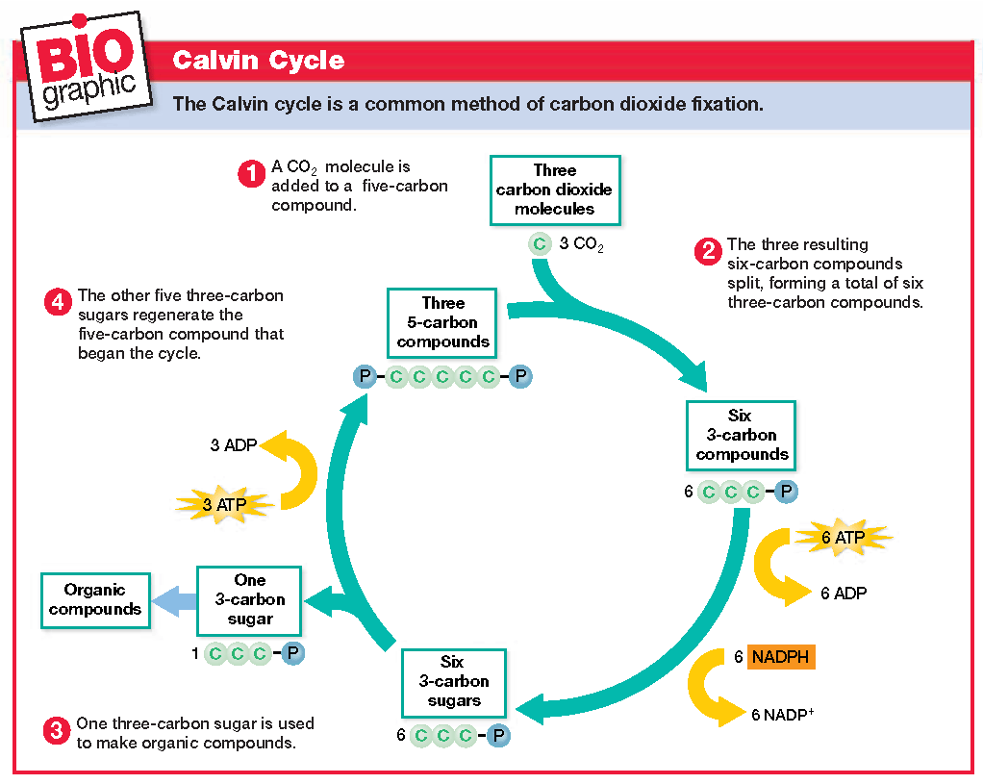

Sugars are formed in the ____________________, which is named after __________ __________, the scientist who discovered it

***Occurs in the ____________

First ____ CO2 molecules are added to ____ 5-carbon compounds called

____________________

____________________

(______________)

* These form 3 unstable ___-carbon compounds that immediately split into ____ 3-carbon compounds called ____________ ____________
* Next, the ATP and NADPH made during the _________ reactions supply _______ for ___ 3-carbon sugars, called ____________ ___________, to be made
* One PGAL is used by the plant to synthesize ___________,while the others regenerate RuBP, which began the cycle
* As shown in the diagram, RuBP needs another phosphate before the cycle can begin again… where does it come from?
* What organic compound does a plant need to make for itself?
  + What is its formula?
  + How many carbon atoms does it contain?
* How many carbons are in the initial sugar produced?
  + So while this diagram shows 3 CO2 molecules, photosynthesis really needs _____
* Fill in the coefficients in the equation for photosynthesis below…

__ CO2 + __ H20 ------------ > C6H1206 + __ O2

* Photosynthesis is directly affected by various environmental factors such as…
  + ________________________________
  + ________________________________
  + ________________________________
* The rate of photosynthesis will increase with light intensity and CO2 concentration, until all of the _________________ are being used or the ______________ cycle cannot process CO2 any faster
* Because photosynthesis involves __________________, it is most _________________ within a specific temperature range

Question 1: In what part of the chloroplast are the electron transport chains located?

Question 2: Which of the following is not a product of the light-dependent reactions?

A. O2

B. glucose

C. ATP

D. NADPH

Question 3: Which molecule is necessary to start the Calvin cycle?

A. O2

B. glucose

C. CO2

D. ADP

Question 4: What two other names are used to describe the Calvin cycle?

**Cellular Respiration**

|  |  |
| --- | --- |
| Objectives | Vocabulary |
| * **Summarize** how glucose is broken down in the first stage of cellular respiration. * **Describe** how ATP is made in the second stage of cellular respiration. * **Identify** the role of fermentation in the second stage of cellular respiration (next class) * **Evaluate** the importance of oxygen in aerobic respiration. | * Aerobic * Anaerobic * Glycolysis * Krebs Cycle * NADH * FADH2 * Fermentation |

* What type of organic compounds are made during photosynthesis?
* Before organisms use the energy in organic compounds, they must convert this energy to _________ during the process of _________________________________
* Remember, ________ organisms respire…even plants. If they don’t respire, they ____________
* _____________________ in the air you breathe makes the production of ATP more efficient, although some ATP is made ______________ oxygen.
  + Metabolic processes that require oxygen are called **__________________________.**
  + Metabolic processes that do not require oxygen are called **_______________________,**
* In the process of cellular respiration, __________________ is broken down to produce ____________ within __________________

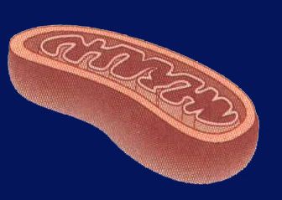

**Structure of the mitochondrion**

* _____ membranes
* Inner membrane is _________
* Space between the two membranes is called the ______________ space
* Space inside the inner membrane is called the mitochondrial ____________

**The equation for cellular respiration is…**

C6H12O6 + 6O2 → 6CO2 + 6H2O + ATP

Which reactant is needed for cellular respiration to be efficient?

In addition to energy, what other products are made?

**The Stages of Cellular Respiration**: Cellular respiration occurs in three main stages:

**Stage 1** Glycolysis: occurs in the ___________________________

**Stage 2** Krebs Cycle: occurs in the ___________________________ _________________

**Stage 3** Electron Transport Chain: occurs along the folded _______________________ membrane

|  |  |
| --- | --- |
| Untitled-11 copy | **Glycolysis**   * Process in which ___________ is broken down into ____________ or _____________ acid * Occurs in the ______________ * Does _________ need oxygen! * 4 steps   + Glycolysis: Step 1     - _____ ATP jumpstart glycolysis     - ____ phosphates from ATP join __________ to form an unstable 6-carbon compound   + Glycolysis: Step 2: This unstable 6-carbon compound immediately breaks into ________ 3-carbon compounds called ________________   + Glycolysis: Step 3 * As glucose is broken down some of its ___________ atoms join _________ to form _____________________, which is an energy storing molecule. The hydrogen atoms are replaced by two more _____________________ groups * Glycolysis: Step 4   + The _______ phosphates bond with 4 molecules of ADP to make 4 ____________ molecules   + The remaining products are two 3-carbon pyruvates, which are ions of ___________ ________   + Remember that 2 ATP are needed to start the process, so glycolysis produces a net gain of ______ ATP |

**Entering the Mitochondria**



The 3-carbon pyruvates are small enough to _______________ through the mitochondrial membranes, where they are each broken down into….

* + One ________
  + & One 2-carbon compound called an ______________________
* This process releases another hydrogen atom which joins NAD+ to make one more molecule of __________
* The acetyl group is attached to a molecule called ______________, (______) forming the compound _________________

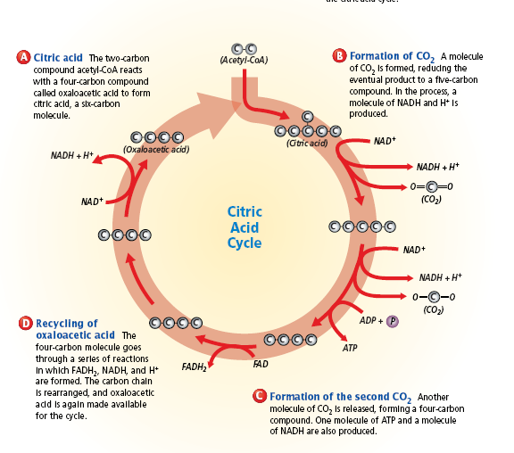

* Each acetyl CoA enters the _________ cycle to start stage 2 of cellular respiration
  + It turns __________, once for each acetyl CoA
  + This cycle is name after ___________________, the scientist who discovered it
  + Occurs in ________ main steps
* Stage Two: Krebs Cycle (Step 1)
  + Acetyl-CoA enters the Krebs cycle by joining a 4-carbon compound called ____________________________________________. The new 6-carbon compound is called ______________________________________________
  + Since this is the first product of the Krebs cycle, it also often called the ___________________ cycle
* Stage Two: Krebs Cycle (Step 2)
  + ______________is released from citric acid, resulting in a _______ carbon compound
* Stage Two: Krebs Cycle (Step 3)
  + ________ is released from the 5-carbon compound, forming a ________ carbon compound
  + So how many molecules of CO2 are made during the Krebs cycle?
* Stage Two: Krebs Cycle (Step 4)
  + The 4-carbon compound is _____________, making oxaloacetic acid available for the cycle again

This cycle also makes energy storing compounds…

* ____ NADH
* ____ ATP
* ____ FADH2

The cycle turns twice for each molecule of glucose that undergoes glycolysis, so it is really…

* ____ NADH
* ____ ATP
* ____ FADH2

**Stage Three: Electron Transport Chain**

* ____________ and ______________ carry high energy _______________________ to the inner membrane of the mitochondria, where they pass through an __________________ _________________________ chain
* The energy released from the moving electrons is used to pump _____________ ions from mitochondrial matrix to the _______________ space. This creates a build-up of hydrogen ions which will _____________ through the ATP _____________ pump, producing __________ amounts of ATP. As the diffusion of water is called osmosis, the diffusion of chemicals, like H+, is called ____________________________ . The last molecule in the electron transport chain to receive an electron is oxygen gas _______. It binds with hydrogen ions to make _________

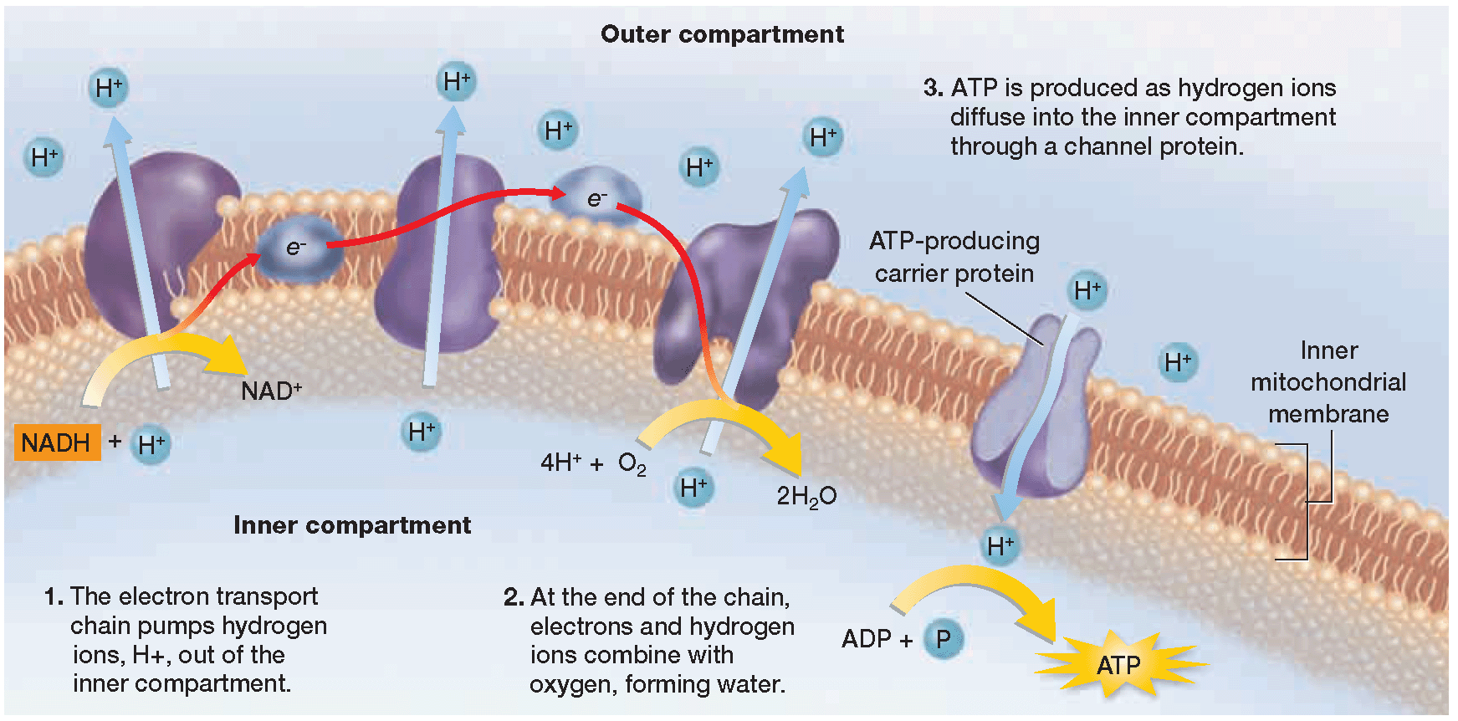

Without ________________, the electron transport chain cannot pass along electrons and it easily gets _____________ or clogged up.

This is why oxygen is so essential for most organisms…without it the electron transport chain will ________ working and ________ will no longer be produced

* The process of making large amounts of ATP in the electron transport chain is called ______________ ______________________
  + Oxidation results when ___________ are lost or donated to other molecules
    - Electrons are _________ from molecule to molecule in the electron transport chain
  + Phosphorylation occurs when a ____________ group is added to a molecule
    - Phosphates are added to _____
* Summary of ATP made during cellular respiration
  + Glycolysis = ____ ATP
  + Krebs Cycle = ____ ATP
  + Electron Transport Chain = ____ ATP to ___ ATP
  + Total… = ____ ATP to ___ ATP

Question 1: What substance is broken down during cellular respiration?

* 1. CO2 (carbon dioxide) c) O2 (oxygen)
  2. H2O (water) d) C6H12O6 (glucose)

Question 2: Why must glucose be converted to 2 pyruvates in the cytoplasm, before these molecules cross through the mitochondrial membranes?

Question 3: What is the first compound made during the Krebs cycle?

* 1. Oxaloacetic acid c) Acetyl CoA
  2. Citric acid d) Pyruvate

Question 4: Which energy storing compound is **not** made during the Krebs cycle?

* 1. ATP c) NADPH
  2. NADH d) FADH2

Question 5: Which molecule is necessary to prevent the electron transport chain from becoming clogged or backed up?

* 1. CO2 (carbon dioxide) c) O2 (oxygen)
  2. H2O (water) d) C6H12O6 (glucose)

**Fermentation**

|  |  |
| --- | --- |
| Objectives | Vocabulary |
| * + **Identify** the role of fermentation in the second stage of cellular respiration.   + **Evaluate** the importance of oxygen in aerobic respiration. | Fermentation  Anaerobic respiration |

* Recall that glycolysis is ________________
* As shown in the diagram, its final product is two molecules of _______________

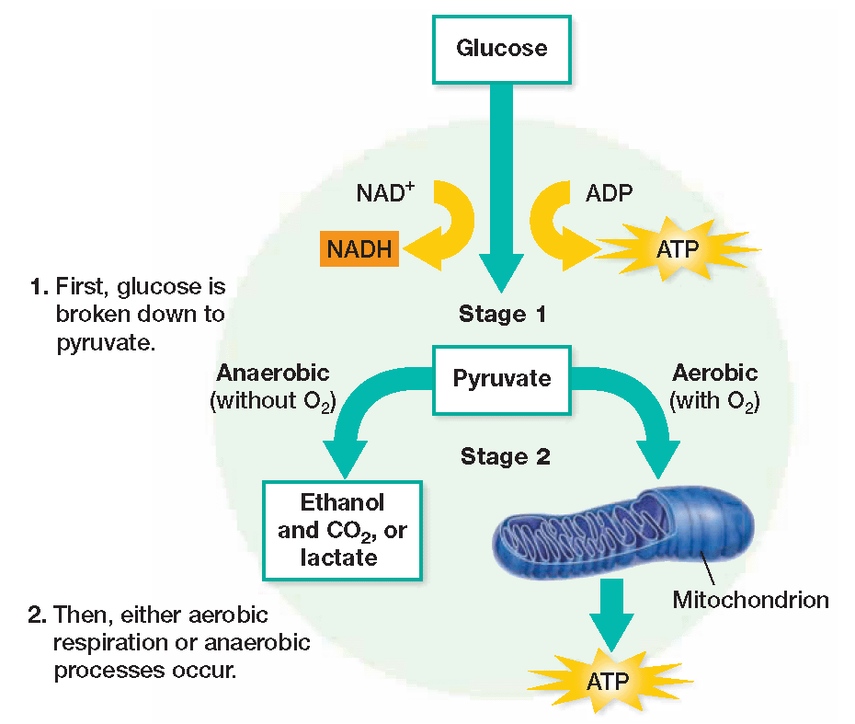

* Once pyruvate is made, either aerobic or anaerobic respiration will continue
* What determines which type of respiration will occur?

**Fermentation**

* When oxygen is not present, cells must produce energy through anaerobic processes called ________________
* There are two types of fermentation
  + _____________________________
  + ______________________________
  + Both follow ______________ because they need one of its products
* Look back at this step in glycolysis…what energy storing compound was made?

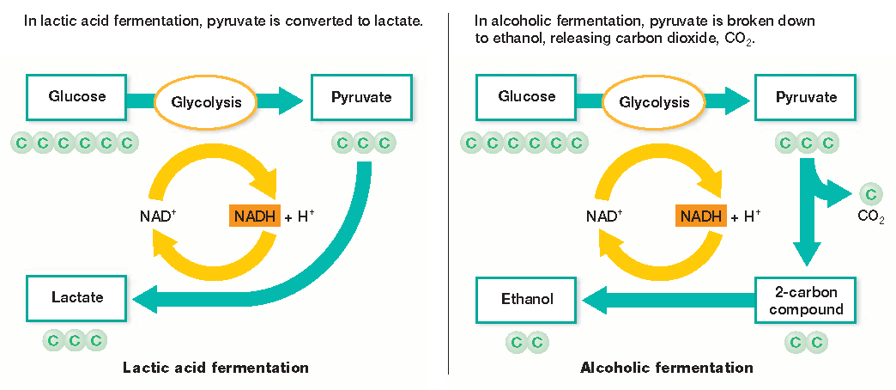

Both types use NADH to make different ________.

When NADH breaks apart, ________ may recycle back to glycolysis, which gains ____ ATP

Look at glycolysis again…what ions are needed to make NADH?

Glycolysis and fermentation constantly _______________ NAD+ and NADH back and forth, so that they may both continue

Fermentation makes much ___________ energy than aerobic respiration, but this is sufficient for simple, ________________________ life forms

|  |  |
| --- | --- |
| **Alcoholic Fermentation** | **Lactic Acid Fermentation** |
| * Carried out by organisms such as yeast * Produces…   + ___________   + ___________   + ___________ * Used to produce wine, beer, and bread * CO2 results in _______________________ or _________________ in the bread | * Carried out by some ___________ and __________________ * Produces…   + ___________   + ___________ * What type of food does “lactate” bring to mind? * Fermenting ________ with anaerobic bacteria produces __________________ * Lactic acid may also build up in ___________ cells * When the average person is exercising and they start to cramp, what do they do? * This allows your body to take in more ___________, and resume aerobic respiration |

ATP production

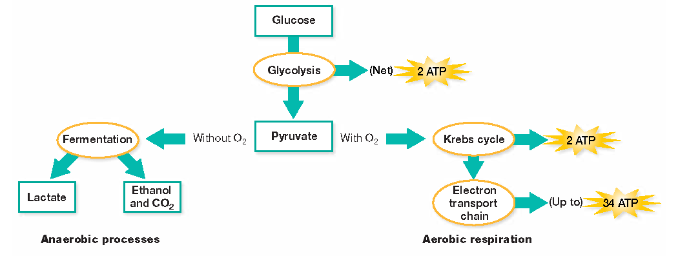

* Fermentation allows _____ ATP molecules to be made,
* Aerobic respiration allows up to ______ ATP molecules to be made

Question 1: Fermentation recycles what molecule back to glycolysis?

* 1. Lactic acid
  2. NAD+
  3. ethanol
  4. CO2

Question 2: List the products of each type of fermentation below.

Alcoholic Lactic Acid