Chapter 8.4 How Proteins are Made
Objectives | Vocabulary
- Compare the structure of RNA with that of DNA.  - Summarize the process of transcription.  - Relate the role of codons to the sequence of amino acids that results after translation.  - Outline the major steps of translation.  - Discuss the evolutionary significance of the genetic code. | Ribonucleic acid (RNA)  Uracil  Transcription  Translation  Gene expression  RNA polymerase  Messenger RNA | Codon  Genetic code  Transfer RNA  Anticodon  Ribosomal RNA  Decoding the Information in DNA  Ribonucleic Acid
Decoding the Information in DNA
- Traits, such as eye color, are determined by _____________ that are built according to instructions ________ in DNA.
- The instructions for making each protein are contained in small segments of our DNA called _______________
- A single molecule of DNA has thousands of genes lined up like __________ ________.
- Proteins, however, are not built directly from DNA…ribonucleic acid or _______ is also involved.
- Like DNA, RNA is a nucleic acid—a molecule made of _________________ linked together.
- RNA differs from DNA in ______ ways
  - RNA consists of a ____________ strand of nucleotides
  - In place of thymine, RNA contains the nitrogenous base _____________
  - In place of deoxyribose, RNA nucleotides contain the five-carbon sugar _______________The only difference between the two sugars is that deoxyribose contains one less ___________
    - So, deoxyribose is said to be ___________________
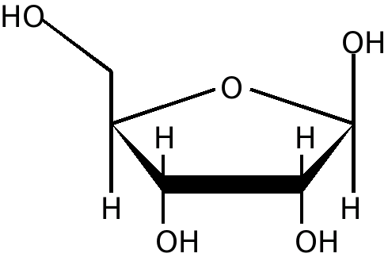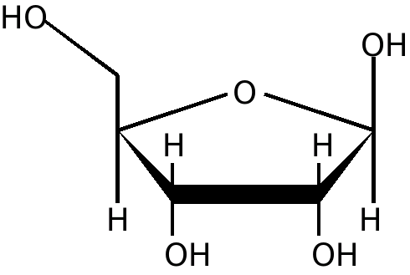
H
Types of RNA
- Additionally, there are three types of RNA
  - Messenger RNA (_________)
  - Transfer RNA (_________)
  - Ribosomal RNA (__________)
Messenger RNA
- mRNA is a _________ strand of RNA nucleotides that is used to acquire DNA’s genetic code
- In a eukaryotic cell, mRNA carries the code ______ of the nucleus in order to make a protein
- Why might it be important for DNA to stay inside of a eukaryotic cell’s nucleus?
Transfer RNA
- tRNA loops up on itself to take on a _________ leaf shape
- This shape is held together by _____________ bonds
- It is used to ___________ amino acids
Ribosomal RNA
- rRNA joins with ______________ to make a structure called a __________________
- Free ribosomes are the __________ or location of protein synthesis
- The instructions for making a protein are ___________ from a gene in DNA to an RNA molecule in a process called _________________. Cells then read the instructions on the RNA molecule to put together the sequence of __________ ___________ that make up the protein in a process called __________________________. The entire process by which proteins are made based on the information encoded in DNA is called gene _______________, or protein _____________.
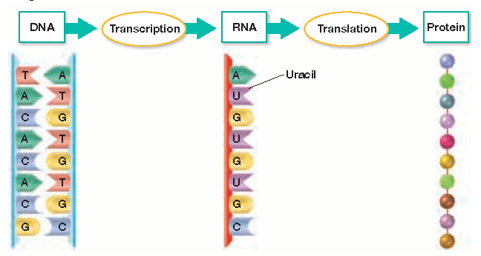

Transcription occurs in three steps
Step 1
______ polymerase, an enzyme that adds complementary RNA nucleotides, binds to a gene’s ________________ site. This site on DNA promotes or _______________ the start of transcription
Step 2
RNA polymerase___________________ and_______________ the DNA strands
Step 3
As it moves along DNA, RNA polymerase adds _________________ RNA nucleotides in order to form __________. Notice that only __________ strand of DNA is used to make RNA…this strand is called the ___________________. As it moves along DNA, RNA polymerase adds _________________ RNA nucleotides in order to form _______________Notice that only _______ strand of DNA is used to make RNA…this strand is called the _____________
- So let’s practice transcribing a strand of mRNA
make complementary mRNA base pairs with the DNA strand below…Remember…RNA does NOT have thymine!
DNA G C A T A C G T A
RNA
- In eukaryotic cells, there are typically about ______ RNA polymerase molecules working on one gene
- The mRNA being transcribed fans out to give the DNA a _______________ appearance
- Also in a eukaryotic cell, the mRNA has to leave the nucleus and enter the ___________________ in order to find a free _________________, which is where a protein will be _________________
- How does mRNA get out of the nucleus?
- In prokaryotic cells, transcription occurs in the cytoplasm, and not in a nucleus…why?

- Compare the structure of RNA with that of DNA

- Summarize the process of transcription.

Objectives
- Relate the role of codons to the sequence of amino acids that results after translation.
- Outline the major steps of translation.
- Discuss the evolutionary significance of the genetic code.
The Genetic Code: Three-Nucleotide “Words”
- In order for a protein to be made, the code stored in mRNA must be __________________
- The code is stored in a series of ________ nucleotide sequences on mRNA called _______________
- Each codon codes for a specific __________ _________ that will be placed in a protein
Codes in mRNA
To determine which amino acid is coded for, find the area on the chart where all three of the nucleotides in a codon _______
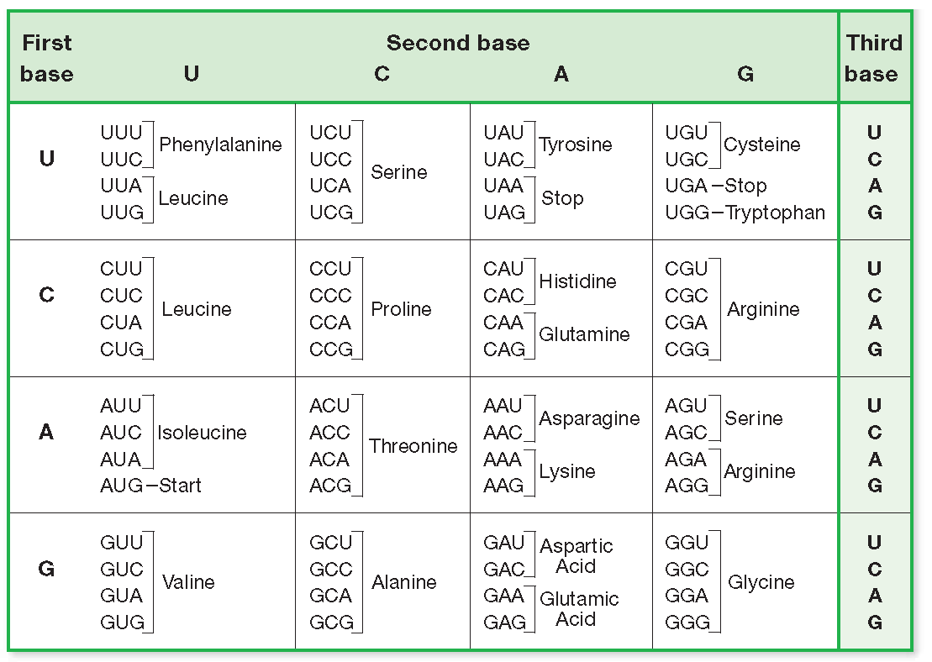
- Practice…What does AUG code for?
- So AUG is a ________ codon, that signals the beginning of translation
  - It codes for the amino acid _________________, abbreviated _____
  - It is found at the beginning of most proteins, but is often ___________ after translation
- What does CCC code for?
- What does GGU code for?
- What does UAU code for?
- What does UGA code for?
  - UGA is a _______________ codon that terminates protein synthesis
- What are the other two stop codons?

- _____ codons signal for the _____ amino acids found in proteins
Why are there so many codons?

- If codons only contained a combination of ____ nucleotides, mathematically there would not be ____________ codons to signal for twenty different amino acids. To determine the amount of nucleotide combinations, you must know how many bases are ______________ and how many bases will be in a _____
- So, how many RNA bases are there?
- If there was only ____ base in a codon, you would raise the number of ______________ bases to the 1st power
4¹ ⁼
- If there are ____ bases in a codon, you raise the number of available bases to the ________ power
4² or 4 x 4 =
- How many different codons are possible if they contain three bases?

- So several different codons code for the _______ amino acid, but each codon only codes for _____ specific amino acid
Translation
- Translation occurs when the three types of RNA work __________________ to assemble a protein
- Recall that a ribosome consists of ______ and ________________. It also consists of _____subunits
- The ribosome will read the codons in ______ as it passes between the
two subunits
- The ribosome also contains two different_______, labeled ____and ____
which hold____________ RNA molecules
- Recall that tRNA molecules are single strands of RNA that _______
up on themselves
- One side of tRNA has an ______________ site that temporarily
carries a specific _______ ____________
- The other end contains an _____________, which is
a series of three nucleotides that will base pair with codons on _______
Steps of Translation
Step 1 Translation begins when the ribosomal subunits, the mRNA, and the tRNA carrying _____________ bind together. If the mRNA start codon AUG codes for methionine, what tRNA anticodon will it base pair with?
Notice that the first tRNA molecule attaches to the ribosome at its ____ site
Step 2 Next, the tRNA carrying the amino acid specified by the codon in the ____ site arrives. If the codon in the A site is UUG, what amino acid does it code for?
What tRNA anticodon will transfer the amino acid to the ribosome?
Step 3 A __________ bond forms between the adjacent amino acids. This bond is catalyzed by a substance called ________ ____________. Previously this substance was thought to be an ____________ but current research indicates that it is a ______ molecule that acts as an enzyme
Step 4 The tRNA in the P site ___________ and leaves its amino acid behind. Scientists have recently discovered that there is an additional site, the ___ site or _______ site, from which the tRNA molecules actually leave
Step 5 The tRNA in the A site ______ to the P site and a _______ tRNA molecule brings in another amino acid. If the new codon in the A site reads CAG, what amino acid will it code for?
What tRNA anticodon will bind with it?
Step 6 Another peptide _______ is formed between the two amino acids, and the tRNA in the _____ site detaches and leaves its amino acid behind.
Step 7 The process is repeated until a ________ codon is reached. The ribosome complex falls __________ and the newly made protein is ____________.
- With few exceptions, the genetic code is the _______ in all organisms
  - For example, the codon GUC codes for the amino acid ___________ in bacteria, birds, plants, and humans
  - For this reason, the genetic code is often said to be ______________
  - From an evolutionary standpoint, it appears that all organisms share a _____________ ancestor with a __________ genetic code
- Relate the role of codons to the sequence of amino acids that results after translation.

- Outline the major steps of translation.

- Discuss the evolutionary significance of the genetic code.

