**Chapter 5: Mitosis Notes**

|  |  |  |
| --- | --- | --- |
| Objectives | Vocabulary | |
| **Identify** four examples of cell division in eukaryotes and one example in prokaryotes.  **Differentiate** between a gene, a DNA molecule, a chromosome, and a chromatid.  **Differentiate** between homologous chromosomes, autosomes, and sex chromosomes.  **Compare** haploid and diploid cells.  **Predict** how changes in chromosome number or structure can affect development. | * Gamete * Binary fission * Gene * Chromosome * Chromatid * Centromere * homologous chromosome | * Diploid * Haploid * Zygote * Autosome * Sex chromosome * karyotype |

**Formation of New Cells by Division**

* Cell division, also called cell _________________, occurs in humans and other organisms at different times in their life. Before a cell can divide, the DNA must first be __________ and then _______________ to new cells
* Why does each new cell need an identical copy of DNA?

**Prokaryotic Cells**

* Prokaryotes carryout a very simple type of cell division called ______________ ___________
* Occurs in two stages:
  + 1st DNA is _____________
  + 2nd the original cell divides into _______ new cells
* The original cell divides by adding a new cell _____________ between the copied DNA. As new material is added, the membrane ___________________ in. Next, a new cell ____________ forms around the membrane. Last, the original cell pinches off into two _______________ cells
* Binary fission is a form of _________________ reproduction because….It only involves a _____________ parent that passes ___________ copies of its DNA to its offspring. So the offspring are __________ copies of the parent prokaryotic cell.

**Eukaryotic Cells**

* Before eukaryotic cells divide, their DNA is ____________ and referred to as _______________
* Recall that DNA is a _____________ helix made up of subunits called _________________. Your DNA is normally uncoiled because the _______________ it contains is being used to make _______________. Recall that specific segments of your DNA, called _______________, code for the production of _____________ proteins
* Before a eukaryotic cell divides, the DNA is ____________, and it __________ up to form a chromosome. First, DNA coils around proteins called _________ to form small structures called ______________. Next, the nucleosomes actually end up coiling __________ on themselves to form a _________________. This supercoil is tightly packed in a structure called a ________________

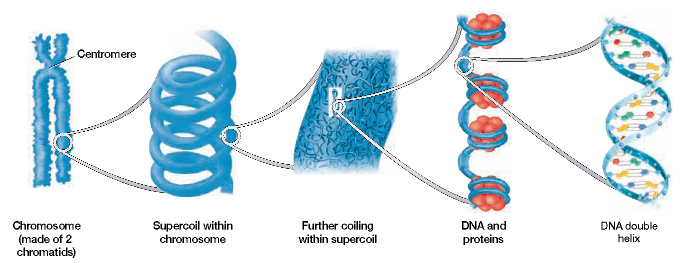

|  |  |
| --- | --- |
| * Chromosomes have two ________________ sides because they contain DNA that has already been ____________. Each side is called a sister _____________ and they are attached at a point called a _________________. These sister chromatids _______________ at the centromere during cell division to ensure that each new cell has the _________ genetic information as the original cell * Different species contain different numbers of chromosomes🡪 Ex: Humans have ______ chromosomes while a dog has _______ chromosomes | **Untitled-1 copy** |

**Asexual Reproduction—Eukaryotic Cells**

* Eukaryotic cells will make _________ copies of themselves during asexual reproduction for four different types of cell division
  + One type is simply for ___________________
  + Eukaryotes may also make new cells for _________________, ________________, or _____________________
* Asexual reproduction only occurs in body cells which are also called ___________________ cells. Examples of somatic cells are _______________, _____________, and ________________ cells. You want these new cells to do the same job as their parent cell, so it is good that they make exact __________of each other. Overtime…the ends of your DNA strands start to deteriorate so your cells ______ and change slightly even though they are “copies”. All of your somatic cells contain ____ chromosomes, which means they are _________ cells. A **diploid** cell is mathematically written as ______, which means they have two _______ of chromosomes…you inherit one set from your _____________ and ____________

**Sexual Reproduction—Eukaryotic Cells**

* ______ pair of your chromosomes are called your _______ chromosomes, because they are involved with determining your ____________. Your other 22 pairs of chromosomes are called ________________.
* Your two sex chromosomes are referred to as _____ and _____
* You inherit one from each parent ______ = male ______ = female
* Females can donate only X’s while males can donate an X or a Y…
* Your _________ cells reproduce sexually because ______ cells are needed to make another cell. Your sex cells, also called _________________, consist of ________ or _________ cells. Gametes are _____________ cells, which are written mathematically as ______, meaning they have a _____________ set of chromosomes. If human somatic cells (2n) have 46 chromosomes…how many chromosomes do gametes (n) have?
* When two gametes _____________, they make a diploid body cell in the process of _______________
* This fertilized cell is called a ____________. The zygote will then continue to grow and develop through ____________ into an ___________ organism
* Interesting Question…If a zygote divides and grows through mitosis, how does our body contain so many different types of cells?
* Developing _________________ consist of ____________ cells that have the ability to ___________________ into different cells. Adults have _______ cells too, but scientists currently think that their ability to differentiate is ________________. In order for sexual reproduction to occur, organisms must inherit ____________ chromosomes, which are similar in ________, ________, and genetic __________
* Your 46 chromosomes are actually ____ sets or pairs of homologous chromosomes
* Having too many or too few chromosomes can result in _____________Abnormalities in chromosome # can be detected in a ________________, which is a ________ of the chromosomes in a dividing cell that shows the chromosomes arranged by ___________
* Sometimes an individual may inherit an incorrect number of chromosomes if the chromosomes fail to ______________________ properly. This type of error is called ___________________. One well known disorder that results from nondisjunction is ___________ ______________

|  |  |
| --- | --- |
|  | 🡨Example: Down syndromThis condition is also called __________________ because it results from having ____________sets of chromosome 21  You can also identify sex in a karyotype. Does this karyotype show a male or female?  Untitled-3 copy |

* Your sex chromosomes are the only chromosomes that are not _______________because they are different in ______________

**Chromosome Mutations**

* Breakage of a chromosome can lead to four types of mutations that are usually ___________ in animals
  + _____________________: Occurs when a gene from a chromosome breaks off or is _______________ during division. A new cell will__________ a certain gene and the __________it coded for

* How is a gene deletion different from a deletion in a frameshift mutation?

* + _______________________: Occurs when a chromosome fragment ___________ to its homologous chromosome . A new cell will have ________ of certain genes and the __________ it coded for
  + ______________________: Occurs when a chromosome fragment breaks off and reattaches in the wrong ____________. Genes will be______ of order and certain proteins may _____be made
  + ___________________: Occurs when a chromosome fragment breaks off and attaches to a ________________________ chromosome. The gene may not be _________ because it is on the wrong chromosome

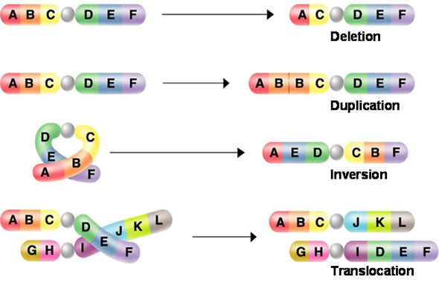

1. **Identify** four examples of cell division in eukaryotes and one example in prokaryotes.
2. **Differentiate** between a gene, a DNA molecule, a chromosome, and a chromatid.
3. **Differentiate** between homologous chromosomes, autosomes, and sex chromosomes.
4. **Compare** haploid and diploid cells.
5. Predict how changes in chromosome number or structure can affect development.

|  |  |  |
| --- | --- | --- |
| Objectives | Vocabulary | |
| * **Identify** the major events that characterize each of the five phases of the cell cycle. * **Describe** how the cell cycle is controlled in eukaryotic cells. * **Relate** the role of the cell cycle to the onset of cancer. | * Cell Cycle * Interphase * Mitosis * Cytokinesis * Cancer | P53  Cyclin  Mutagen  Checkpoint  Oncogene  Mitotic spindle |

**Eukaryotic Cell Division**

* Cell division in eukaryotic cells is more complex than division in bacteria because…
  + DNA is located in the _______________
  + Many other membrane-bound _____________ must also be constructed and distributed to each new cell

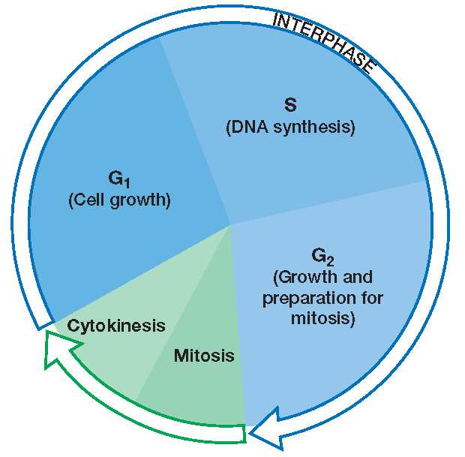

* **The life of a eukaryotic cell is often depicted as a _________**
* The **cell cycle** is a repeating sequence of cellular _________ and ________________ during the life of an organism
* A cell spends _____ percent of its time in the first three phases of the cycle, which are collectively called **_________________**
  + **______**
  + **______**
  + **_____**

**G1 Phase (Gap 1)**

* A period of ___________ growth
* The cell carries out all of its ____________ functions
* Cells that are not dividing ___________ in the G1 phase
  + Example:
    - After you are developed ***some*** of your _____________ and _______________ cells stop dividing and replicating…so it is important to take care of them
* If a cell no longer divides, sometimes scientist say that it is in the ______ stage, because it has left the cell cycle

**S Phase**

* Period during which DNA is __________ or ______________
* To be copied, the DNA must be ___________ out, so it is called ______________
* The two identical copies will form the _______________ in a chromosome

**G2 Phase (Gap 2)**

* Other organelles necessary for reproduction, such as ___________ fibers, are made
  + They consist of _______________ that pull apart the _______________ of chromosomes so that they can be divided between new cells
* After interphase, _______________ occurs, which is sometimes called the _____ phase
* During mitosis, the copied DNA coils up into ______________
* These chromosomes, are passed onto each new cell when the cell divides…but the ______________ ________________ must first disintegrate.
  + A new nucleus _______________ in each new cell
  + Due to this occurrence, mitosis is often referred to as ________________ division
* After mitosis, _________________ occurs. Cytokinesis involves the splitting of the _________________
* Once cytokinesis is complete, the original cell has divided into _______ new, _____________ cells

**Control of the Cell Cycle**

* How exactly does a cell know when to divide… or not divide?
  + The cell has three inspection points, called ___________________ that provide feedback which will _________ or ____________ the occurrence of the next phase

**G1 Checkpoint**

* ____________________checkpoint
* As long as the cell is _________ enough and ________________, cell proteins will trigger the synthesis of DNA

**G2 Checkpoint**

* DNA _______________ checkpoint
* DNA polymerases check and ____________ any errors made while copying the DNA
* If the DNA has been copied correctly, cyclins will trigger the start of _______________
* If too much damage has accumulated in the copied DNA, another protein called _______ can halt division and signal for _____________________, which is cell death…
* Half of all human cancers result from a ______________ or _______________ p53 protein

**M Checkpoint**

* _____________ checkpoint
* Triggers the _________ from mitosis
* Once cell division is complete, a cell will reenter the _____________ stage

**When Control is Lost 🡪 Cancer**

* Certain genes, called _________________, contain the information necessary to make the proteins that regulate cell growth and division.
* If one of these genes is ________________ or ________________, cell reproduction may occur at an uncontrolled rate
* The uncontrolled replication of cells results in _________________________
* What are some factors that can damage or mutate your cells?
  + Any factor that can cause your cells to mutate is called a __________________
* Once damaged…
  + The cell loses ______________ of the cell cycle
  + _________________ division occurs
  + A ___________ forms, blocking ______________ from reaching nearby healthy cells
  + If you develop cancer in somatic cells, like your lung cells, will your offspring inherit lung cancer?

1. Identify the major events that characterize each of the five phases of the cell cycle
2. Describe how the cell cycle is controlled in eukaryotic cells
3. Relate the role of the cell cycle to the onset of cancer

|  |  |
| --- | --- |
| Objectives | Vocabulary |
| * **Describe** the structure and function of the spindle during mitosis. * **Summarize** the events of the four stages of mitosis. * **Differentiate** cytokinesis in animal and plant cells. | * Spindle * Prophase * Metaphase * Anaphase * Telophase * Cell plate * Cleavage furrow * Kinetechore |

* Once cells pass the G1, DNA is ________________
* Each copy of the DNA is then separated into _____ new cells through the process of _______________
* Chromosomes are actually pulled apart with the help of a ________________
* A spindle consist of ________________ and individual ____________ which are made up of _______________

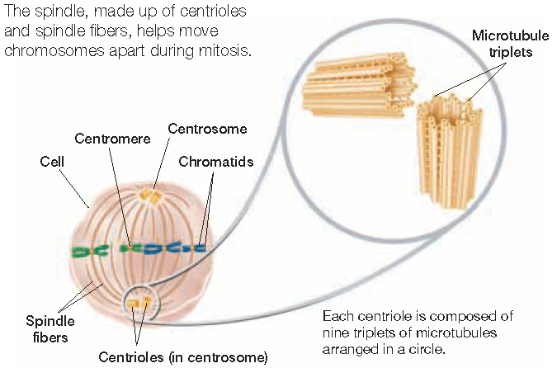

At the beginning of mitosis, the centrioles move to areas on the opposite poles of the cell called __________________. The centrosome organizes the formation of the ____________

As the centrioles move, the spindle fibers begin to form and _____________ towards the chromosomes

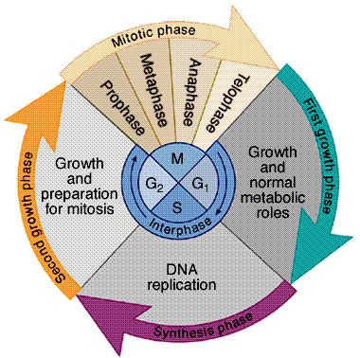

* Scientists are unclear about the role of centrioles in cell division, because they are not necessary for spindle _________________. Plant cells, which do not have centrioles, form a spindle that is almost ________________ to those in animal cells

**Separation of Chromatids**

* The two _______________ that make up a chromosome are moved to each pole of the cell in a manner similar to bringing in a fish with a fishing rod and ___________
* When the microtubule “fishing line” is “reeled in,” the chromatids are ______________ to opposite poles.
* When the chromatids separate, you may call each one a _________________

Mitosis actually occurs in ______ continuous phases…

|  |  |  |
| --- | --- | --- |
|  | Description | Picture |
| **Prophase** |  |  |
| **Metaphase** |  |  |
| **Anaphase** |  |  |
| **Telophase** |  |  |
| **Cytokinesis** | In animal cells, cytokinesis actually begins during _______________. A belt of protein __________ pinches the cell in half. This indentation is called a ___________  In plant cells, vesicles containing ____________ begin to congregate between the two nuclei. These vesicles begin to fuse, forming a cell _______________, while the cellulose is used to form a cell __________. As the new cell wall forms in between the cell membranes, this structure is called a cell _________ |  |

End result of mitosis🡪 A diploid parent cell has been divided into two, identical ____________ daughter cells. These new cells are small and will begin to grow during the _____ phase of interphase

1. **Describe** the structure and function of the spindle during mitosis.
2. **Summarize** the events of the four stages of mitosis.
   1. Prophase
   2. Metaphase
   3. Anaphase
   4. Telophase
3. **Differentiate** cytokinesis in animal and plant cells