**Cells & Their Environment**

**CH3.4 Diffusion & Osmosis**

* All cells must respond to their environment to maintain stable _______________ conditions

|  |  |  |
| --- | --- | --- |
| Objectives | Vocabulary |  |
| * **Relate** concentration gradients, diffusion, and equilibrium. * **Predict** the direction of water movement into and out of cells. * **Describe** the importance of ion channels in passive transport. * **Identify** the role of carrier proteins in facilitated diffusion. | Passive transport  Concentration gradient  Equilibrium  Diffusion  Osmosis | Hypertonic solution  Hypotonic solution  Isotonic solution  Ion channel  Carrier protein  Facilitated diffusion |

* One way cells maintain homeostasis is to control the movement of substances across their cell ________________
  + When this process does not use energy, it is called ______________ transport
  + When this process does use energy, it is called ___________ transport

**Diffusion**

* One type of passive transport is called _____________________
* It is the result of the ____________ motion of particles, which was first observed by Robert ______
  + Using a microscope, he observed pollen grains in water
  + He noticed that the grains were moving in little ___________, like they were being struck by invisible objects
  + The invisible objects were _________ particles
* The random motion of particles is similar to balls bouncing in a closed room
* If a door is opened, balls will randomly bounce off of each other moving from an area of ___________ concentration to an area of __________concentration



* This difference in concentration is called a concentration ________________
* It is natural to move ________ the gradient, following the ______ to _______ pattern
* This is similar to swimming with the flow of a river…it requires no _______________
* The particles continue to follow the gradient until they are _____________ distributed
* At this point, they have reached ______________ ________________
* They still continue to randomly move, which is ____________, but there will be no net change in concentration, representing ____________________

Sometimes particles in a solution, called ____________, diffuse across a semi-permeable membrane

-This process is called _______________

-Kidneys usually carryout dialysis, by filtering ___________ out of our blood

-If kidney failure occurs, a patient will receive dialysis treatment with a ________________

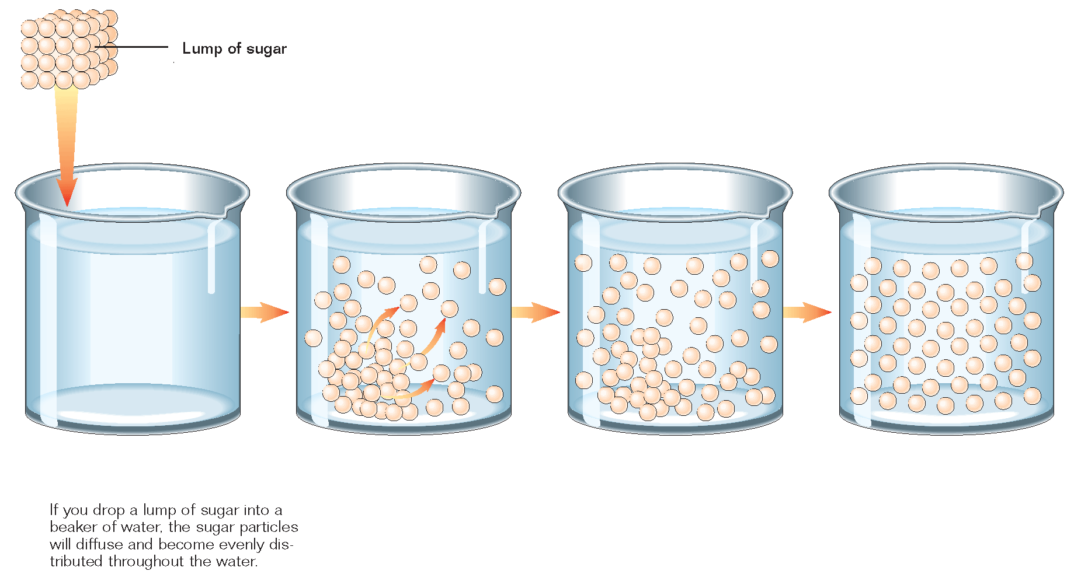

* Only certain substances can diffuse through the cell membrane due to its lipid bilayer structure
* Review…
  + The phosphate heads are ______________
  + The fatty acid tails are _____________
* Since “like dissolves like,” the polar heads will repel ______________ substances and the nonpolar tails will repel _____________ substances
* Only _______substances will diffuse through the cell membrane

**Osmosis**

* Another type of passive transport is __________
* It is specifically the diffusion of ___________ across the cell membrane
* Even though water is __________, it is ___________ enough to pass through the nonpolar tails

Before Osmosis

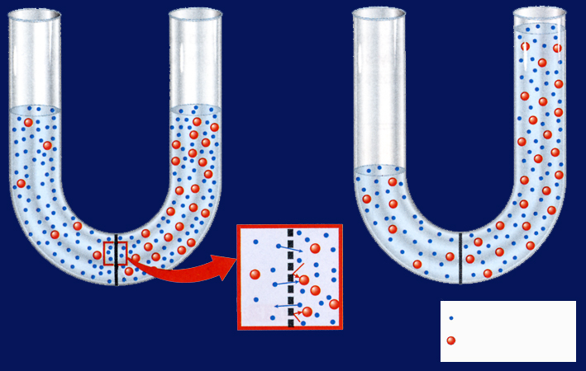

* On which side of the membrane are there more sugar molecules?

*___________*

* *Sugar molecules are too _______ to pass the membrane*

After Osmosis

* Water has moved to the _________ so that there is an equal concentration on both sides
* There are three types of solutions that will affect how water diffuses into or out of the cell
  + ______________________________________ solution
    - Hypo- means _________solute, so a hypotonic solution contains a lower concentration of particles than are found inside the cell, more water
    - These particles cannot move across the membrane
    - Only water can move
    - So where is there a higher concentration of water, outside or inside the cell?
    - Where does this water want to diffuse?
    - This will cause the cell to ___________
    - In plant cells, this increases _________ pressure
    - When plant cells are full with water, they stand __________
    - But if there is too much pressure, plant cells can become ______________
    - Animal cells lack a strong cell wall
    - What do you think will happen to them if they swell too much?
  + ____________________________ solution
    - Hyper- means _________, so a hypertonic solution contains a higher concentration of particles than are found inside the cell
    - So where is there a higher concentration of water?
    - Where does the water want to diffuse?
    - This will cause the cell to ___________
    - Because of this, plant cells decrease in turgor pressure and _________
    - When the cell membrane pulls away from the cell wall of a plant cell it is said to be __________
    - This process is called _____________________

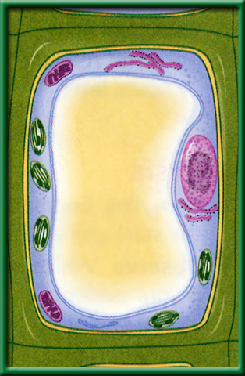

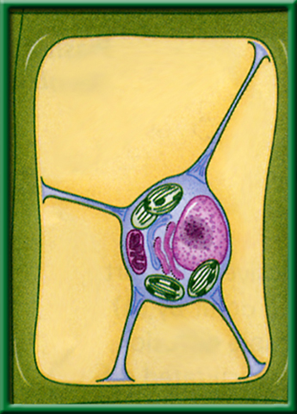

* + ____________________________ solution
    - Iso- means _________, so an isotonic solution contains the same concentration of particles that are found inside the cell
    - So water will diffuse_________________ into and out of the cell because it is in dynamic equilibrium

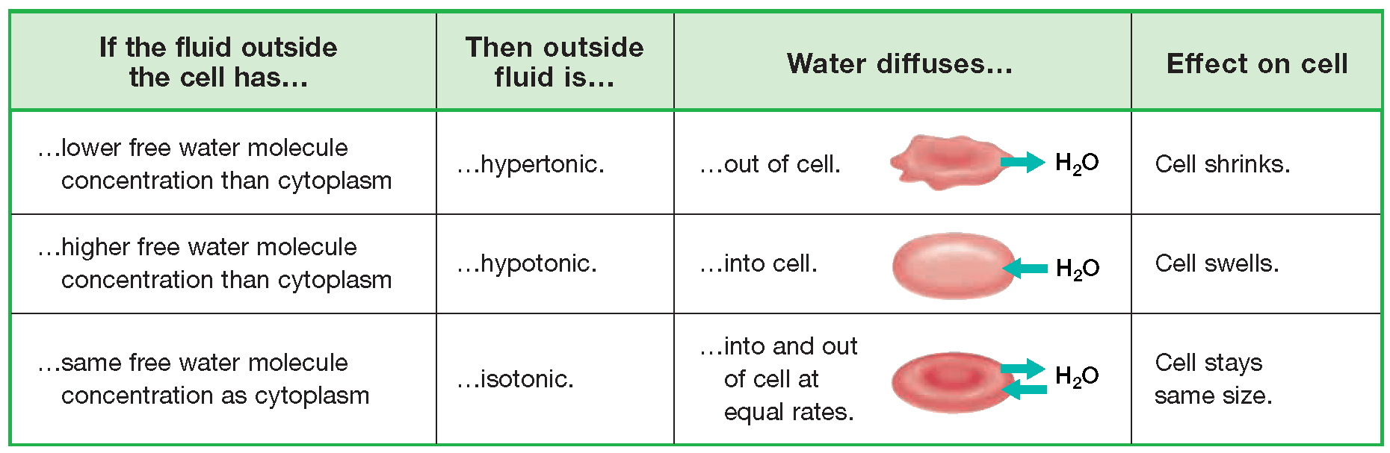

**Diffusion Through Ion Channels**

* Ions have ____________, so they are attracted by ____________ molecules but repelled by ___________ molecules
  + Therefore they can’t pass through the __________
* An **ion channel** is a transport protein with a ________ pore or opening through which ions can pass.

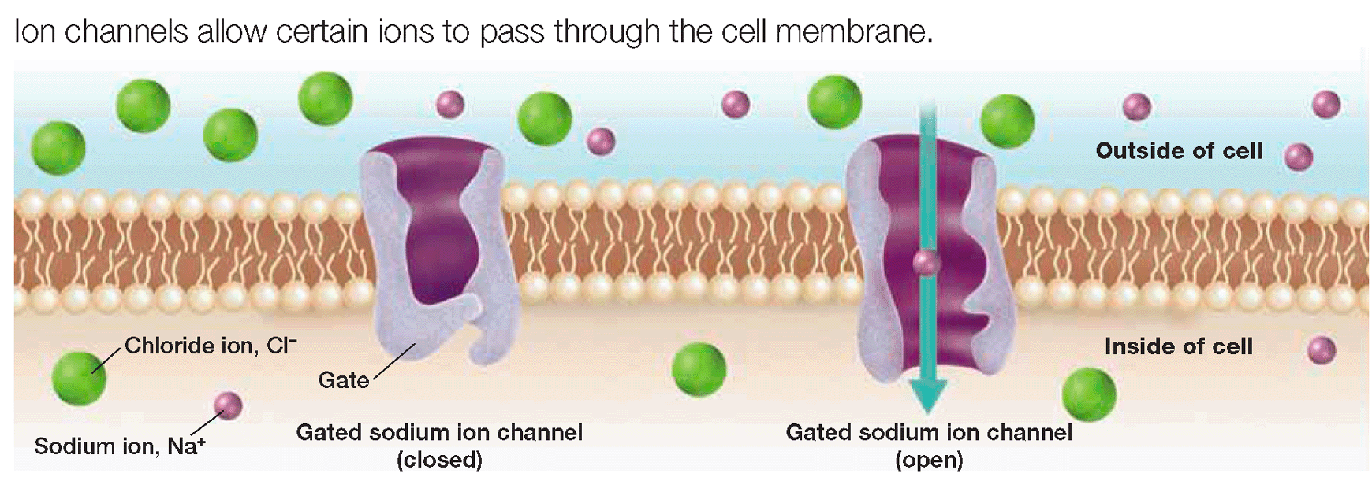

**Electrical Charge & Ion Transport**

* The movement of a charged particle across the cell membrane is also influenced by the particle’s ____________ or ______________ electrical charge.
* The inside of the cell is _________________...
  + So a positive particle will diffuse ___________ the cell
  + And a negative particle will diffuse ___________ of the cell

**Facilitated Diffusion**

* Some substances need help or ______________ to move across the membrane
  + They still move “down” the concentration gradient so this process does not need ____________
* Facilitated diffusion uses transport proteins called _______________ **proteins,** that…
  + ___________ to a specific substance
  + ____________ it across
  + and _____________ it on the other side.
* Used to move larger substances like________________ and _____________ across the membrane

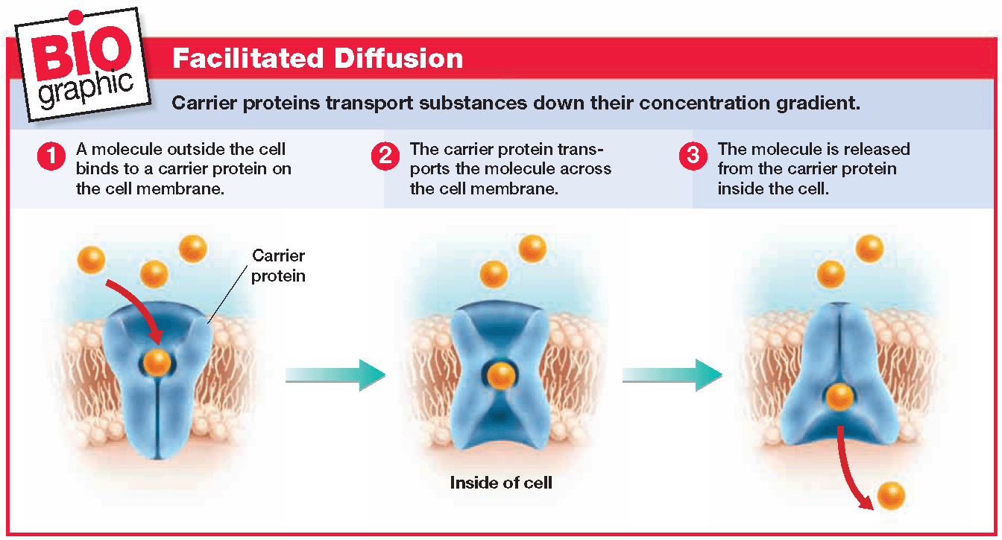

1. What does it mean when particles move “down” a concentration gradient?
2. Which type of solution makes cells shrink?
3. Is the pore of an ion channel polar or nonpolar?
4. What is the charge inside a cell?
5. What kind of transport proteins are involved in facilitated diffusion?

**CH3.5 Active Transport, Endocytosis, & Exocytosis**

|  |  |
| --- | --- |
| Objectives | Vocabulary |
| * **Compare** active transport with passive transport. * **Describe** the importance of the sodium-potassium pump. * **Distinguish** between endocytosis and exocytosis. * **Identify** three ways that receptor proteins can change the activity of a cell. | Active transport  Endocytosis  Exocytosis  Phagocytosis  Pinocytosis |

* Many important cellular substances have a lower concentration outside the cell than inside the cell
* If a cell could only move substances with passive transport, where would these substances

**Movement Against a Concentration Gradient**

* To move certain substances into the cell, they must have a way to move substances

_______________ _________ the concentration gradient…

* + That is from a __________ to ___________ concentration
  + This type of transport requires ____________ so it is called _____________ transport
  + It is similar to how you need energy to swim ___________ the flow of a river
* Most often, the energy needed for active transport is supplied directly or indirectly by _________.
* Some active transport processes use __________ proteins, like those used in facilitated diffusion

So let’s review…A carrier protein…

* + ___________________ to a substance
  + ___________________ it across the membrane
  + ___________________ it on the other side
* However, in active transport, carrier proteins move substances from a ________ to _________ concentration, acting like a membrane __________
* One of the most important membrane pumps in animal cells is a carrier protein called the ___________ - __________ **pump.**
* In a complete cycle, the sodium-potassium pump transports __________ sodium ions, Na+, ______ of a cell and two potassium ions, K+, _____ the cell.

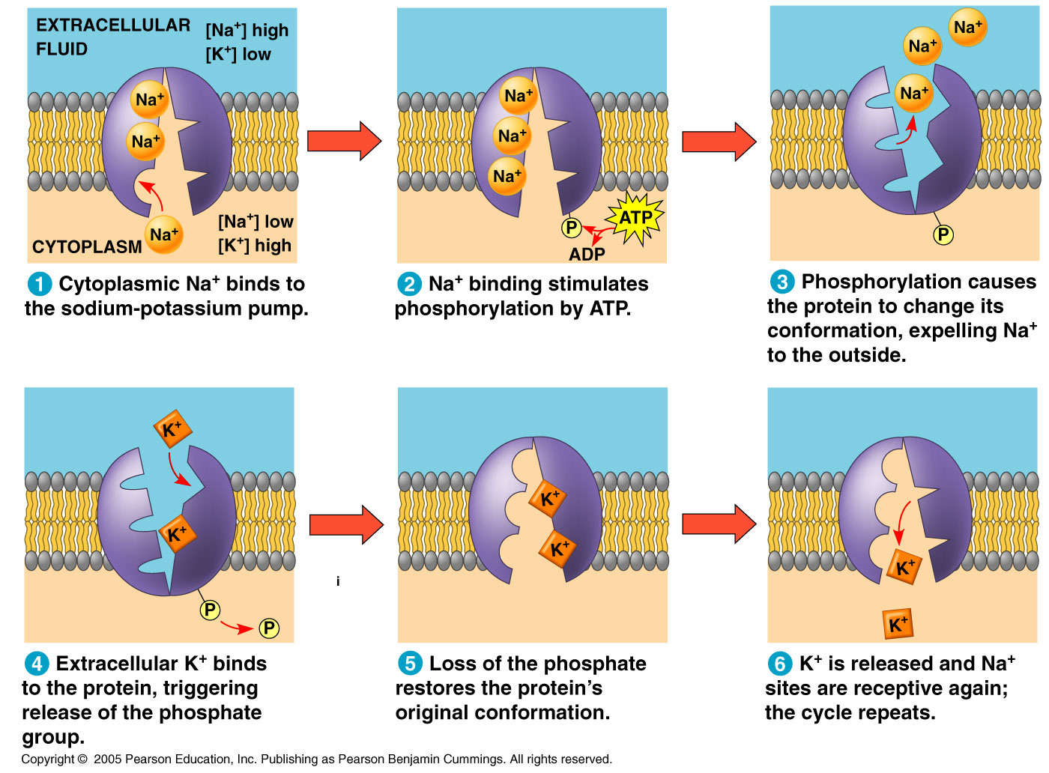

Step 1: _________ sodium ions and a __________ group from ATP bind to the pump

Step 2: The pump changes ________ and transports sodium ions ________ of the cell

Step 3: Two ______________ ions bind to the pump and are transported _________ the cell

Step 4: The phosphate group is ____________ back inside the cell

* Some simpler organisms have a different “pump” called a ______________ vacuole
* It expands and contracts to _________ water out of the cell
* This is important because it lives in a watery environment, which would be a _____________ solution

**Movement In Vessicles**

* Many substances, such as _____________ and ____________________, are too __________ to be transported by carrier proteins.
* These substances are moved across the cell membrane by _______________.
* The movement of a substance into a cell by a vesicle is called **__________________**
  + **Think “en” is like “in”**
* The movement of a substance by a vesicle to the outside of a cell is called ___________________**.**
  + **Think “ex” is like exit**

**Endocytosis**

* The cell membrane forms a _________ around a substance, then ________ off to form a vesicle that transports materials, like ________, into the cell

There are two types of endocytosis

* + Phagocytosis = engulfing

__________ particles like food

* + Pinocytosis = engulfing

____________ particles

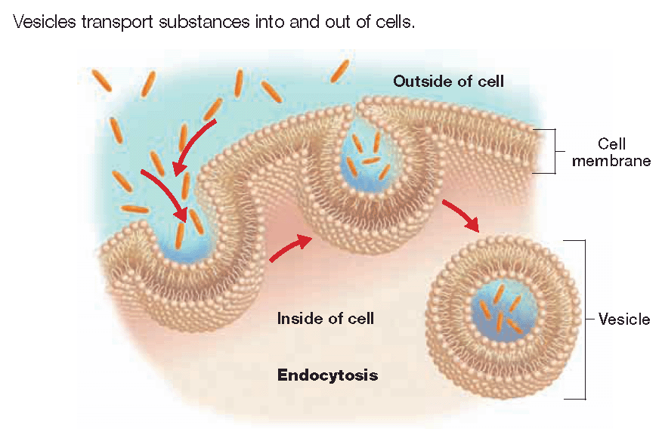

* The vesicle _________ to the cell membrane, which __________ up to release items like _______ or ____________ made by the cell

**Exocytosis**

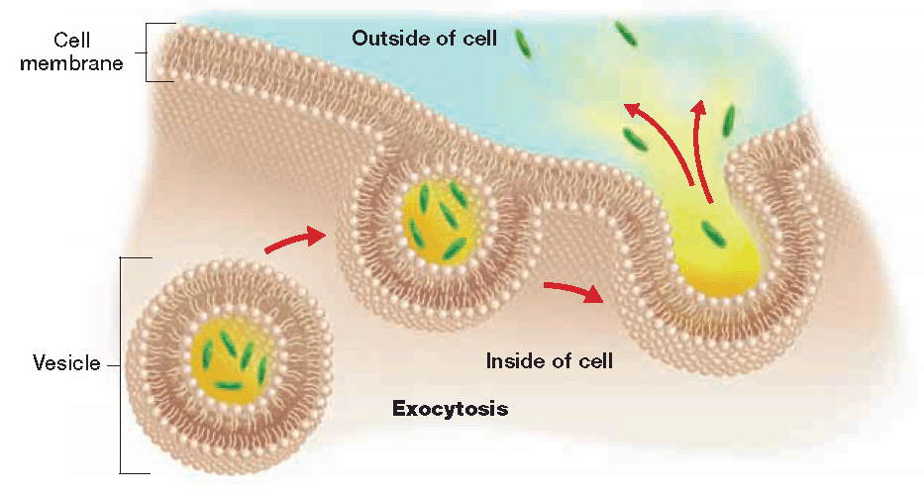

**Membrane Receptor Proteins**

* Cells must ______________ with each other to coordinate your growth, metabolism, and other activities
* To do so, some cells release ____________ ______________ that carry information or ________________ to nearby cells
* Cells can receive the messages because the cell membrane contains specialized proteins, called ______________ proteins, that bind to these signal molecules.
* **When signal molecules bind to receptor proteins, they may cause three different changes in the cell…**
  + Changes in ________________________
  + Triggering the formation of a __________ ______________
  + Activating ________________

**Changes in Permeability**

* The binding of a signal molecule to the receptor protein causes an ion channel to __________, allowing specific ions to cross the cell membrane.

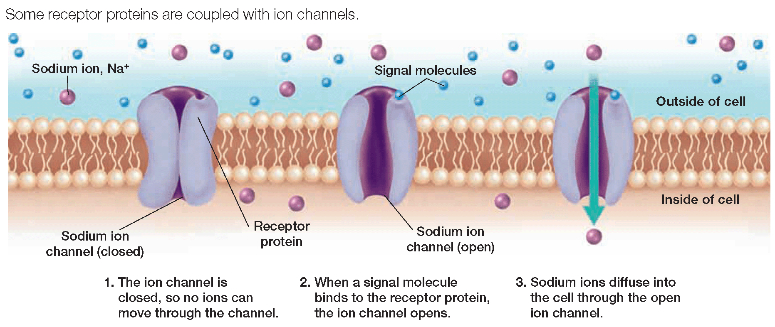

**Second Messengers**

* The original _____________ molecule triggers the production of a second messenger, which may trigger a series of _______________________ reactions in the cell

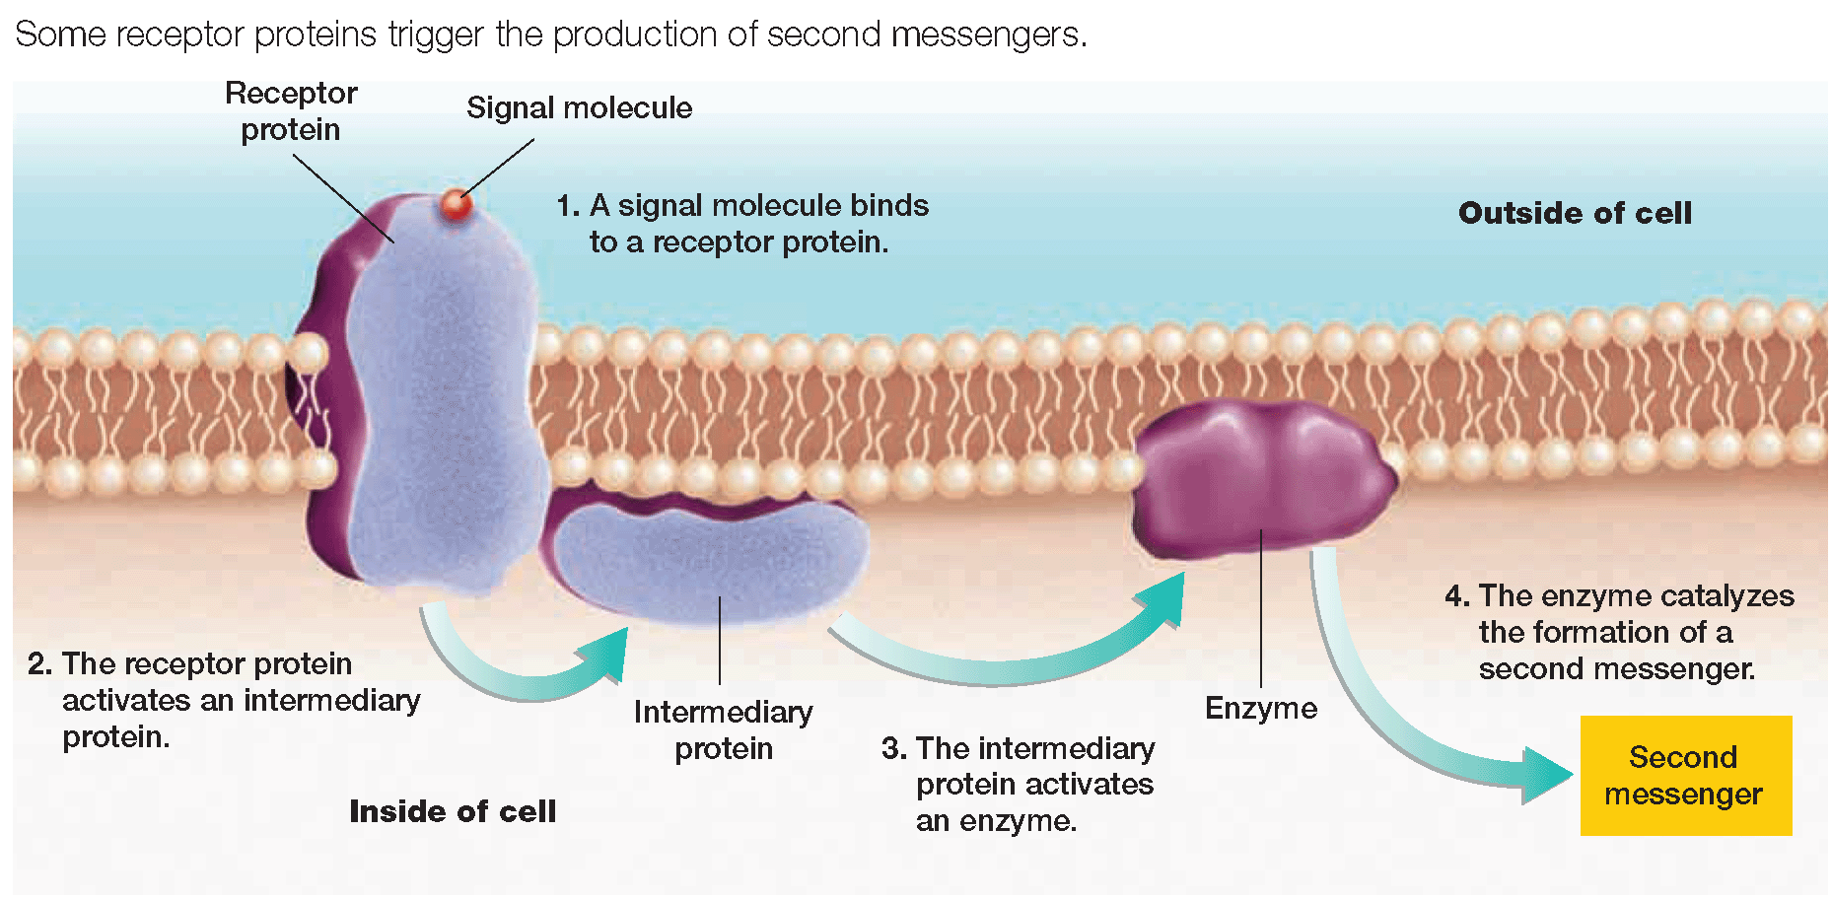

**Enzyme Action**

When a signal molecule binds to the receptor protein, the receptor protein may act as an

_________ _________________,

speeding up chemical reactions inside the cell.

* Many __________ affect the binding of signal molecules to receptor proteins, affecting the function of the cell
  + Examples…
    - The illegal drug heroin __________________ a signal molecule and binds to receptor proteins
    - Prescribed drugs called __________________ _____________ prevent or block signal molecules from binding to receptor proteins in _________________ cells, which _________ down the heart rate of patients with rapid heart beats

1. Which molecule provides energy for active transport to occur?

Chlorophyll ATP Carbon dioxide Signal molecule

1. In the sodium potassium pump, which substances get released inside of the cell?

Sodium ions Potassium ions Phosphate groups Both B and C

1. Which substance would a cell take in through endocytosis?

Sodium ions polysaccharides Amino acids monosaccharides

1. What type of membrane protein interacts with signal molecules?
   1. Cell surface marker
   2. Receptor protein
   3. Transport protein
   4. enzymes
2. Which type of transport may occur in dead cells…passive or active?