Name: ________________________________________________________________________________
- Label the following parts of the neuron. Identify where the neuron receives signals, and draw an arrow in the direction of an action potential.
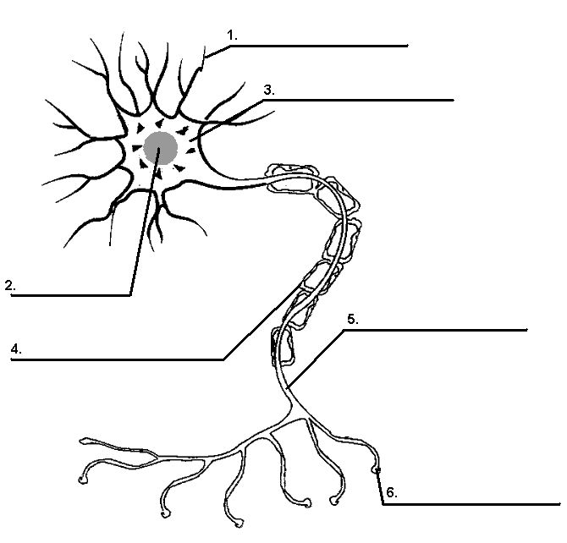
- Explain how an action potential and graded potential are different.

- Describe the following in your own word:
  - Resting potential

  - Hyperpolarization

  - Threshold

  - Depolarization

  - Repolarization

- What triggers an action potential? What happens to the membrane to trigger an action potential?

- What is the role of the voltage gated sodium channels for producing an action potential?

- What is the role of the voltage gated potassium channels?

- What would happen if the voltage gated sodium and potassium channels opened
  - At the same time
  - Farther apart (longer delay)
- What is the absolute refractory period? What is the relative refractory period?

- Consider the following diagrams of a nerve cell membrane. They show resting potential, depolarization, and hyperpolarization. Figure out which one is which and label them.

10. Graph the following set of voltage and time data. Be sure to put each on the correct axis (remember, you independent variable is always on the x-axis and you dependent variable is always on the y-axis. Make sure to title each axis and the graph, scale it correctly, identify your units, and label the following parts:
absolute refractory period depolarization graded potential hyper polarization repolarization action potential (AP) relative refractory period resting membrane potential

