Organic Polymers Lab
Directions: Discuss and answer the following questions in groups and come to a consensus before documenting any answers. All answers can be found in your textbook, notes, journals, and organic polymer chart. Once answers are located, they should be seen and discussed by all members of the group. Read for understanding and answer in your own words when an explanation is indicated. DO NOT WRITE DEFINITIONS OR EXCERPTS DIRECTLY FROM SOURCES!
Each group needs to designate the following roles:
Writer: Writes the answers in the packet and ensures everyone else answers the same.
Manager: Helps keep everyone on task so that time limits are made.
Reader: Reads aloud all box work, objectives, and questions to the group.
Builder: Builds molecules as directions indicate.

Writer: _______________________________________ Reader: ________________________________
Manager: _____________________________________ : Builder: _______________________________
What are the 4 most important classes of polymers important to living systems?
- ____________________________________________
- ____________________________________________
- ____________________________________________
- ____________________________________________
What type of Chemical Reaction is used to build organic polymers? In other words, what are the reactions called that link monomers together (there are 2 different names for this reaction, write them both)?
- ____________________________________________
- ____________________________________________
What molecule must be removed from two monomers to link them together?

What type of Chemical Reaction is used to break down organic polymers? In other words, what breaks monomers apart?
____________________________________________

Model 3:
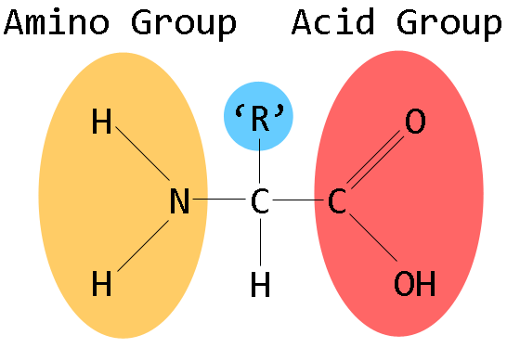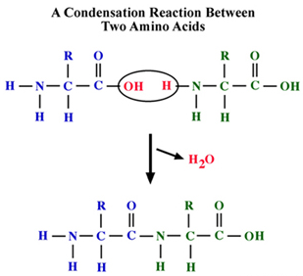
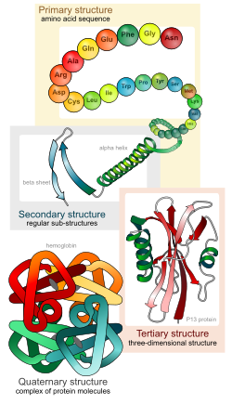

Amino Group Carboxyl Group
Proteins are macromolecules composed of monomers called amino acids. Proteins have many functions in the body including acting as hormones, transporting materials around the body or across cell membranes, acting as catalysts for chemical reactions, and aiding in structural support. Proteins have 4 levels of folding that they undergo to form the correct shape.

Primary level: consists of the sequence of amino acids
Secondary level: is when the amino acids either coil to form a structure known as the alpha helix, or fold to make a pleated sheet
Tertiary level: is when the secondary coils and sheets continue to fold and bend
Quaternary level: is when two different polypeptides interact to form a functional protein

On your pink pieces of paper, put a box around all the R groups in pencil (proline is tricky, do your best!)
For alanine, valine, and methionine; circle the OH- that will leave the carboxyl end, and the H- that will leave the amino end.
What is the special kind of covalent bond that holds two amino acids together called?

Model 5:
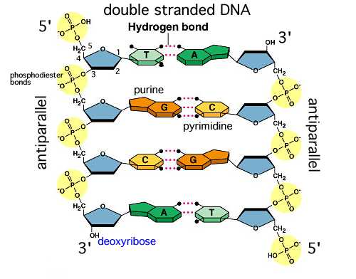
Nucleic Acids are an important class of organic molecules used in heredity. The two nucleic acids are DNA and RNA. Both DNA and RNA are made of monomers called nucleotides. DNA is inherited from your parents in the form of chromosomes. You get one set of chromosomes (23) from your mom, and another set (23) from your dad. DNA provides the instructions to the body on how to build proteins. RNA is the builder of the proteins. We will learn more about this process at a later time.

There are some distinguishing differences between DNA & RNA. DNA is double stranded and in the shape of a double helix. RNA is single stranded and can take many shapes.
Fill in the chart comparing DNA to RNA including, number of strands, shapes, and differences in their nucleotides
DNA | RNA

