Name: | Date:
Class: Honors Biology Period 1 2 3 4 5 6 7 8 9 | Teacher: McQuade
Parts of an Experiment Level 2
Cancer Deaths Among Different Ethnicities
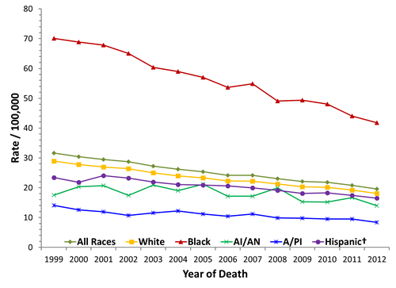
- What is the independent variable, and how do you know?

- What is the dependent variable, and how do you know?

- What group has the highest rate of cancer deaths?

- What 2 groups have the lowest rate of cancer deaths?

- Summarize the overall trend in cancer deaths between 1999 and 2012.

- What kinds of things might account for the different rates of cancer deaths between the different ethnicities? List at least 5.

- Predict if and how you think cancer related deaths will change in the next 10 years. Use evidence from the graph to support your answer.

Parts of an Experiment Level 3
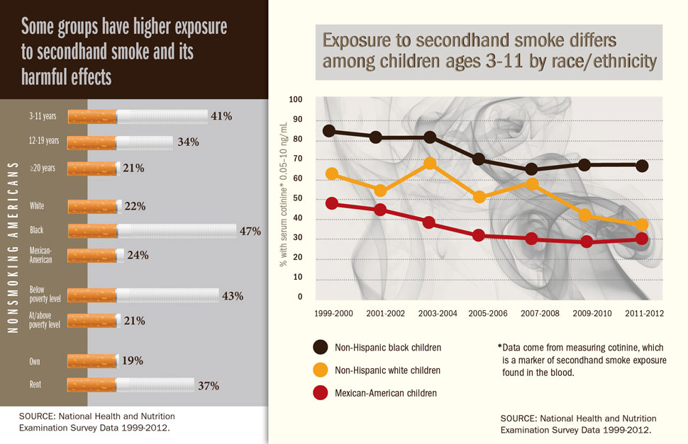
- Based on the data above, write a hypothesis you think the scientist was testing.

- Does the data presented in the graph and chart above support or contradict the data seen in the graph on page 1? Cite evidence from the graphs to support your claim.

Parts of an Experiment Level 4
Design an experiment to test some aspect of cancer diagnosis or prognosis in some group of people. You must include the following.
- The independent variable. ______________________________________________________________
- The dependent variable. ________________________________________________________________
- A control group. _______________________________________________________________________
- Controlled variables (constants)

- A hypothesis that includes the independent variable, dependent variable, and that makes a prediction.

- If your hypothesis is supported, what would you expect to see in your results?

- If your hypothesis is rejected, what would you expect to see in your results?

