RadioLab Podcast: Parasites
Name: ____________________________________________ Class: _____________ Date: _________
- According to the RadioLab podcast, what is it about the scene from “Alien” that makes it so scary?

- In the podcast parasites are said to be “degenerate” because they are not independent. What was the defense Carl Zimmer gives against this claim of degeneracy?

Parasites…. Are they evil or are they awesome

Parasitic Wasps
- How many species of parasitic wasps are out there_______________________________
- What is the host of the parasitic wasp?_________________________________________
- How many times does the wasp sting the host, and what is the purpose of each sting?

- Why does the wasp ultimately do all of this?

- How does the wasp larvae keep the host alive as long as possible

- Why are parasitic wasps compared to neurosurgeons?

Parasitic Nematode
- Why does the ant stick its “big red butt” in the air?

- Where can a nematode reproduce?

Blood Flukes
- Where do blood flukes spend the 1st part of their life

- Where do they go next for their final host

- Blood flukes are types of plants/ protists/ bacteria/ animals/ or fungi?
- How long can blood flukes remain in a person?

Hookworms
- John D Rockefeller set up a commission to figure out what was wrong with the Southerners. What did was the conclusion of this commission?

- What did the southerners look like?

- What was the connection between soil type , anemia, and poverty?

- Why did the doctors ask people where they defecate?

- How was hookworm spreading?

- How far can a hookworm crawl

- How long did it take for them to die?
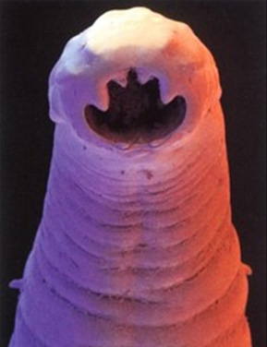

- What major development was invented because of understanding hookworm?

- What was wrong with Jasper Lawrence

- In the developing world, people don’t really have asthma or allergies. Why?

- How did Jasper ultimately get hookworm?

- What is coevolution
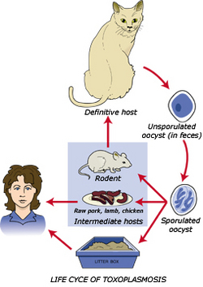
- What does Hookworm do to the immune system?

- What is the Hygiene Hypothesis

Toxoplasma
- What effect can toxoplasma have on pregnant women?

- Where can Toxo reproduce

- What part of the rat does the toxo travel to?

- How does toxo change rat behavior

- Does the lady in the story test positive for toxo?

