CH8.6-8.7: Gene Regulation, Structure, & Mutations
Objectives | Vocabulary
- Describe how the lac operon is turned on or off.  - Summarize the role of transcription factors in regulating eukaryotic gene expression.  - Describe how eukaryotic genes are organized.  - Evaluate three ways that gene alterations can alter genetic material. | - Lac operon  - Repressor protein  - Operator  - Operon  - Transcription factor | - Intron  - Exon  - Point mutation  - Frameshift mutation  - Transposon
Regulation of Gene Expression in Prokaryotes
- Both prokaryotic and eukaryotic cells are able to _______________ which genes are expressed and which are not, depending on the cell’s _________.
  - If specific proteins are not needed all of the time, it would be a ___________ of energy for the cell to continually make them
  - Review…
  - What did we call the sequence of DNA that signals for the start of transcription?
- In prokaryotes, a _______________ protein may bind to DNA in order to ________ or ___________ RNA polymerase from binding to the promoter site and beginning transcription
- The three genes on the prokaryotic DNA strand below are involved with ______________, ________________, and ______________ down lactose
- The entire set of bacterial DNA that controls the consumption of lactose is called the lac ________________
- Recall that lactose is a disaccharide ___________ found in milk
- When you consume dairy products, the lactose eventually makes its way into your _______________, where prokaryotic bacteria must break it down
- When you are _____ consuming dairy, the repressor protein binds to DNA and the series of gene are _________
- When lactose is present, it binds to the repressor protein, changing its ____________, which causes it to _________ off of the DNA strand
- Now it is no longer blocking ______ polymerase from binding with the ______________ site, so transcription may occur and the genes are _______
- The regulation of gene expression in eukaryotes is more _____________ than in prokaryotes for several reasons…
  - Eukaryotes have many more ________ than prokaryotes
    - Typical prokaryote = __________ genes
    - Humans = ____________ genes
  - Similar genes in eukaryotes are not ________ together like in prokaryotes…they are often found on different _______________
  - Additionally, a nuclear _____________ separates transcription and translation in eukaryotes, so there are many more opportunities for gene regulation
    - Regulation may occur _______________, ______________, or ___________ transcription,…but most often occurs at the _____________
Regulation of Gene Expression in Eukaryotes

Special proteins, called _________________
factors and _________________________ help to
arrange RNA polymerase on the promoter site properly

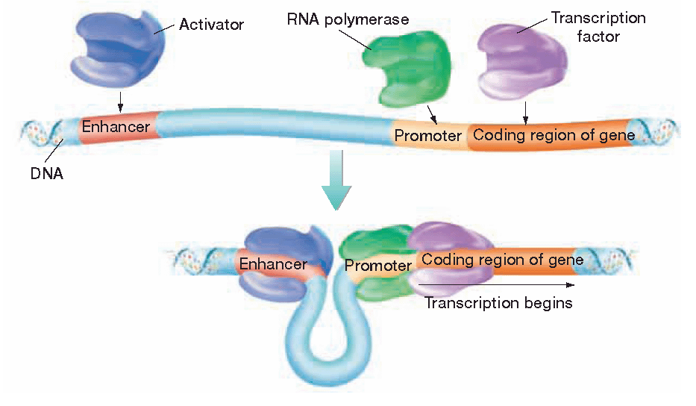
Intervening DNA Sequences in Eukaryotes
- In eukaryotes, many genes are interrupted by ____________ —long segments of nucleotides that have no __________ information.
  - These portions are said to _______________ with protein synthesis
- The portions of a gene that are translated or expressed into proteins are called __________
- After a eukaryotic gene is transcribed, the introns in the resulting mRNA are _______ out by proteins called ______________
- Spliceosomes also __________ or “stitch” the remaining __________ together
- The new mRNA containing only __________, exits the nucleus
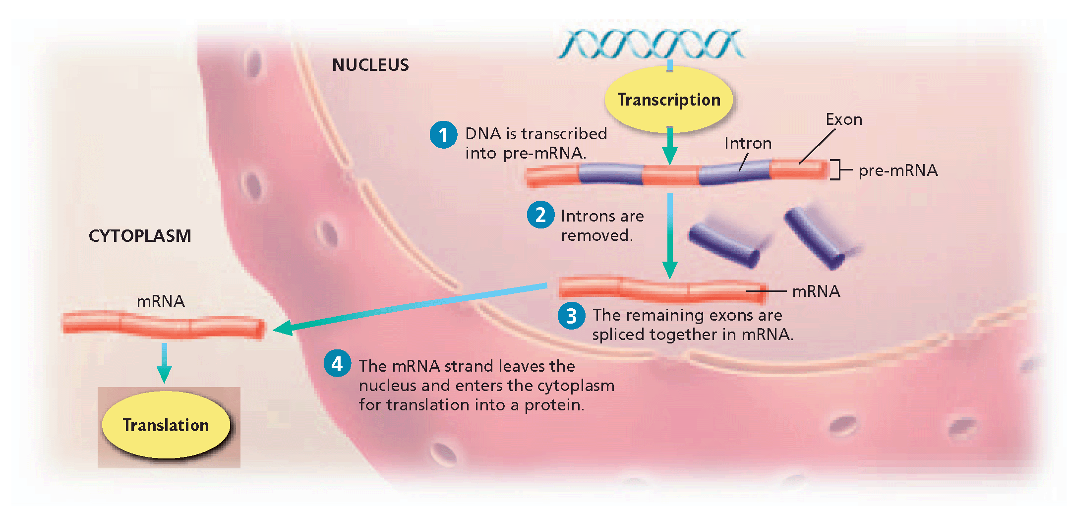
- This arrangement of exons and introns in genes may have an evolutionary advantage…
  - Sometimes the exons get ___________ between different gene segments, allowing several different _____________ of a gene to exist
  - For example, our cells have _____ different hemoglobin genes that are all capable of producing the protein hemoglobin
Mutations
- Errors in DNA ______________ or ____________ may cause mutations that code for ____________ amino acids
- Mutations may…
  - have ____ effect on an organism
  - be ____________
  - Be ____________
- The two main types of mutations are gene _______________ and gene _________________
Gene Rearrangements
- Gene rearrangements are mutations that move an __________ gene to a new location on a chromosome
  - This may affect a gene’s expression because it is exposed to different _____________ proteins
  - It could be comparable to moving to France but not being able to __________ French
- Sometimes gene rearrangements occur when DNA does not ___________ properly during cell division
- Other gene rearrangements are the result of ______________, special genes that can actually ________ and change positions along a DNA strand
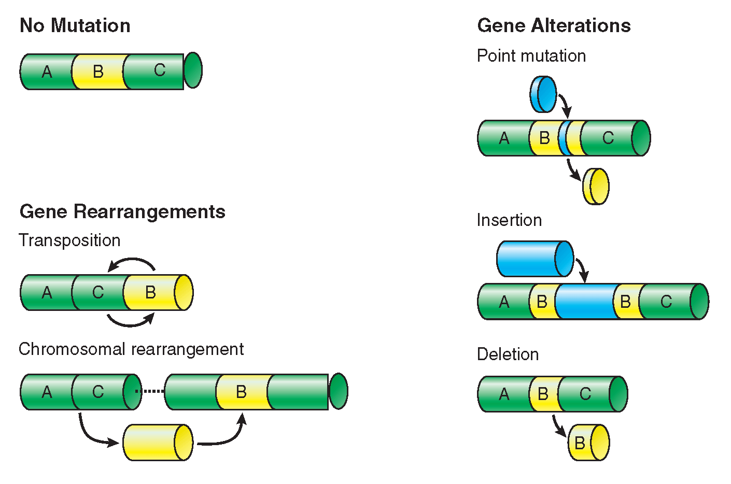
- Before a transposition, a gene sequence may read A B C, but after it may read ___________
- Transposons are responsible for the streaked ________ pattern seen on Indian corn… their positions prevent _________ proteins from being produced, causing portions of the cob to lack color
- Scientists think that transposons may play a significant role in _________________ and may help researchers pinpoint the causes of ___________
- They were actually first discovered by Barbara _____________ in the 1950s, but her work was not recognized or honored for more than 20 years
Gene Alterations
- Gene alterations are mutations that change a portion of a __________ gene
- Two types of gene alterations are…
  - _______________ mutations
  - _______________ mutations
Point Mutations
- In a point mutation, a single nucleotide _____________
- So, if a codon reads GGG, after a point mutation it may read _______
- Since several codons code for the same amino acid, sometimes point mutations do _____ alter the protein being made…but sometimes they do
- Point mutations may also be called________________

Frameshift Mutations
- In a frameshift mutation, nucleotides are ________________________or _________________
- Because the genetic code is read in ___________, insertions and deletions often upset the triplet grouping
- These mutations may cause a gene’s nucleotides to __________, causing the _________ three nucleotide sequences to be read
- Sometimes scientists compare proteins to sentences…
  - Imagine deleting the letter C from the sentence…
THE CAT ATE ____________________
- The remaining triplet sequences would be altered and rendered ________________
- Describe how the lac operon is turned on or off.

- Summarize the role of transcription factors in regulating eukaryotic gene expression.

- Describe how eukaryotic genes are organized.

- Evaluate three ways that gene alterations can alter genetic material.

