The Genetic Code
Name: ________________________________________________________ Class: _________
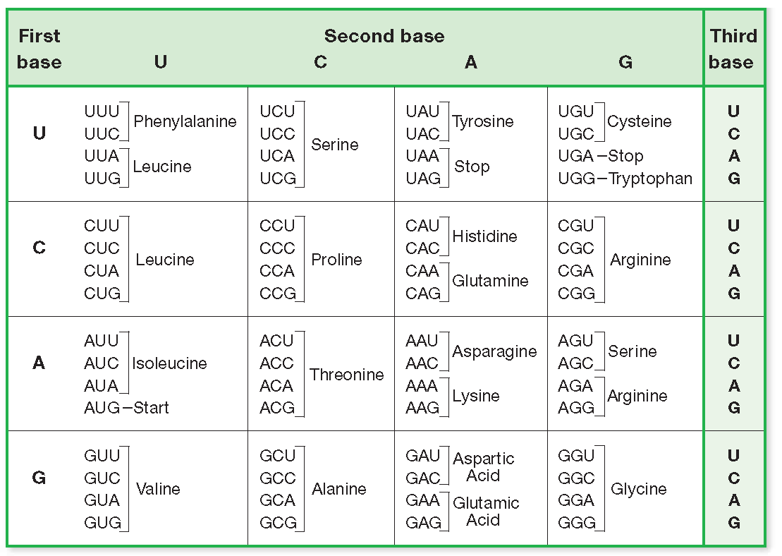
- The process of using DNA as a template to make RNA is called __________________________
- The process of using the instructions in RNA to build a protein is called___________________
- These two processes together, going from DNA to protein, is known as ________________________________ _________________________________________
- RNA is read in groups of 3 called __________________________________
- For each of the types of RNA listed below, write what the 1sdt letter stands for, and describe their role in protein synthesis
  - mRNA

  - tRNA

  - rRNA

- How many subunits are in a ribosome?________________
- Label the 3 sites on the ribosome below.

- For the following strand of DNA, write out the complementary DNA strand
ATTCGCTACGTGGGCCCGTATATATA

- For the following strand of DNA, write out the complementary RNA strand
ATTCGCTACGTGGGCCCGTATATATA

- For the following strand of RNA, circle where translation will start, and put a box around where it will stop. UCAUGCACGUGAGCAACGUUUGAGCACGG

- How many amino acids will be incorporated into the protein____________________
- List all the amino acids in the correct order that will be in the protein

