See Chapter 8.1 in your book for help with this worksheet
The History of DNA
Even though DNA has been known since the mid 1800’s, its structure and function weren’t discovered until the beginning of the 20th century. Our understanding of what DNA does and what it looked like took a long time to come together, but there were three key experiments that helped scientists learn what DNA does. Those experiments have been summarized for you here. Use the information in the passages and your own critical thinking skills to answer the following questions.
Griffith’s Experiment – 1928
Fill in the blanks with the following words:
transformed capsule lived rough smooth pneumonia died
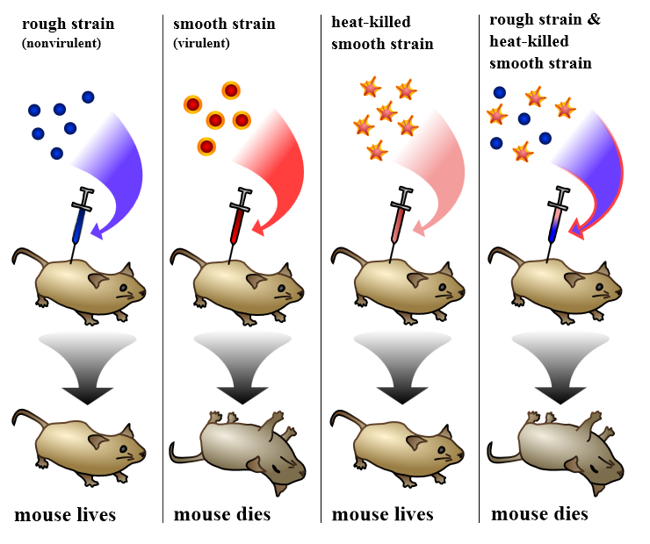
Frederick Griffith wanted to explore the differences between different types of Streptococcus pneumonia
bacteria (a bacteria that causes ____________________). He did this by injecting mice with two different strains of bacteria. One, the __________________ strain, doesn’t cause disease. The other, the ___________________ strain, causes the mice to die. The reason the smooth strain causes the mice to die is because they have a ____________________________ that makes them virulent. He noticed that when the smooth strain was heated and then injected, the mice _________________. But he also noticed that when both the heated smooth strain and the normal rough strain were both injected into the same mouse, the mouse ______________________. When he looked at the bacteria that killed these mice he saw that they were some ho _____________________ into the virulent s-type. The figure summarizes the findings of his experiment.
1. What is the independent variable in Griffith’s experiment? What is the dependent variable?

2. Why did Griffith need to show that the heat-killed bacteria didn’t make the mouse die?

Griffith’s Conclusion
Because the heat-killed bacteria mixed with the rough bacteria were lethal to the mouse, Griffith concluded that something from the heat-killed bacteria “transformed” the rough bacteria and made them lethal. But at this time, he had no idea what had caused the transformation. Other scientists picked up where he left off and tried to figure out what was causing the transformation. The first scientist to try was Oswald Avery.
3. Based on what you know, why do you think that the mix of bacteria killed the fourth mouse? Use the following words in your answer: genotype, phenotype, capsule, transformed

Avery killed the s-type bacteria in the same way as Griffith, and they then the bacteria with enzymes that either destroyed DNA or protein. He showed that when they destroyed proteins and so injected the DNA portion of the bacteria into the mice, the mice died just as they did in Griffith’s experiments. But when they destroyed DNA the mice lived because the bacteria were not transformed. This was the first evidence that DNA was the genetic material.
Hershey and Chase – 1952
In the diagram below, label the Capsid of the bacteriophage and color it blue. Label the DNA and color it Orange

Alfred Hershey and Martha Chase took Avery’s experiment even further. They wanted to confirm what Avery and his colleagues found, so they studied the effects of a virus called a bacteriophage on bacteria cells. At the time, many people thought that proteins carried genetic information, so they put radioactive elements on both the proteins and the DNA of the virus. After the virus attached itself to the bacteria, they checked to see if the cell was radioactive. Their results are summarized in the figure below to the left.
bacteriophage 1, color the protein coat red to indicate the radioactive 35-S | In bacteriophage 2, color the DNA green to indicate the radioactive 32-P

Color all the protein coats Red Color all the DNA Green

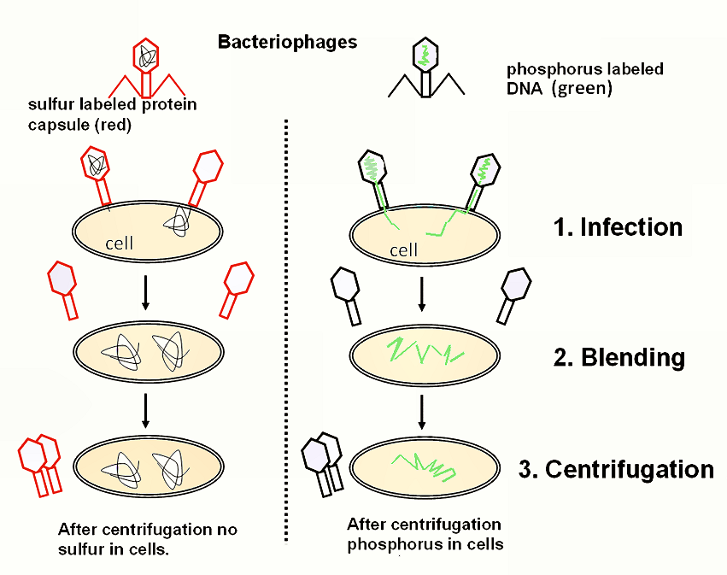

4. Based on Hershey and Chase’s results, how was the virus infecting the bacteria?

5. Based on the results, do you think that DNA or proteins carry genetic information?

