**The Theory of Evolution**

Why Its Important: Evolution is the key concept to understanding biology. It explains the _______________ of species and predicts _________________

|  |  |
| --- | --- |
| Objectives | Vocabulary |
| * **Identify** several observations that led Darwin to conclude that species evolve. * **Relate** the process of natural selection to its outcome. * **Summarize** the main points of Darwin’s theory of evolution by natural selection as it is stated today. * **Contrast** the gradualism and punctuated equilibrium models of evolution. | * Population * Natural Selection * Adaptation * Reproductive Isolation * Gradualism * Punctuated equilibrium |

**Darwin Proposed a Mechanism for Evolution**

* In 1859, the English naturalist Charles ___________ published convincing ______________ that species evolve, and he proposed a reasonable mechanism explaining ________ evolution occurs. Like all scientific theories, the theory of evolution has developed through decades of scientific ________________ and _____________________. Darwin made many of his observations while traveling around the world on a ship called the _____________________

**Science Before Darwins Voyage**

* In 1859, the English naturalist Charles ___________ published convincing ______________ that species evolve, and he proposed a reasonable mechanism explaining ________ evolution occurs. Like all scientific theories, the theory of evolution has developed through decades of scientific ________________ and _____________________. Darwin made many of his observations while traveling around the world on a ship called the _____________________.
* We now know that individuals cannot gain new adaptations during their lifetime, rather they are ________________________ Ex: giraffes do not acquire long necks by reaching for leaves on trees
* However, Lamarck did correctly point out that changes in species are due to their ______________________ conditions. Ex: If around tall trees, giraffes with longer necks will survive better than ones with short necks

**Darwins Observations**

* On the _____________________ islands, Darwin found evidence that challenged the traditional belief that species are unchanging. This group of islands is located about 1000km (620 mi) off the ________________ coast of South America. On the islands, Darwin noticed that many of the plants and animals _____________________ those of the nearby coast of South America.
* Darwin proposed that after these organisms ______________________ to the islands, they changed ___________________ overtime
* He later called this change “descent with ____________________” or evolution

**Example: The evolution of different bird beaks based on the ________ available in the _________________**

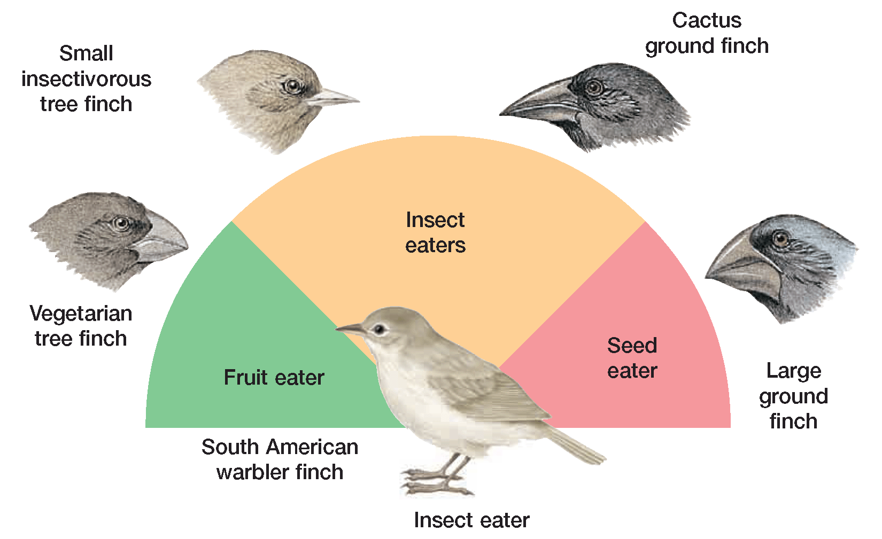

**Why might the large ground finch be a good seed eater?**

* Darwin also found ________________ of extinct armadillos in South America
  + These fossils _________________ resembled, but were not identical, to armadillos living in the area
  + When Darwin returned home, he continued to study his findings for two _____________. He was certain that evolution occurred, he just didn’t know _______.

**Growth of Populations**

* The key that unlocked Darwin’s thinking about how evolution takes place was an essay written in 1798 by the English economist Thomas __________________.
  + Malthus suggested that human populations do not grow _________________ because death caused by disease, war, and famine _____________ population growth.
* In the study of biology, a **population** consists of all the individuals of _______ species that live in a specific geographical __________ and that can ______________.
* If populations grow ________________, they show an ____________________ pattern of growth
* This growth pattern is also

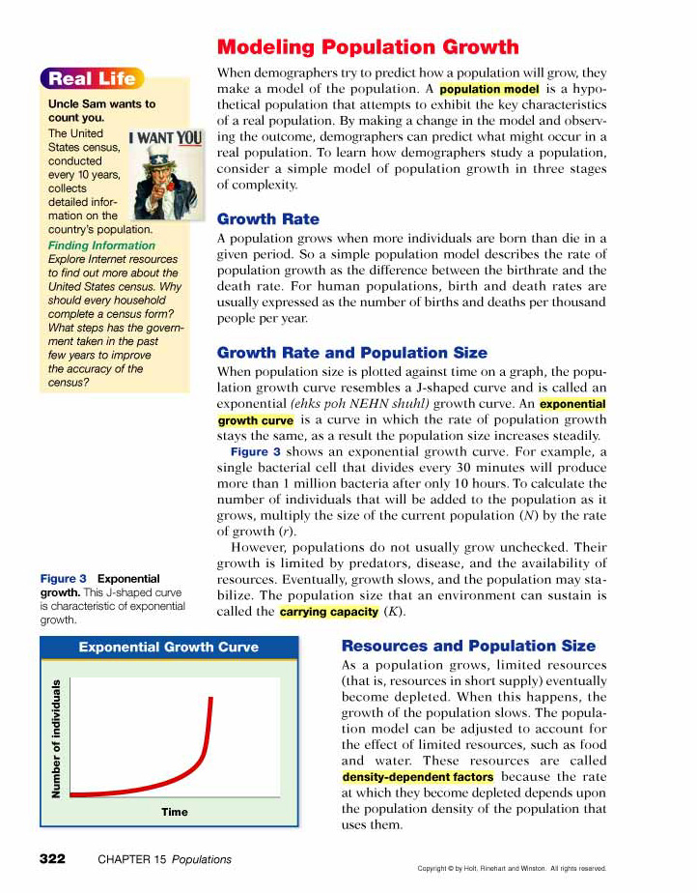

called _____ shaped

growth and continually

increases as the population

grows

* Common in organisms

that reproduce ________________

* The growth of most larger organisms is slowed or “checked” by ________________ factors, like __________________, __________________, _________________, and __________________
* Growth usually stabilizes

at a population’s

_________________

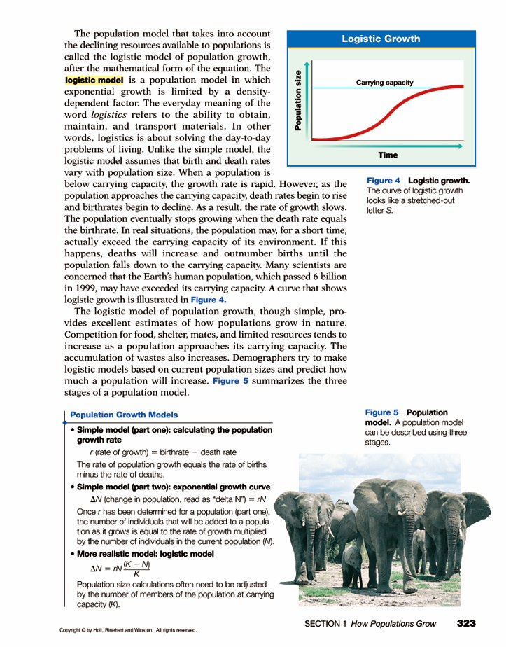

_________________

* This growth is called   
  ____ shaped growth and

is common in organisms

with ______________ life spans

* When Thomas Malthus wrote his

paper, he thought that human

population growth would soon begin to _________ down, due to limiting factors. He probably would have been correct, if the ________________ revolution soon did not occur

* + Better technology made it easier for humans to survive and we have been showing _____ shaped growth ever since
* After reading Malthus’s essay, Darwin recognized that many species produce _________ offspring, but their population growth is still slowed by limiting factors like ___________________
  + and…individuals that have physical or behavior _________________ that are better adapted to their environment are more likely to ___________ and will __________________ more successfully than those that do not have such traits

**Evolution By Natural Selection**

* Remember, adaptations and traits are controlled by ____________, which are inherited
* An adaptation is a feature that has become common in a population because the feature provides a selective ____________________ in a specific __________________
* Darwin called this differential rate of reproduction **_______________ ____________________.**
* In ________, Darwin finally wrote down his ideas about evolution and natural selection in an early outline that he showed to only a ______ scientists he knew and trusted.
* Darwin decided to publish after he received a letter and essay in ________ from another naturalist named Alfred Russel ________________ , who also supported the idea of evolution by natural selection.
* Darwin’s published work was a book called…

________________________________ *by Means of Natural Selection*

Many people were deeply _________________ by Darwin’s theory…but it is supported by four major points…

* 1. _____________________ exists within the genes of every population or species.
  2. In a particular environment, __________ individuals of a population or species are better suited to survive and have more offspring
  3. Overtime, the traits that make certain individuals of a population able to survive and reproduce tend to ______________ in that population
  4. There is overwhelming evidence from ____________ that living species evolved from organisms that are ______________

**Darwins Ideas Updated**

* Darwin’s ideas are further supported by the discovery that an organism’s traits are determined by the _______________ that they _________________
* So, evolution occurs in a _________________ when the _______________ of certain alleles increases or decreases over time.
* _________________ and the ________________ of alleles that occurs during sexual reproduction provide an endless source of new _________________ for natural selection to act upon
  + Keep in mind that most mutations are ______________, but if the mutation is beneficial, it will end up __________________ in a population

**How are New Species Formed?**

* Populations of the same species living in different locations tend to evolve in different __________________.
* When members of a population became separated physically or _____________________, they are also _________________ **isolated** because they can no longer ________
* What are some examples of geographical structures that can separate a population?
* As members of a divided population reproduce separately, DNA __________________ or changes in mating _______________ may prevent them from _________________ even if they are in the same location
* When members of a population can no longer interbreed, they are considered _______________ species
* Example… A squirrel population became isolated in different areas of the Grand Canyon

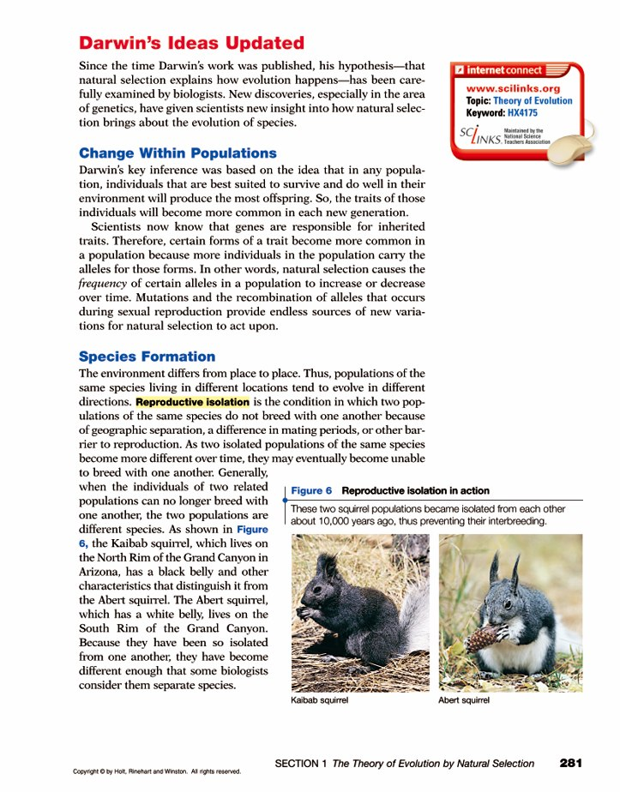

In one population, squirrels with

_________ _____________bellies were more successful, and in another population squirrels with ____________________ bellies were more successful

* A similar pattern of evolution was observed in peppered moths
  + Lighter variations became more prevalent in England’s country side, while darker variations became more prevalent in England’s cities…

[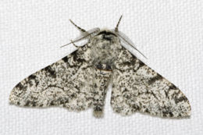](http://en.wikipedia.org/wiki/File:Biston.betularia.7200.jpg)

[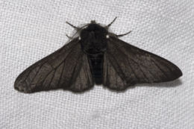](http://en.wikipedia.org/wiki/File:Biston.betularia.f.carbonaria.7209.jpg)

* + Hypothesis?
* The genetic darkening of a population due to pollution has been coined

industrial __________________

* + Melanin – pigment

**The Tempo of Evolution**

* For decades, most biologists have understood evolution as a _____________ process that occurs continuously .
  + This model of evolution is called ____________**.**
* Another model of evolution, in which periods of ___________ change in species are separated by periods of little or _____change, is called **___________________ ____________________**
  + **Usually seen after major _______________ changes and mass ___________________**

1. **Identify** several observations that led Darwin to conclude that species evolve.
   1. Organisms on the Galapagos Islands?
   2. Armadillo fossils in South America?
2. **Relate** the process of natural selection to its outcome.
3. **Summarize** the main points of Darwin’s theory of evolution by natural selection as it is stated today.
   1. _____________________ exists within the genes of every population or species.
   2. In a particular environment, __________ individuals of a population or species are better suited to survive and have more offspring
   3. Overtime, the traits that make certain individuals of a population able to survive and reproduce tend to ______________ in that population
   4. There is overwhelming evidence from ____________ that living species evolved from organisms that are ______________
4. **Contrast** the gradualism and punctuated equilibrium models of evolution.

**Evidence of Evolution**

|  |  |
| --- | --- |
| Objectives | Vocabulary |
| * **Describe** how the fossil record supports evolution. * **Summarize** how biological molecules such as proteins and DNA are used as evidence of evolution. * **Infer** how comparing the anatomy and development of living species provides evidence of evolution. | * Paleontologist * Vestigial Structure * Homologous structure |

* Evidence that supports the theory of evolution comes from different sources…
  + __________________________
  + __________________________
  + __________________________
* Fossils provide an actual _____________ of Earth’s past life-forms and evidence that indicates _____________ over time

* After noticing changes in fossils, Darwin predicted that _____________________ forms between the great groups of organisms would be discovered…
  + While the fossil record is incomplete, some intermediate fossils have been found between…
    - Fishes and _______________________
    - Reptiles and _____________________
    - Reptiles and ___________________________
* The fossil record has led most scientists to agree that….

1. Earth is about 4.5 _______________ years old.

2. Organisms have inhabited Earth for _______ of its history.

3. All organisms living today share _______________ ancestry with earlier, simpler life-forms, based on the principle of ____________

**Formation of Fossils**

* **_______________________ are** scientists who study fossils.
* _________ radiometric dating and relative dating are used to arrange fossils in ______________ from oldest to youngest

**Evidence of Whale Evolution**

* For example, whales are thought to have evolved from extinct, four-legged mammals called ____________________

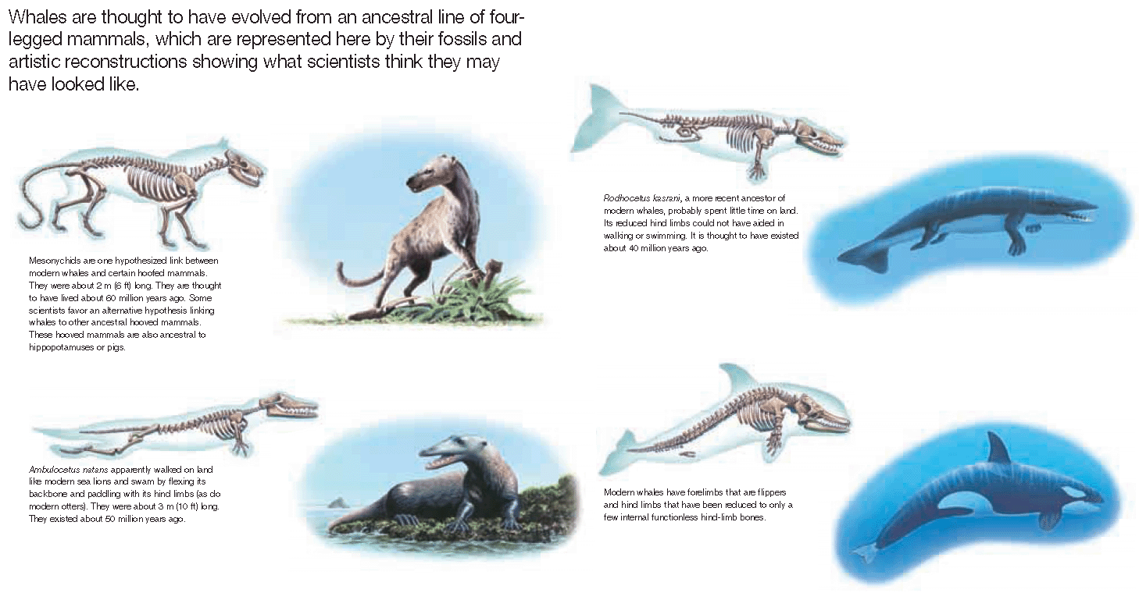

* Fossils indicate that traits helpful for ___________________ may have been passed along
* Modern whales have forelimbs that are ________________ and hind limbs that have been reduce to only a ________ bones
* The fossil record is incomplete because not all organisms are preserved…
  + For fossils to form, dead organisms must quickly be covered in layers of sediment before they ___________________
  + Fossils also only form in layers of ____________________ rock, which forms at relatively ________ temperatures and pressures
  + _____________________ rock, which forms at _______________ temperatures and pressure, _________________ fossils

**Anatomy & Development**

* Comparisons of the anatomy of different types of organisms often reveal basic ___________________ in body structures even though the structure’s _____________ may differ slightly between organisms.
* **Similar structures, called ________________ structures, indicate a _______________ ancestry**
* What is similar about these homologous structures?

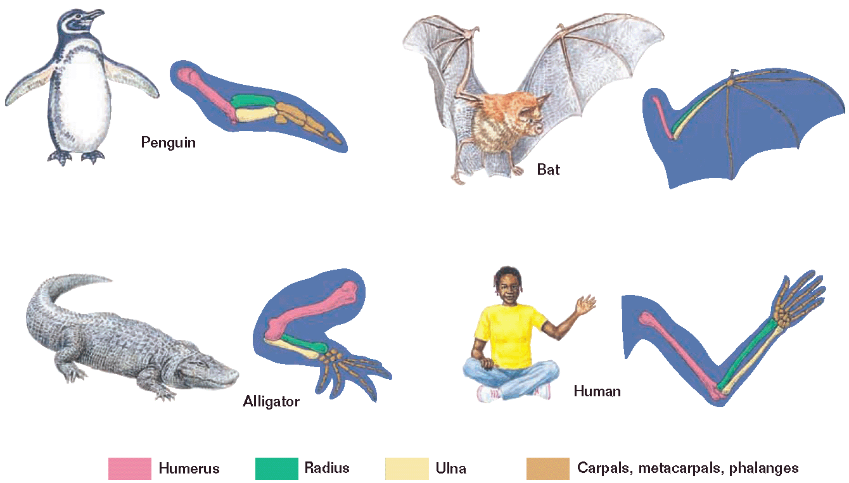

* Sometimes structures are present in an organism, but are __________________ in size and either have ______ use or a ___________ important function than they did in a previous ancestor…

Examples…

* + Whale hind limb bones
  + Ostrich wings
  + Human appendix
  + Vestigial snake feet (buds)

**Embryonic Development**

|  |  |
| --- | --- |
| Untitled-30 copy | The evolutionary history of organisms is also seen in the development of _______________________.  At some time in their development, all vertebrate embryos  have a __________________, ______________________ that become limbs, and pharyngeal pouches  The tail remains in __________________ adult vertebrates. Only adult fish and immature amphibians retain pharyngeal pouches which contain their ___________________________. |

**Biological Molecules**

**DNA and Proteins**

* As species evolve, changes should have become a part of their __________________ instructions. Therefore, more and more changes in a gene’s _______________ sequence should build up over time.
* Since DNA codes for the production of _________________

species that have descended from a recent common ancestor should have _______________ amino acid differences between their proteins than more distant species.

|  |  |
| --- | --- |
| **Hemoglobin Comparison** | |
| Untitled-6 copy | Which organism differs most from humans according to the type of amino acids present in its hemoglobin protein?  And the least different from humans? |

1. **Describe** how the fossil record supports evolution.
2. **Summarize** how biological molecules such as proteins and DNA are used as evidence of evolution.
3. **Infer** how comparing the anatomy and development of living species provides evidence of evolution.

Anatomy

Development

**Evolution of Populations**

|  |  |
| --- | --- |
| Objectives | Vocabulary |
| * Identify four elements in the process of natural selection * Describe how natural selection has affected the bacteria that cause tuberculosis * Relate natural selection to the beak size of finches * Summarize the process of species formation * Identify the Hardy-Weinberg principle * Describe the five forces that cause genetic change in a population * Identify why selection against unfavorable recessive traits is slow * Contrast directional and stabilizing selection | * Divergence * Speciation * Subspecies * Hardy-Weinberg principle * Gene flow * Nonrandom mating * Genetic drift * Normal distribution * Directional selection * Stabilizing selection |

**Natural Selection at Work**

* The process of natural selection is driven by four important points that are true for all real populations:

1. All populations have genetic ____________________.

2. The environment presents _____________________ to successful reproduction.

3. Individuals tend to produce ________ offspring than the environment can support.

4. Individuals that are ___________ able to cope with the challenges presented by their environment tend to leave more offspring than those individuals less suited to the environment do.

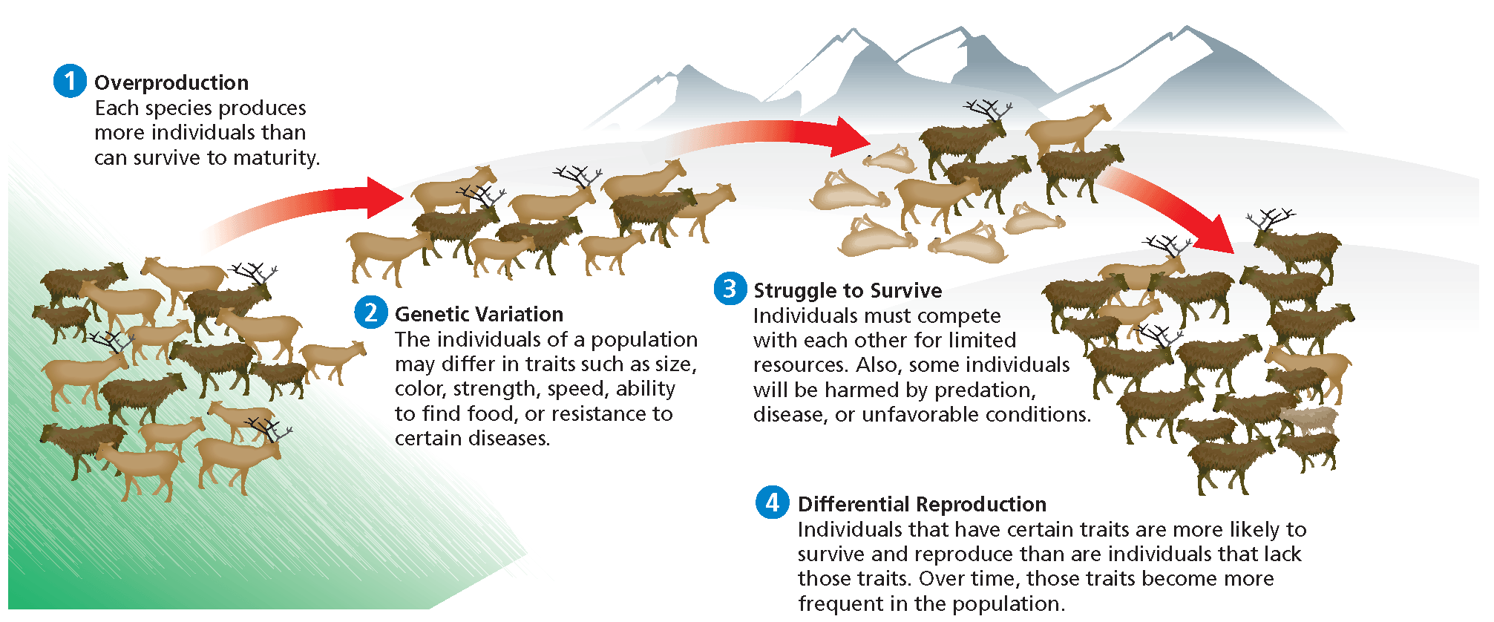

* In some instances, natural selection can be observed in ___________ periods of time
  + When small organisms with short life spans, like _____________ or _____________ become resistant to ______________ or ______________
  + When organisms are exposed to different _______________

**Antibiotic Resistance**

* The lung disease tuberculosis (TB) is caused by the bacterium *_________________ _______________*.
* In the 1950s, two effective _________________, isoniazid and rifampin, became available to treat TB.
* In the late _______, however, _______ strains of *M. tuberculosis* that are largely or completely _______________ to isoniazid and rifampin appeared….

**Evolution of Antibiotic Resistance**

* Rifampin normally kills bacteria cells by binding to RNA polymerase, which will prevent ______________
* However, TB bacteria began passing on a ________________ that prevents rifampin from binding to the polymerase.
* So, TB bacteria with the mutation were able to _____________ treatment with the antibiotic, leading to the evolution of rifampin resistance in *M. tuberculosis.*

**Evolution of Darwins Finches**

* Darwin collected 31 specimens of finches from three ___________ when he visited the Galápagos Islands.
* All in all, he collected nine different species that were all very similar except for their _________
* Darwin suggested that they all evolved from an original _______________ species that changed as different populations accumulated adaptations to different ____________ sources.
* A study of the finches was carried out over ____ years beginning in 1973 by Peter and Rosemary ____________ of Princeton University.
* They discovered that during drier years, birds with __________ beaks survived better because they could eat ___________ seeds…



But during ______ years, birds with ___________ beaks survived just as well because the seeds are ______________

So the beaks of bird populations did ______________ in response to the ___________ food supply

**Formation of New Species**

|  |  |
| --- | --- |
| * The formation of new species, called _________________, occurs in ___________. * The accumulation of differences between groups is called **_________________.** | Untitled-20 copy |

**Adaptive Radiation**

|  |  |
| --- | --- |
| When an original ancestor has diverged into many different species over time, the ancestor has gone through  a special type of divergence, called ______________  ______________  Example…Darwin’s finches | http://www.vce.bioninja.com.au/_Media/adaptive_radiation_med.jpeg |

**Forming Subspecies**

* Divergence occurs as populations of the same species differ _______________ because of adaptations to different living ______________
  + This leads to the evolution of _______________, which can still ________________, but they represent the first steps towards speciation
* Remember, separate species cannot interbreed….
  + This might mean that they…
    - ______________ cannot mate
    - Do not produce _____________ offspring
    - Are isolated because they have different ____________ seasons
    - Produce ______________ offspring
* Example….The offspring of a donkey and a horse is called a ____________
  + - This hybrid offspring is _____________, so donkeys and horses are considered separate species
* Example…A similar situation applies to lions and tigers
  + - The offspring of a male lion and female tiger is called a __________
    - The offspring of a male tiger and female lion is called a ______________
* The male hybrids are ________________, so ligers cannot interbreed with other ligers, as tigons cannot interbreed with other tigons, so lions and tigers remain classified as ________________ species
* Furthermore, tigers and lions do not live in the same _____________ so they don’t reproduce together _______________

**Hardy Weinberg Principle**

* After studying Mendel’s work regarding genetics, scientists wondered if dominant traits would randomly or ________________ replace recessive alleles in a population
* In 1908, an English mathematician named G. H. _____________ and a German physician named Wilhelm ______________ devised a mathematical equation that allows us to keep track of the ________________ in a population

**p2 + 2pq + q2 = 1**

p2 = frequency of homozygous _____________ alleles

2pq = frequency of _________________

q2 = frequency of homozygous ______________ allele

*****All of the frequencies must add up to _____

**p2 + 2pq + q2 = 1**

* So, for example, the frequency of individuals with cystic fibrosis (cc) is 0.00048
  + In the equation above, where would this number be plugged in?
  + Then, you can determine the rest of the frequencies __________________
* Hardy and Weinberg determined that allele frequencies do _____ change from population to population, unless the population is acted on by a process that ____________ particular alleles
* So for example, a lethal dominant allele does not become more ____________ just because it is dominant
* This discovery, called the Hardy-Weinberg ______________, states that allele frequencies do not change unless ___________________ forces act on a population
* Five evolutionary forces frequently act upon the all of the genes in a population called a gene _______
* These forces are…
  + _________________
  + _________________
  + _________________
  + _________________
  + _________________

Mutations:

* Mutations in _____ affect the codons in mRNA produced during ________________
* Recall, however, that several codons code for the same amino acid, so not all mutations affect _____________ synthesis
* Mutations rates in populations are usually very ______________, but they still provide new variation in a population

Gene Flow

* Gene flow is the movement or ______________ of alleles into or out of a population
  + Immigration = new alleles ___________ a population
  + Emigration = alleles ____________ a population
  + Example…
  + If tall individuals leave a population, what kind of alleles will be left?

Nonrandom Mating

* Nonrandom mating occurs when organisms chose their mates based on certain ____________
* In animals, for example, females often select males based on their….
  + __________
  + __________
  + Ability to gather ________ or provide _____________
* Female widowbirds prefer males with ________ tails. How will this change the alleles for tail length over time?

Genetic Drift

* Occurs when the allelic frequencies in a population are altered by __________ events
* The effects of genetic drift are seen more often in _______________ populations because their gene pool is _______________
* Example…Imagine that there is a bird population containing 90 red birds and 10 white birds. A hurricane blows 10 birds off of the mainland which end up on an island….
  + ____ of these birds are red and _____ are white
  + Due to chance, the allele frequencies of the 10 ___________ birds of the new island population are drastically different from birds on the mainland
  + This type of genetic drift is often called the ________________ effect

Natural Selection

* Favorable traits are caused by genes, but natural selection acts upon the __________ which is a phenotype
* So, for example, natural selection cannot eliminate a ______________ disease like cystic fibrosis, because heterozygous carriers have the same ______________________ as homozygous dominant individuals
* There are also different __________ of natural selection that affect gene pools differently
  + ________________ selection
  + ________________ selection
  + Disruptive selection

Directional Selection

* Selects for _____ extreme version of a trait, so the population is said to be moving in one ___________
* Example….Why might woodpeckers with long beaks be selected for?

Stabilizing Selection

* Occurs when individuals with ____________ variations of a trait are selected for
* Example…spider size
  + Birds prefer to eat _____________ spiders
  + Small spiders do not __________ prey well
  + ______________ sized spiders survive the best

Disruptive Selection

* Where both extremes of a trait are selected for and the average is selected against
* Can lead to speciation over time
* Why might very large beaks or very small beaks be an advantage over medium sized beaks?

1. **Identify four elements in the process of natural selection**
   1. **________________________________ of offspring**
   2. **________________________________ variation**
   3. **________________________________ to survive**
   4. **________________________________ reproduction**
2. **Describe how natural selection has affected the bacteria that cause tuberculosis**
3. **Relate natural selection to the beak size of finches…**
   * 1. **Which type of beak enabled survival in dry environments**
     2. **Did beak type affect survival during wet/rainy years?**
4. **Summarize the process of species formation…**

**What is different about subspecies versus separate species?**

1. **Identify the Hardy-Weinberg principle…**
2. **Describe the five forces that cause genetic change in a population**
   1. **Mutations**
   2. **Gene flow**
   3. **Nonrandom mating**
   4. **Genetic Drift**
   5. **Natural Selection**
3. **Identify why selection against unfavorable recessive traits is slow**
4. **Contrast directional and stabilizing and disruptive selection**